Ultrasonic intensification to produce diester biolubricants

Nicolas A. Patience^{a,b^}, Federico Galli^{a,c^}, Marco G. Rigamontiª, Dalma Schieppatiª, Daria C. Boffito^{a,}*
ªPolytechnique Montréal – Department of Chemical Engineering, C.P. 6079, Centre ville H3C 3A7 Montréal (QC) Canada
^{b}McGill University– Department of Agricultural and Environmental Sciences, 21111, Lakeshore road, Saint-Anne-de-Bellevue, H9X 3V9 (QC) Canada
^{c}Università degli Studi di Milano – Chemistry Department, via Golgi 19, 20133, Milan, Italy
*corresponding author: daria-camilla.boffito@polymtl.ca, tel: (514) 340-4711 ext. 2446.
^These authors contributed equally.
Abstract
Biolubricants synthesized from vegetable oils with oleic acid and 1,3-propanediol possess better cold flow properties and have a smaller environmental footprint than mineral-based lubricants. However, their synthesis is lengthy (> 6 h) and requires temperatures above 120 °C. We applied ultrasound to synthesize long chain di-esters (biolubricants): an ultrasonic horn delivered rated powers of 500 and 750 W at 20 kHz frequency to a solution of oleic acid and 1,3-propanediol. Amberlyst®15-H esterified the acid to the di-ester biolubricant. 750 W and 500 W ultrasound horns increased the reaction rate by factors of 2 and 1.2-1.5, respectively. A temperature of 100 °C is necessary to convert oleic acid to over 50 %. A partial factorial experimental design confirmed that temperature, ultrasound power and initial reactants’ molar ratio affect reaction rate and oleic acid conversion (p-value < 0.05). The 500 W horn is 17 % less expensive than the 750 W horn.

Introduction
Lubricants are a combination of viscous liquids and additives that reduce mechanical attrition between machine parts – car axels, pistons, reciprocating compressors, etc. ^{1,2} Projections on the global lubricants market forecast its expansion from 36 Mt in 2014 to 44 Mt in 2022, as a consequence of the increased demand from automotive, industrial machinery and construction industry ³. Shifting our focus to biolubricants will mitigate the stress on the environment while concurrently offering technical advantages over lubricants. Mineral oil lubricants typically fail at operating temperatures exceeding 160 °C in the presence of air due to oxidation⁴. Vegetable oil derivatives can replace standard lubricants⁵ or additives⁶ because they are denser, have higher viscosity index, lower pour points and flash points, and lower volatility. They are as well nontoxic and biodegradable. This translates into enhanced lubricity, which reduce friction losses, application at higher temperature, reduced exhaust emissions because of the lower volatility, and mitigation of human and environmental hazard ⁷. The main disadvantage of vegetable-oil derived biolubricant is their oxidation stability, which is poor due to i) the hydrogen atom in the β position on the ester group of the glycerol⁸; which eliminates and forms unsaturations and ii) possible mono or multiple naturally occurring unsaturations in the side chains of the feed material. The presence of these unsaturations leads to polymerization into solid polymer particles that alter the lubricant rheology. McNutt and He reviewed the three main chemical routes to obtain more stable biolubricants from vegetable oils, i.e. i) estolide synthesis, ii) epoxidation and iii) esterification or transesterification ⁹. i) Estolide synthesis requires a capping fatty acid, which makes the process expensive ¹⁰. The addition across an unsaturated bond or an hydroxyl group in the middle of the fatty acid chain to the carboxyl moiety of another free fatty acid (FFA) yields an estolide. ii) Low temperature epoxidation of oils or fatty acids esters^{11,12} implies operating in a double-phase reactor, with severe mass transfer limitations, as demonstrated by Pirola et al. for a similar system (free fatty acid esterification with excess of methanol)¹³. Borugadda et al. alkoxylated epoxidized triglycerides over montmorillonite in over 350 min ¹⁴. iii) Esterification is a reaction between an acid and an alcohol to yield an ester and water in the presence of an acid catalyst. Water limits the thermodynamic equilibrium of the esterification ¹⁵, therefore controlling temperature and the reactant molar ratio is essential to increase yield. Transesterification involves a basic catalyst, either homogeneous or heterogeneous¹⁶, that reacts vegetable oil with low molecular weight alcohols (e.g. methanol) and then the fatty esters react with a di- or tri- functional alcohol to form biolubricants. Oleic acid-based glycerides have the best cold-flow properties and oxidative stability¹⁷. Sulphuric acid esterifies vegetable oil in a homogeneous phase¹⁸ but heterogeneous catalysts attenuate corrosion and reduce waste when recycled. Zaccheria et al.¹⁹ prepared biolubricants with silica, alumina, zirconia, and their mixed oxides at 200 °C for 6 h. However, Lewis-type catalysts are sensitive to water. Pyridine adsorption demonstrated that water deactivates 42 % of the active sites at 150 °C. Even if the activity of the catalyst remained stable for 36 h, the reaction time is unacceptable in an industrial setting. Oh et al.²⁰ reacted different alcohols and oleic acid with sulphated zirconia. They reached full conversion with all reactants in 10 h. Diester lubricants have inherently good oxidation stability and low volatility. Diesters have high viscosity index over a wide temperature range, which minimizes the need of additives¹. Raghunanan et al. measured the thermal stability of saturated and unsaturated diol esters, and dibasic esters, and concluded that unsaturated diol derived diesters are suitable for a wider range of applications as their evaporation point is above 240 °C in all instances²¹. Raghunanan and Narine synthesized branched diesters with exceptional low temperature and flow properties in one pot, at temperatures above 95 °C in 5 h. Although biochemicals such as diester biolubricants perform better than petroleum-derived products, their production times are not suitable for commercial applications. Designing innovative processes to shorten the time to market of bio-based technologies is imperative to attain the far-reaching goal of sustainable development. Intense sound passing through a liquid interacts with the matter at different scale levels, from the macroscopic scale (agitation) down to the molecular level (production of radicals ²²). Ultrasound (frequency >20 kHz) has thus the potential to impact on any process in liquid phase. As such, ultrasound delivers mechanical energy to accelerate and increase the selectivity of chemical reactions²³. The main mechanism is acoustic cavitation; it produces gas bubbles in the liquid medium that accumulate energy before violently collapsing and releasing this power that becomes available to the reaction²⁴. Ultrasound intensifies reactions including selective reductions, esterification, transesterification, epoxidation, and polymerizations²⁵. Several data concern the ultrasound-assisted conversion of triglyceride-based feedstock into methyl esters (biodiesel) through transesterification or esterification. For instance, in the presence of ultrasound, methanol, ethanol and isopropanol transesterify canola oil in one minute. At high ultrasound energy densities, the conversion surpass 90 % in 18 seconds even in the presence of pulsed ultrasound ²⁶. The same reaction without ultrasound takes 60 minutes²⁷. Similarly, Shinde and Kaliaguine transesterified canola oil in a continuous reactor with conversions over 90 % in a little over one minute ^{28,29}. Boffito et al.³⁰ also esterified oleic acid in canola oil with methanol using ultrasound (nominal power of 295 ± 2 W and a frequency of 20 kHz) and the conventional method with a heterogeneous catalyst; ultrasound was three times faster. Maddikeri et al.³¹ interesterified waste cooking oil with methyl acetate in the presence of ultrasound (rated power of 750 W with a frequency of 22 kHz) to obtain higher conversion rates compared to conventional methods. Additionally, at 375 W and 22 kHz, Pukale et al.³² transesterified waste cooking oil with methanol using a tripotassium phosphate catalyst. Gole and Gogate³³ intensified biodiesel synthesis with a 20 kHz ultrasonic horn (102 W) from high-acid-value Nagchampa oil and homogeneous catalysts. Pacheco et al.³⁴ esterified 10 different aliphatic acids with ethanol or methanol applying 500 W with a frequency of 20 kHz. In case of triglyceride-based feedstocks the increase in biodiesel yield is ascribable to the improved mass transfer coefficient which is up to 6 times higher than the one in absence of ultrasound ^{27,30}. These are all examples of process intensification as ultrasound decreases reagent inventory, thus increasing safety and reduce equipment size in reasons of the order of magnitude faster reaction rates. It ultimately relates to the reduction of production costs. For all the mentioned reasons process intensification is deeply rooted in sustainable development³⁵. Here we prepare di-ester biolubricants from the reaction between oleic acid with 1,3-propanediol to enrich the limited literature on ultrasound-assisted production of biolubricants. We adopt ultrasound to accelerate the reaction and Amberlyst-15 as a solid catalyst. We studied the effect of different ultrasound power and varied the molar concentration of acid and alcohol as well as the reaction temperature. Our work is original for several reasons: i) we synthesized for the first time the 1,3- propanediol, dioleate as a biolubricant; ii) we varied ultrasound conditions to produce a biolubricant and correlated the data with a statistical model; iii) we applied ultrasound in the presence of Amberlyst 15-H for an esterification reaction; iv) we applied a rheological model to simulate the viscosity data of the di-ester biolubricant.
Experimental Section
Materials. We purchased oleic acid, 1,3-propanediol and Amberlyst® 15 hydrogen form (dry) from from Sigma-Aldrich, and the ultrasound horns from Sonics & Materials. Acid Amberlysts are macroreticular resins with different Brønsted site concentration that are active in esterification ^{13,36}. Amberlyst® 15 has a nominal acidity of 1.7 meq mL⁻¹. We selected it because of its superior conversion compared to gel-type resins³⁷. We did not purify these chemicals further.
Experimental set-up. All experiments were conducted in a jacketed glass reactor (inner diameter = 425 mm, height = 100. mm ± 0.5 mm) placed on a magnetic hotplate agitating at 600 rpm.³⁸ The reactor was charged with 60.00 g ± 0.01 g oleic acid. The tip of the ultrasonic horn was 70 mm ± 10 mm from the bottom of the reactor. We measured the actual power delivered to the solution with the calorimetric method of Uchida and Kikuchi³⁹. We defined time zero as the point at which we added 1,3-propanediol at molar ratios of 0.5, 1 or 2 and Amberlyst® 15 (10 % of oleic acid’s weight, pre-heated at reaction temperature). We varied ultrasound power and ended the reaction after 3 to 4 h depending on the conversion. We sampled the solution every 30 min and set the temperature at either 70 ± 1 °C or 100 ± 1 °C. Tap water flowing through the jacket controlled the reaction temperature (Table 1).
Colorimetric titrations determined the residual oleic acid content. 0.1 N solution of KOH in ethanol neutralized a quantity of 0.05 g of sample, diluted with 10 mL of isopropanol. Phenolphthalein (one drop of 4 % phenolphthalein solution in ethanol) was the indicator. From the volume of KOH solution required to titrate W grams of sample, we calculate oleic acid content (in percent) in a sample with (Eq. 1):
$Ω_{FFA} =\frac{V*0.1*286.46}{W}*100$ (1)
286.46 g mol⁻¹ is the molecular weight of oleic acid. From oleic acid content at time t (X_{FFA, t}) and time zero (X_{FFA, 0}), we calculate its conversion (χ) with (Eq. 2):
$χ=\frac{X_{FFA, 0}-X_{FFA, t}}{X_{FFA,0}}$ (2)
We repeated all tests at least two times.
Biolubricant Characterization. An Agilent 7890A GC-MS equipped with a DB-Wax column (30 m x 0.250 mm x 0.25 µm) connected to a 5975C VL MSD with Triple-Axis Detector, measured mono- and di-ester content. We diluted a drop of the sample in 5 mL of toluene and injected a 1 µL aliquot. He was the carrier gas at 1.4 mL min⁻¹ and it also purged the septum at 3 mL min⁻¹. The split ratio was 10:1. The injector temperature was 300 °C and initially the oven operated at 60 °C. After 2 min the oven ramped at a rate of 10 °C min⁻¹ until it reached 200 °C. At 7 min, the oven reduced the ramp to 5 °C min⁻¹ and held 250 °C for the duration of the analysis. The TCD detector operated at 250 °C with 5 mL min⁻¹ of He (reference).
An ANTON PAAR DMA 4500 determined the density of our samples from 40 to 80 °C. The device measures the damping of a U-tube’s oscillation caused by the viscosity of the filled-in sample and sets it against a reference oscillator. Two integrated Pt 100 thermocouples measured the temperature.
A Rheometer HAAKE Viscotester iQ Air (Thermo Scientific) with a CC27 coaxial cylinder configuration measured the apparent viscosity. We introduced 3.00 ± 0.05 mL of sample in the instrument chamber and set at 20.0 °C, 40.0 °C or 79.0 °C with an external water circulator (± 0.1 °C, polystat Cole-Parmer). After the temperature stabilized, we increased, stepwise, the shear rate from 100 s⁻¹, 500 s⁻¹, 1000 s⁻¹, 2000 s⁻¹ and 5000 s⁻¹. After tixotropy, we recorded data while spinning at a constant shear of 1000 s⁻¹ and ramping the temperature from 20 to 79 °C (continuous) over a period of 900 s. This analysis elucidated the trend relationship between temperature and viscosity.
Statistical analysis. Minitab 18.1 designed the experimental plan according to a fractional factorial design (Table 1). We selected three factors: temperature, alcohol/free fatty acid (FFA) molar ratio and power delivered by the ultrasonic horn. We selected two levels (70 °C and 100 °C) for temperature and three levels for the molar ratio (0.5, 1, and 2) and US power (0 W, 33.8 W, and 88.2 W). The Pareto chart screened the significant factors with a 90 % confidence level, and the ANOVA statistical test regressed the linear model coefficients.
Results and discussion
Operating variables
The power delivered by the 500 W and 750 W horns at 60 % amplitude was 33.8 ± 0.9 W and 88.2 ± 0.5 W, respectively, according to the calorimetric calibration.
At 33.8 ± 0.9 W and 100 °C with ultrasound, FFA completely converted at each alcohol/FFA molar ratio in 3 h maximum. At 88.2 ± 0.5 W and 100 °C with ultrasound, FFA completely converted at a molar ratio alcohol/FFA twice and 4 times the stoichiometric one and converted more than 90 % at the stoichiometric ratio.
Literature on biolubricants production reports a lower conversion than the one attained in this work. For instance, Nagendramma prepared pentaerythritol tetraoleate with Indion-130 acid resin. Full conversion was achieved after 6 h at 110 °C ⁴⁰. Kuzminska et al.⁴¹ converted oleic acid and trimethylolpropane into biolubricants over Amberlyst 36, Dowex 50wx2, Purolite CT482 and Purolite CT275DR. They obtained the equilibrium conversion after 17 h at 120 °C.
The esterification of oleic acid with 1,3-propanediol is thermodynamically limited below 100 ºC (Fig. 1) by the chemical equilibrium since water does not evaporate. Above 100 ºC, water evaporates and shifts the thermodynamic equilibrium towards the products (Table 1).
Table 1: Experimental condition adopted and FFA conversion at 1 and 3 h. Alcohol/FFA molar ratio error is less than 0.01 % and FFA conversion error is ± 10 % (n=2, confidence interval = 95 %). When the conversion is higher than 90 %, the error reduces to ± 3 %.
Run # | US power (W) | Alcohol/FFA molar ratio (-) | Temperature (°C) | FFA conversion, 1 h (%) | FFA conversion, 3 h (%)
1 | 0 | 0.5 | 100 ± 1 | 49 | 69
2 | 0 | 1 | 100 ± 1 | 70 | 96
3 | 0 | 2 | 100 ± 1 | 62 | 95
4 (1r) | 0 | 0.5 | 100 ± 1 | 56 | 70
5 | 33.8 ± 0.9 | 0.5 | 70 ± 1 | 27 | 32
6 | 33.8 ± 0.9 | 1 | 70 ± 1 | 30 | 34
7 | 33.8 ± 0.9 | 2 | 70 ± 1 | 38 | 44
8 | 33.8 ± 0.9 | 1 | 100 ± 1 | 80 | 99+
9 | 33.8 ± 0.9 | 2 | 100 ± 1 | 87 | 99+
10 | 33.8 ± 0.9 | 0.5 | 100 ± 1 | 64 | 90
11 | 88.2 ± 0.5 | 0.5 | 70 ± 1 | 16 | 30
12 | 88.2 ± 0.5 | 2 | 70 ± 1 | 33 | 48
13 | 88.2 ± 0.5 | 1 | 100 ± 1 | 84 | 99+
14 | 88.2 ± 0.5 | 2 | 100 ± 1 | 88 | 99+
15 | 88.2 ± 0.5 | 0.5 | 100 ± 1 | 74 | 92

Oleic acid fully converted at 100 °C with a molar ratio of 2, at actual powers of 88.2 W and 33.8 W after 150 min. When the molar ratio is 1, 88.2 W converted oleic acid 30 min faster than 33.8 W (120 min vs 150 min).
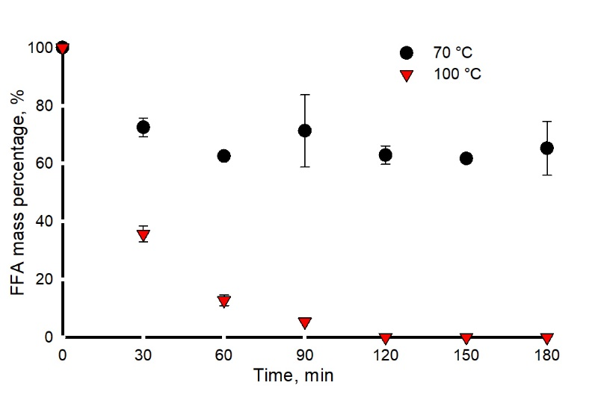
Figure 1. Reaction at 70 °C do not reach full conversion ( FFA final conversion = 44 %, molar ratio = 2, 500 W US nominal power).

GC-MS calculated 3-hydroxypropyloleate (monoester) selectivity and, from a mass balance, the diester selectivity. With an equinormal amount of 1,3-propanediol and FFA (alcohol/FFA molar ratio of 0.5), diester selectivity increases linearly with FFA conversion (Fig. 2) after 180 min of reaction. At 100 °C, the only reaction product is the diester (at high FFA conversion).
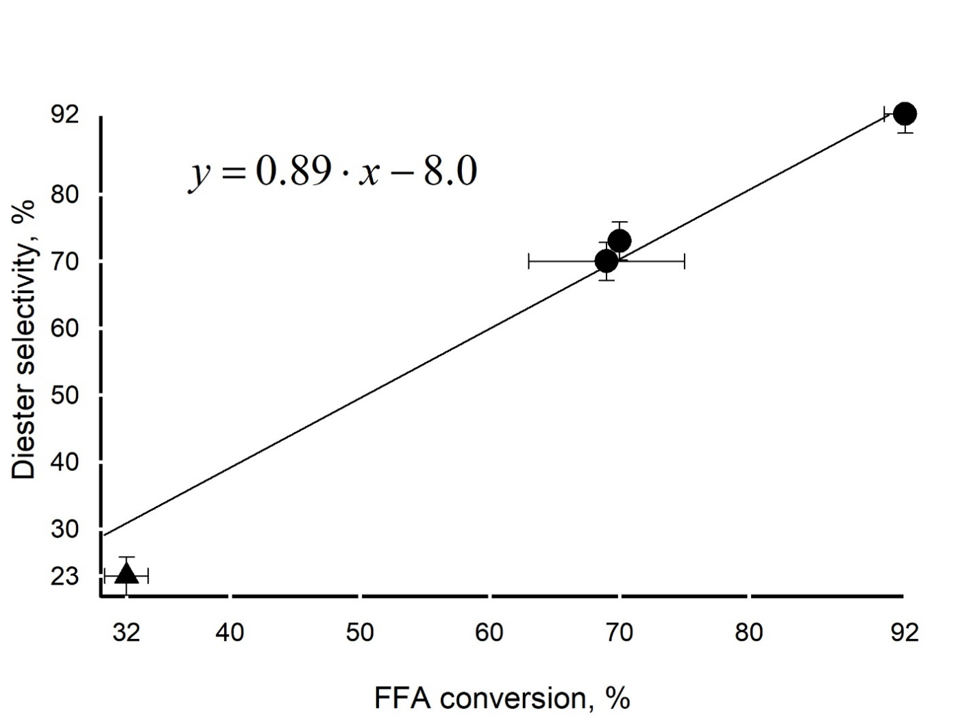
Figure 2. Oleic acid conversion vs diester (biolubricant) selectivity after 180 min of reaction. Alcohol:FFA molar ratio of 0.5. Triangle represents the reaction at 70 °C, circle at 100 ° C. We assumed a cautelative value for diester selectivity uncertainty of ± 10 %

Ultrasound power and reaction rate
Ultrasound increases the rate of reaction (Fig. 3). At a stoichiometric ratio of reactants, the 750 W and 500 W horn (nominal power) convert oleic acid 2 and 1.2-1.5 times faster, respectively, compared to no US. Ultrasonic cavitation may affect catalyst integrity but we observed no fine particles at the end of the reaction and our recovered catalyst, despite being a resin, seemed untouched; Boffito et al.’s³⁰ esterification reactions at ultrasound conditions of 20 kHz and 295 W did not result in any observed modification of their resin catalyst.
Cavitation improves mass transfer to the catalyst and therefore enhances the rate of reaction. Kumar et al.⁴² demonstrate this in the transesterification of Jatropha oil with a Na/SiO2 catalyst. Ramachandran et al.⁴³ reviewed many ultrasound-assisted transesterification using different catalysts and concluded that ultrasound reduces reaction temperature, time, and biodiesel production costs. Equilibrium conversion depends on temperature and initial concentrations. In the absence of ultrasound, even after 4 h no test reaches equilibrium (Table S1-15, supporting information).

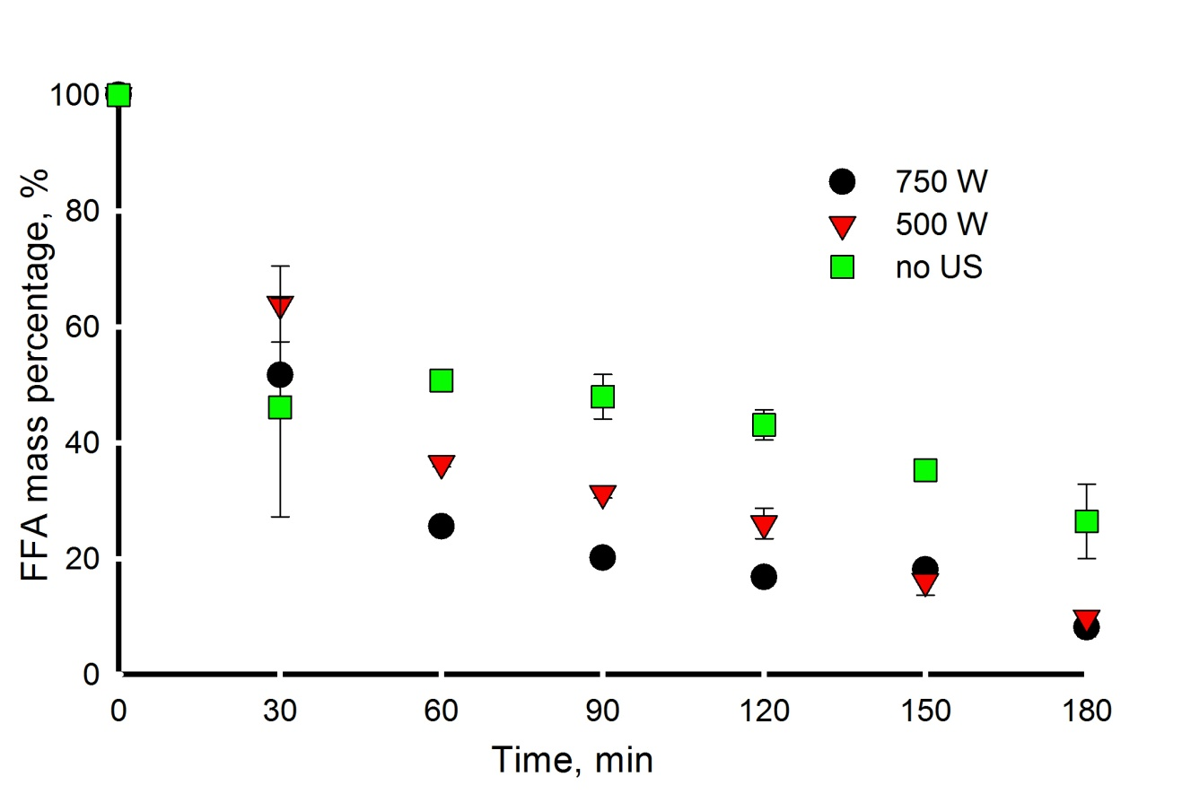
Figure 3. FFA mass percentage versus time at different ultrasound nominal powers, 1,3-propanediol/oleic acid molar ratio of 0.5 (stoichiometric), 100 °C. Final FFA conversion of 69 %, 90 % and 92 % for the reaction with no ultrasound, with 500 W and 750 W ultrasound, respectively.

The reaction order for both the FFA and the alcohol is 1, Pirola et al. and Tesser et al. made the same assumption for the esterification of oleic acid with sulphonic resins as the heterogeneous catalyst^{13,44}. Zou and Lei observed a linear relationship between ultrasound power density (from 0 to 600 W L⁻¹) and forward kinetic constant⁴⁵. They reacted FFA contained in Jatropa oil with methanol applying ultrasound power from 0 to 1200 W L⁻¹ at a 40 kHz of frequency. Here, the initial reaction rate, i.e. the derivative at time zero of the three curves represents the initial reaction rate for FFA and the alcohol, which depends on the forward kinetic constant, is proportional to the power delivered from the ultrasound horn. We calculated the kinetic constants by fitting a second order polynomial that fits the experimental data up to 90 min, and calculated the derivative at time 0. The relation is also valid at 20 kHz (Fig. 4) but the effect on the kinetic constant is one order of magnitude lower compared to 40 kHz⁴⁵. Chen and Kalback demonstrated the US increases the reaction rate of acetic acid hydrolysis because the cavitation delivers energy to the molecules increasing their vibrations⁴⁶. We speculate that the same happens in the esterification reaction.
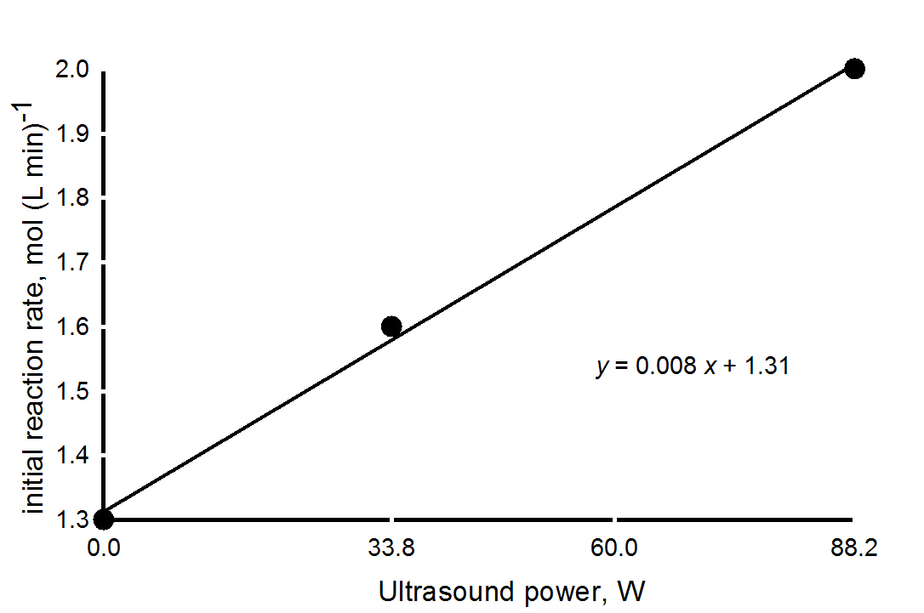
Figure 4. Linear relationship between ultrasound power and esterification rate at time zero, at 100°C.
However, US used more than twice as much energy (443 kJ vs. 975 kJ for 500 W and 750 W horn respectively). With the stoichiometric ratio of reactants and the 500 W horn, the reaction with a molar ratio of 0.5 did not reach full conversion after 3 hours but decreased steadily (Fig. 5).
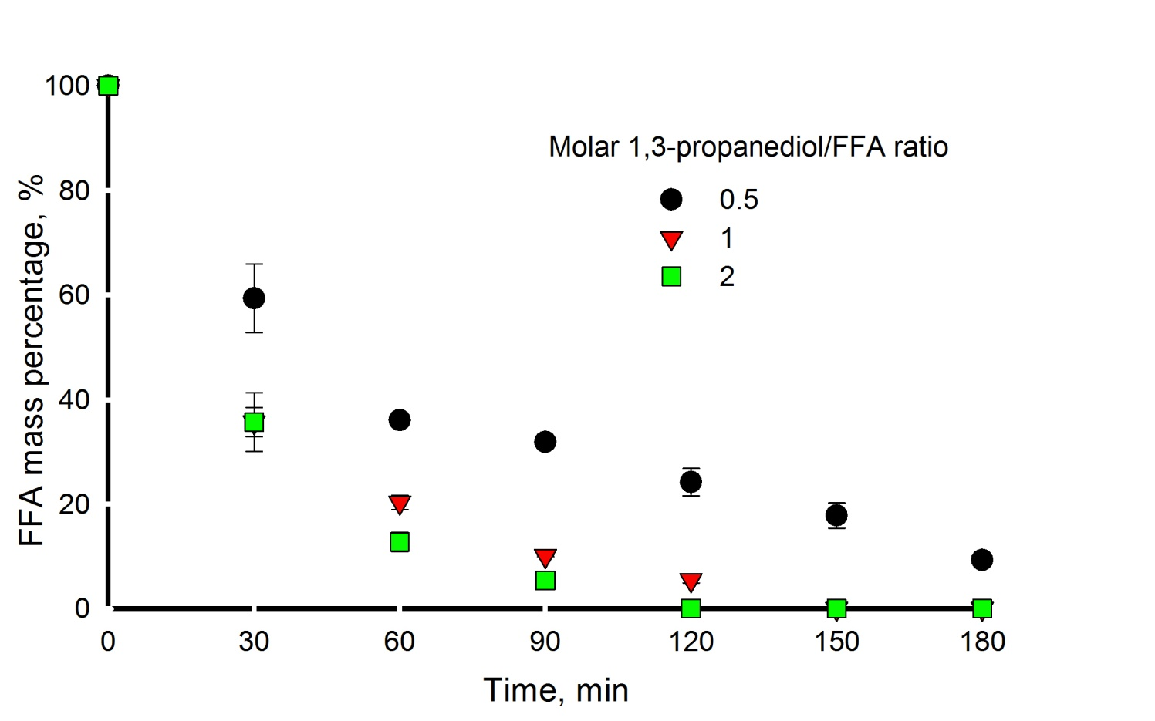
Figure 5: Comparison between different molar ratios of the 500 W ultrasound (nominal power) at a temperature of 100 ºC. Final FFA conversion of 90 %, 99+ %, and 99+ % for a molar 1,3-propanediol/FFA molar ratio of 0.5, 1 and 2, respectively.
We did not assess catalyst’s stability and reusability because it is out of the scope of the work. Nguyen et al. ⁴⁷ reported that Amberlyst 15 leaches sulphur proportionally to the water content in the reacting mixture. For example, they reported a sulphur leach of 1.88 % by weight at 80 °C in the presence of a solution whose content of water is 15 % by weight. Even though we tested Amberyst 15 at 100°C, such temperature removes almost all water from the mixture. However, ultrasound may promote sulfur leaching trough cavitation. Further tests will elucidate this phenomenon.
Pareto and regression analysis
Steinigeweg and Gmehling showed that the molar feed ratio influences acid conversion during esterification of decanoic acid, as a model compound for biodiesel, with methanol. An excess of reactant will yield higher conversions⁴⁸. With our ratio of 0.5 (stoichiometric), the reaction needs more than three hours to complete (χ = 69 %), while with a ratio of 1 conversion reaches 96 % in 3 h at 100 °C. The three factors (temperature, molar ratio and US power) do not have any interactive contribution on the FFA content after 1 h and 3 h (Fig. 6).
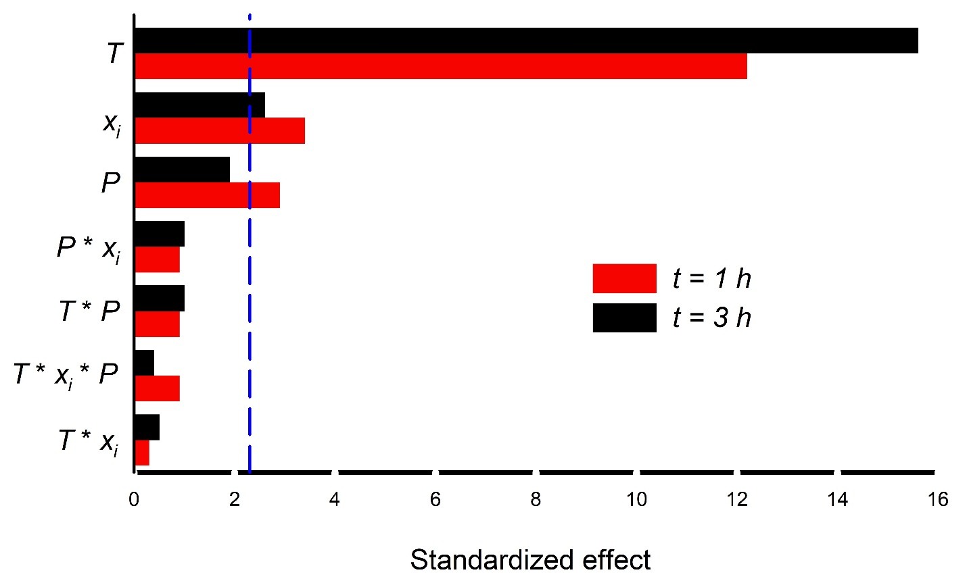
Figure 6. Pareto chart of standardized effect (t-statistics that test the null hypothesis that the effect is 0). Response variable: FFA concentration at 1 h (red) and 3 h (black). The reference line at 2.3 indicates which variable (T = temperature, χ_{j} = alcohol/FFA molar ratio, P = ultrasound power) has a significative effect (α = 0.1).
After 1 h, all individual factors affect conversion (p < 0.05), while at 3 h, US power becomes statistically insignificant. The US power influences the reaction rate (Fig. 4). But after 3 h, the reaction approaches equilibrium, which is thermodynamically fixed at a certain temperature, and the FFA concentration remains invariant with respect to the US power applied (Fig. 3). Temperature is always significant, and become even more important at 3 h as the reaction equilibrium is pushed towards the formation of the diester by evaporating water. The Pareto chart identified these three significant factors and we regressed the coefficients assuming a linear model for FFA conversion at 1h and 3 h (eq. 3 and 4), considering: US power (P, W), molar ratio (R), and temperature (T, °C)):
$X_{FFA, model, t = 1 h}=-100+ 1.6 T+9.7 R+ 0.15 P$ (3)
$X_{FFA, model, t = 3 h}=-110+ 1.9 T+9.2 R+ 0.12 P$ (4)
Both R² are higher than 90 % and coefficients p values were lower than 0.05, except for US power at 3 h, that increased to p = 0.09 for the aforementioned situation. The standard of error of the estimate was 9 %, which is on the same order of magnitude as the uncertainty on the experimental results. If we consider the reaction with an oleic acid to alcohol molar ratio of 1 at 100 °C, the reactions take 150 and 120 min using the 500 and 750 W horn, respectively. Thus, the electric power consumed is 0.5 kW and 0.75 kW. The actual (2017) cost of industrial-use electricity is 0.09 CAD $ kWh⁻¹ in Canada.⁴⁹ Although the reaction takes 30 min longer to complete with the 500 W horn, the total sonication cost is 2 cent CAD $ less. The 500 W horn is 17 % less expensive – excluding all other operative costs (batch time, utilities, and operators’ salaries). One needs to consider, for scale-up, flow behaviour, power dissipated, frequency of irradiation, as well as reactor design to optimize power consumption and reaction productivity⁵⁰ . Further work is required to transfer this process from a laboratory to an industrial environment.
Biolubricant rheometry
Samples are sensitive to temperature variation. An increase of 0.1 °C reduces the apparent viscosity by 0.1 mPas. This leads to apparent non-Newtonian trends when increasing the shear rate as the higher spinning rate generates more heat by friction. Despite the external liquid temperature controller and because of the thermal inertia of the biolubricant, temperature increases locally, and therefore viscosity decreases when increasing the shear rate (by 0.1-0.3 mPas over the entire range). For this reason and given the fact that the viscosity variation (between 2-4 %) is negligible compared to the average value, we decided to assume a Newtonian behaviour for our biolubricant. Similarly, when we investigated a possible time-dependency rheology at 20.0 °C and at a constant shear rate of 1000 s⁻¹, the sample took 200 s to reach steady state, starting from 54.60 ± 0.05 mPa s and reaching 54.75 ± 0.05 mPa s (0.3 % variation). We attributed this negligible variation to thermal inertia and assumed that our biolubricant’s rheology is not time dependent.
We chose three random samples and recorded a temperature ramp analysis (20 to 79 °C at constant shear 1000 Hz), the HAAKE rehowin data manager software regressed the data, in all cases, and the best fit was obtained with a logarithmic equation, log μ = a + b*T (μ in mPas,T in °C, χ² < 0.01 and R² > 0.99). This function then fitted the a and b parameters from the viscosity data for each sample, recorded at 1000 s⁻¹ at a constant temperature of 40.0 °C and 79.0 °C, after sample temperature equilibration (Figure 7).
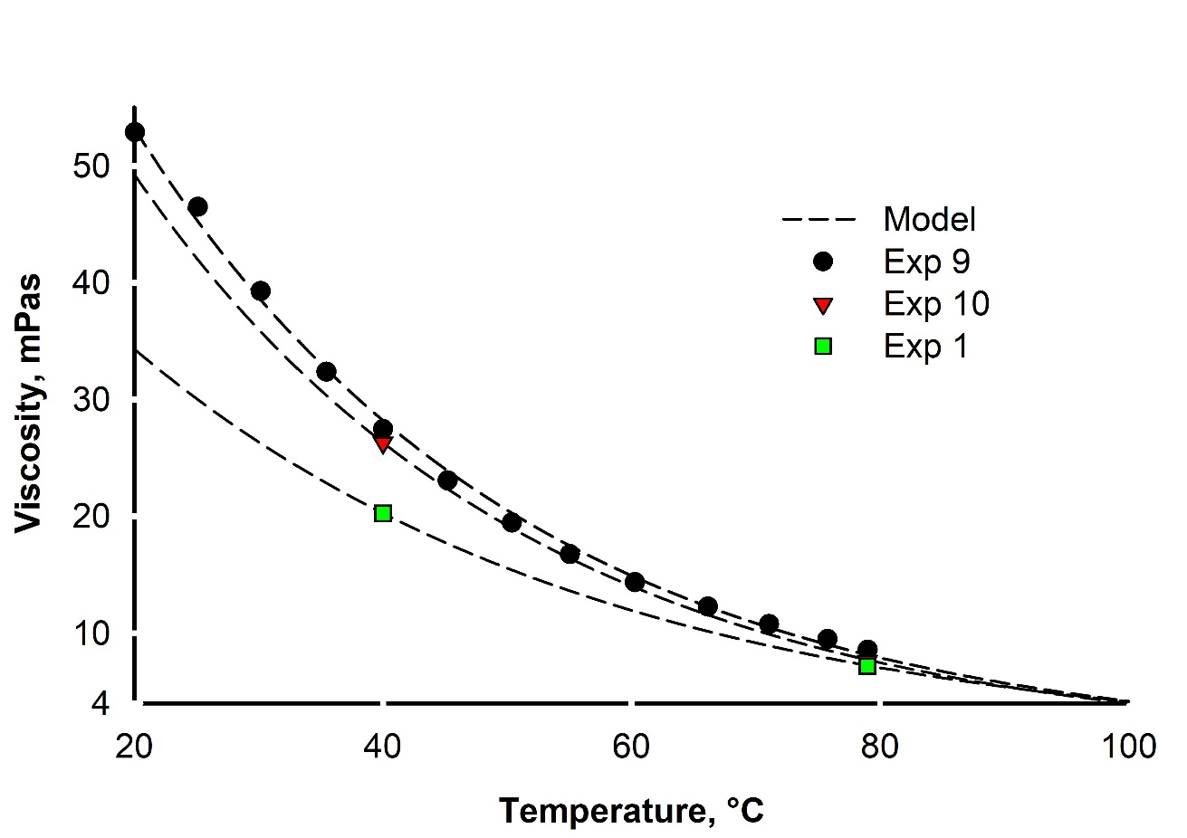
Figure 7: Viscosity of biolubricants vs T and logarithmic regression and extrapolation up to 100 °C
Eventually we calculated the viscosity index according to the ASTM D2270⁵¹, extrapolating the viscosity at 100 °C with the logarithmic equation obtained from experimental data (Table 2).
Samples’ average density varied between 0.879 g ml⁻¹ at 40 °C to 0.887 g ml⁻¹ at 80 °C (standard deviation 0.01, Supporting Information Table S16).
ASTM D2270 describes this calculation at section X1.1. Viscosity at 100 °C was not measured due to instrument limitation.
Table 2: Viscosity index the samples in Table 1
Sample | Viscosity Index
1 | 124
2 | 87
3 | 23
4 | 137
5 | 132
6 | 58
7 | 34
8 | 147
9 | 114
10 | 25
11 | 139

According to the API classification, our samples belong to Group II and III lubricants⁵¹ which accounts for over 90 % of the lubricant market⁵².
Conclusions
Ultrasound intensifies the esterification of 1,3-propanediol with oleic acid. The reaction is 2 h faster with the 500 W and 750 W ultrasound horns compared to the traditional stirring method when the reagents are fed at the stoichiometric ratio. When this ratio increases to 4 times the stoichiometric one, equilibrium is achieved in 2 h (vs. 6 h reported in the literature). Additionally, the diester biolubricant produced meets the API standard. From an economical and energy standpoint, the 500 W horn is better than the 750 W. Ultrasound and high temperature may reduce catalyst life through the sulphur leaching mechanism. New tests may confirm this hypothesis. These results offer a starting point for the esterification of trimetilol propane (a trifunctional alcohol with two primary OH groups and one secondary), which is the typical substrate used to produce biolubricants. The high energy density delivered per unit of volume of reactor opens up the possibility of scaling up this intensified process.
Acknowledgments
The authors would like to thank Prof. Gregory Patience and Dr. Davide Carnevali for the helpful scientific discussion and the proof reading. The authors gratefully acknowledge the support of The Natural Sciences and Engineering Research Council of Canada (NSERC). This research was undertaken, in part, thanks to funding from the Canada Research Chairs program.
Supporting Information. The file contains the raw experimental data for all tests.

References
(1) Mortier, R. M.; Fox, M. F.; Orszulik, S. T. Chemistry and Technology of Lubricants; Springer Netherlands: Dordrecht, 2010.
(2) Mang, T.; Noll, S.; Bartels, T. Lubricants, 1. Fundamentals of Lubricants and Lubrication in Ullmann’s Encyclopedia of Industrial Chemistry; Wiley-VCH Verlag GmbH & Co. KGaA: Weinheim, 2011.
(3) Grand View Research. Lubricants Market Size & Share.
(4) Siouris, S.; Wilson, C. W. Thermodynamic Properties of Pentaerythritol-Based Species Involved in Degradation of Aviation Gas Turbine Lubricants. Ind. Eng. Chem. Res. 2010, 49, 12294.
(5) Mobarak, H. M.; Niza Mohamad, E.; Masjuki, H. H.; Kalam, M. A.; Al Mahmud, K. A. H.; Habibullah, M.; Ashraful, A. M. The Prospects of Biolubricants as Alternatives in Automotive Applications. Renew. Sustain. Energy Rev. 2014, 33, 34.
(6) Karmakar, G.; Ghosh, P. Soybean Oil as a Biocompatible Multifunctional Additive for Lubricating Oil. ACS Sustainable Chem. Eng. 2015, 3, 19.
(7) Singh, Y.; Farooq, A.; Raza, A.; Mahmood, M. A.; Jain, S. Sustainability of a Non-Edible Vegetable Oil Based Bio-Lubricant for Automotive Applications: A Review. Process Saf. Environ. Prot. 2017, 111, 701.
(8) Gryglewicz, S.; Piechocki, W.; Gryglewicz, G. Preparation of Polyol Esters Based on Vegetable and Animal Fats. Bioresour. Technol. 2003, 87, 35.
(9) McNutt, J.; He, Q. Development of Biolubricants from Vegetable Oils via Chemical Modification. Ind. Eng. Chem. Res. 2016, 36, 1.
(10) García-Zapateiro, L. A.; Franco, J. M.; Valencia, C.; Delgado, M. A.; Gallegos, C.; Ruiz-Méndez, M. V. Viscosity Modification of High-Oleic Sunflower and Castor Oils with Acid Oils-Derived Estolides for Lubricant Applications. Eur. J. Lipid Sci. Technol. 2013, 115, 1173.
(11) Castro, W.; Perez, J. M.; Erhan, S. Z.; Caputo, F. A Study of the Oxidation and Wear Properties of Vegetable Oils: Soybean Oil without Additives. J. Am. Oil Chem. Soc. 2006, 83, 47.
(12) Galli, F.; Nucci, S.; Pirola, C.; Bianchi, C. L. Epoxy Methyl Soyate as Bio-Plasticizer: Two Different Preparation Strategies. Chem. Eng. Trans. 2014, 37, 601.
(13) Pirola, C.; Galli, F.; Bianchi, C. L.; Boffito, D. C.; Comazzi, A.; Manenti, F. Vegetable Oil Deacidification by Methanol Heterogeneously Catalyzed Esterification in (Monophasic Liquid)/Solid Batch and Continuous Reactors. Energy Fuels. 2014, 28, 5236.
(14) Venu Babu Borugadda, A. K. R. S. and A. K. D. Chemical/Structural Modification of Canola Oil and Canola Biodiesel: Kinetic Studies and Biodegradability of the Alkoxides. Lubricants. 2017, 5, 11.
(15) Park, J. Y.; Kim, D. K.; Lee, J. S. Esterification of Free Fatty Acids Using Water-Tolerable Amberlyst as a Heterogeneous Catalyst. Bioresour. Technol. 2010, 101, S62.
(16) Boffito, D. C.; Galli, F.; Pirola, C.; Patience, G. S. CaO and Isopropanol Transesterify and Crack Triglycerides to Isopropyl Esters and Green Diesel. Energy Convers. Manag. 2017, 139, 71.
(17) Knothe, G. “Designer” Biodiesel: Optimizing Fatty Ester Composition to Improve Fuel Properties †. Energy Fuels. 2008, 22, 1358.
(18) Bondioli, P. The Preparation of Fatty Acid Esters by Means of Catalytic Reactions. Top. Catal. 2004, 27, 77.
(19) Zaccheria, F.; Mariani, M.; Psaro, R.; Bondioli, P.; Ravasio, N. Environmentally Friendly Lubricants through a Zero Waste Process. Appl. Catal. B Environ. 2016, 181, 581.
(20) Oh, J.; Yang, S.; Kim, C.; Choi, I.; Kim, J. H.; Lee, H. Synthesis of Biolubricants Using Sulfated Zirconia Catalysts. Appl. Catal. A Gen. 2013, 455, 164.
(21) Raghunanan, L.; Narine, S. S. Influence of Structure on Chemical and Thermal Stability of Aliphatic Diesters. J. Phys. Chem. B 2013, 117, 14754.
(22) Suslick, K. S. The Chemical Effects of Ultrasound. Sci. Am. 1989, 260, 80.
(23) Sancheti, S. V.; Gogate, P. R. A Review of Engineering Aspects of Intensification of Chemical Synthesis Using Ultrasound. Ultrason. Sonochem. 2017, 36, 527.
(24) Fang, Z.; Smith, R. L.; Qi, X. Production of Biofuels and Chemicals with Ultrasound; Springer Netherlands: Dordrecht, 2015.
(25) Boffito, D. C.; Van Gerven, T. Process Intensification and Catalysis. Ref. Modul. Chem. Mol. Sci. Chem. Eng. 2019.
(26) Boffito, D. C.; Mansi, S.; Leveque, J.-M.; Pirola, C.; Bianchi, C. L.; Patience, G. S. Ultrafast Biodiesel Production Using Ultrasound in Batch and Continuous Reactors. ACS Sustainable Chem. Eng. 2013, 1, 1432.
(27) Boffito, D. C.; Galli, F.; Martinez, P. R.; Pirola, C.; Bianchi, C. L.; Patience, G. S. Transesterification of Triglycerides in a New Ultrasonic-Assisted Mixing Device. In ICHEAP12: 12TH INTERNATIONAL CONFERENCE ON CHEMICAL & PROCESS ENGINEERING; 2015, 43, 427.
(28) Shinde, K.; Kaliaguine, S. Triglycerides Transesterification Reactions under Ultrasounds. ChemistrySelect 2016, 1, 6008.
(29) Shinde, K.; Nohair, B.; Kaliaguine, S. A Parametric Study of Biodiesel Production Under Ultrasounds. Int. J. Chem. React. Eng. 2017, 15.
(30) Boffito, D. C.; Galli, F.; Pirola, C.; Bianchi, C. L.; Patience, G. S. Ultrasonic Free Fatty Acids Esterification in Tobacco and Canola Oil. Ultrason. Sonochem. 2014, 21, 1969.
(31) Maddikeri, G. L.; Pandit, A. B.; Gogate, P. R. Ultrasound Assisted Interesterification of Waste Cooking Oil and Methyl Acetate for Biodiesel and Triacetin Production. Fuel Process. Technol. 2013, 116, 241.
(32) Pukale, D. D.; Maddikeri, G. L.; Gogate, P. R.; Pandit, A. B.; Pratap, A. P. Ultrasound Assisted Transesterification of Waste Cooking Oil Using Heterogeneous Solid Catalyst. Ultrason. Sonochem. 2015, 22, 278.
(33) Gole, V. L.; Gogate, P. R. Intensification of Synthesis of Biodiesel from Nonedible Oils Using Sonochemical Reactors. Ind. Eng. Chem. Res. 2012, 51, 11866.
(34) Pacheco, B. S.; Nunes, C. F. P.; Rockembach, C. T.; Bertelli, P.; Mesko, M. F.; Roesch-Ely, M.; Moura, S.; Pereira, C. M. P. Eco-Friendly Synthesis of Esters under Ultrasound with p-Toluenesulfonic Acid as Catalyst. Green Chem. Lett. Rev. 2014, 7, 265.
(35) Stankiewicz, A.; Moulijn, J. A. Process Intensification. Ind. Eng. Chem. Res. 2002, 41, 1920.
(36) Pirola, C.; Manenti, F.; Galli, F.; Bianchi, C. L.; Boffito, D. C.; Corbetta, M. Heterogeneously Catalyzed Free Fatty Acids Esterification in (Monophasic Liquid)/Solid Packed Bed Reactors (PBR). Chem. Eng. Trans. 2014, 37, 553.
(37) Saboya, R. M. A.; Cecilia, J. A.; García-Sancho, C.; Sales, A. V.; de Luna, F. M. T.; Rodríguez-Castellón, E.; Cavalcante, C. L. Synthesis of Biolubricants by the Esterification of Free Fatty Acids from Castor Oil with Branched Alcohols Using Cationic Exchange Resins as Catalysts. Ind. Crops Prod. 2017, 104, 52.
(38) Stucchi, M.; Elfiad, A.; Rigamonti, M.; Khan, H.; Boffito, D. C. Water Treatment: Mn-TiO2 Synthesized by Ultrasound with Increased Aromatics Adsorption. Ultrason. Sonochem. 2018, 44, 272.
(39) Uchida, T.; Kikuchi, T. Calorimetric method for measuring high ultrasonic power using water as a heating material. J. Phys.: Conf. Ser. 2011, 279, 1.
(40) Nagendramma, P. Study of Pentaerythritol Tetraoleate Ester as Industrial Gear Oil. Lubr. Sci. 2011, 23, 355.
(41) Kuzminska, M.; Backov, R.; Gaigneaux, E. M. Behavior of Cation-Exchange Resins Employed as Heterogeneous Catalysts for Esterification of Oleic Acid with Trimethylolpropane. Appl. Catal., A 2015, 504, 11.
(42) Kumar, D.; Kumar, G.; Poonam; Singh, C. P. Ultrasonic-Assisted Transesterification of Jatropha Curcus Oil Using Solid Catalyst, Na/SiO2. Ultrason. Sonochem. 2010, 17, 839.
(43) Ramachandran, K.; Suganya, T.; Nagendra Gandhi, N.; Renganathan, S. Recent Developments for Biodiesel Production by Ultrasonic Assist Transesterification Using Different Heterogeneous Catalyst: A Review. Renewable Sustainable Energy Rev. 2013, 22, 410.
(44) Tesser, R.; Di Serio, M.; Guida, M.; Nastasi, M.; Santacesaria, E. Kinetics of Oleic Acid Esterification with Methanol in the Presence of Triglycerides. Ind. Eng. Chem. Res. 2005, 44, 7978.
(45) Zou, H.; Lei, M. Optimum Process and Kinetic Study of Jatropha Curcas Oil Pre-Esterification in Ultrasonical Field. J. Taiwan Inst. Chem. Eng. 2012, 43, 730.
(46) Chen, J. W.; Kalback, W. M. Effect of Ultrasound on Chemical Reaction Rate. Ind. Eng. Chem. Fundam. 1967, 6, 175.
(47) Steinigeweg, S.; Gmehling, J. Esterification of a Fatty Acid by Reactive Distillation. Ind. Eng. Chem. Res. 2003, 42, 3612.
(48) UK Department for Business Energy & Industrial Strategy. International industrial energy prices.
(49) Gogate, P. R.; Sutkar, V. S.; Pandit, A. B. Sonochemical Reactors: Important Design and Scale up Considerations with a Special Emphasis on Heterogeneous Systems. Chem. Eng. J. 2011, 166, 1066.
(50) ASTM Standards. Standard Practice for Calculating Viscosity Index from Kinematic Viscosity at 40. Br. Stand. 4459 1991, 93 (Reapproved), 1–6.
(51) Mang, T.; Dresel, W. Lubricants and Lubrication ; Wiley-VCH Verlag GmbH & Co. KGaA: Weinheim, 2007.
(52) Brown, S. F. Base Oil Groups: Manufacture, Properties and Performance https://www.stle.org/images/pdf/STLE_ORG/BOK/OM_OA/Base Oils/Base Oil Groups_Manufacture_Prop_Perform_April15 TLT.pdf.

