Partial in situ reduction of copper(II) resulting in one-pot formation of 2D neutral and 3D cationic copper(I) iodide –pyrazine coordination polymers: structure and emissive properties

Iurie L. Malaestean, Victor Ch. Kravtsov, Janusz Lipkowski,¹Elena Cariati,^{2,3} Stefania Righetto,³ Daniele Marinotto,³ Alessandra Forni,² Marina S. Fonari

Institute of Applied Physics, Academy of Sciences of Moldova, Chisinau, Moldova
¹Cardinal Stafan Wyszynski University in Warsaw, Faculty of Mathematical and Natural Sciences, 01-938, Warszawa, Poland
²ISTM-CNR, Institute of Molecular Sciences and Technologies of CNR and INSTM UdR, Milano, Italy
³Department of Chemistry, Università degli Studi di Milano, Milano, Italy

ABSTRACT: On the way to copper(I) iodide coordination polymers with specific luminescent properties, the in situ reduction of Cu(II) in the presence of KI and bidentate N-heteroatomic ligand, either pyrazine (pyz) or 4,4’-bipyridine (bpy), resulted in one two-dimensional and two three-dimensional new coordination networks. Starting from Cu(NO₃)₂.3H₂O in the presence of pyz, successive precipitation of known yellow [(Cu^{I}I)₂(pyz)]_{n}, new orange [Cu^{I}I(pyz)]_{n}, and new dark blue [Cu^{I}(pyz)₂I₅]_{n} polymeric solids was observed. The same procedure in the presence of bpy resulted in the successive precipitation of known yellow [(Cu^{I}I)₂(bpy)]_{n} and new brown [Cu^{II}(NO₃)(bpy)₂(I₃)]_{n}.(dmf.H₂O)_{n} coordination polymers. By using either Cu(CH₃COO)₂.H₂O or Cu(BF₄)₂ as starting materials both known forms, yellow [(Cu^{I}I)₂(bpy)]_{n} and orange [Cu^{I}I(bpy)]_{n} precipitated successively. The new solids were characterized by IR spectroscopy and X-ray analysis. [Cu^{I}I(pyz)]_{n} represents the missing member in the row of two-dimensional coordination networks with general formula [Cu^{I}X(pyz)]_{n} (X=Cl, Br, I). Its steady state and time resolved characterization together with DFT and TDDFT calculations revealed that the emission at room temperature is mainly delayed fluorescence originating from mixed singlet metal-to-ligand charge transfer (MLCT) and halide-to-ligand charge transfer (XLCT) states, while that at 77 K is phosphorescence, associated with the small singlet–triplet energy differences (ΔE = 70 meV).

Introduction

The continuous interest towards Cu(I) coordination compounds stems from their fascinating physico-chemical properties that include but are not restricted to synthetic and enzymatic copper-mediated catalysis,¹ luminescence and non-linear optical phenomena.²⁻⁴ The Cu(I) d¹⁰ electronic configuration plays a prominent role in the photophysical behavior of its derivatives whose luminescence can be originated from ligand centered, charge transfer or, in the case of polynuclear compounds, even metal-centered excited states.⁵ While interest was previously focused on the photophysical properties of discrete Cu(I) complexes, recently research has been extended to include the emissive behavior of polymeric compounds.^{2-4, 6-15}
Cu(I)-halide complexes are particularly attractive because of their promising optical properties and the ready obtainability of various building blocks. Cu(I)-halides react eagerly with nitrogen-donor ligands as a result of the soft−soft bonding preference, generating diverse geometries with various [CuX]_{n} structural motifs.³⁻¹⁵ Since seminal work by Blake et al ¹⁶ who reported a family of Cu(I) iodide coordination networks with different bidentate ligands including 1,10-phenanthroline, pyrazine, 4,4’-bipyride, this topic has attracted much interest from the crystal engineering perspective due to the variety of structural formats obtainable by using different halides and N-bases. Cu(I)-halide coordination polymers have been prepared both by hydrothermal procedure and by using ambient conditions. Very often the synthetic procedure influences the nature of the obtained compounds in both structure and composition.¹⁶⁻²⁷ From the crystal engineering perspective, along with the Cu(I) coordination grids the mixed-valence Cu(II)-Cu(I) coordination networks are widely studied due to the different Cu(I) and Cu(II) (d¹⁰and d⁹) coordination preferences that allow to manipulate the coordination architecture and dimensionalities of the final solids in view of the application requirements.²⁸ The mixed-valence Cu(II)-Cu(I) compounds are obtained either starting from the mixture of Cu(II)/Cu(I) salts or by partial in situ reduction of Cu(II).²⁸⁻³⁷
Recently, research in the field of luminescent copper(I) complexes has gained additional interest owing to their possible application in organic-light emitting diodes (OLEDs) or light-emitting electrochemical cells (LEECs).³⁸⁻⁵² Cu(I) complexes, in fact, often exhibit thermally activated delayed fluorescence (TADF),⁵³⁻⁶² which allows utilizing all injected excitons for the generation of light by making use of the singlet harvesting effect.^{53-57, 59-62} In this regard, Cu(I) complexes can provide a low-cost alternative to expensive emitters based on 3rd row transition metals, such as platinum or iridium.
This work was aimed at preparing and characterizing the missing member in the row of [CuX(pyz)]_{n} complexes (X=Cl, Br, I), and to compare its photoluminescence behavior with that of the already known 4,4’-bipyridine analogue.^{25, 27} We started from the in situ reduction of Cu(II) salts in the presence of KI as a long-term recognized reducing agent.⁶³ This approach resulted in the successive isolation of three new coordination compounds, [Cu^{I}I(pyz)]_{n}, [Cu^{I}(pyz)₂I₅]_{n}, and [Cu^{II}(NO₃).(bpy)₂(I₃)]_{n}.(dmf.H₂O)_{n} which were characterized by IR spectroscopy and X-ray analysis. Photoluminescence spectroscopy was performed both at room and low temperature for [Cu^{I}X(pyz)]_{n}, the only emissive of the three.

Results and discussion

Compounds prepared from Cu(NO₃)₂.3H₂O/KI/pyrazine. An acetonitrile solution of Cu(NO₃)₂⋅3H₂O, KI and pyrazine (pyz) (1:1:4 molar ratio) was refluxed for 30 min. The yellow precipitate formed during the reaction was filtered off and washed with MeCN. The orange filtrate of the original solution was left in a covered vial for about one month giving two types of crystals, orange plates and dark blue blocks (Figure 1).

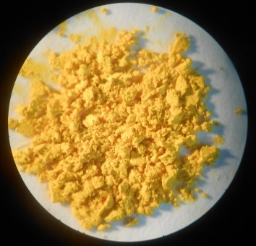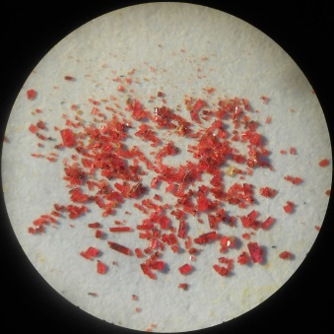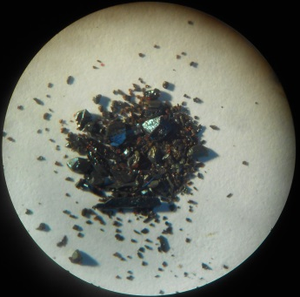
( a) ( b) ( c)

Figure 1. Solid CuI–pyrazine derivatives: (a) powder of yellow [(CuI)₂(pyz)]_{n}; (b) Orange crystals of [(CuI)(pyz)]_{n}; (c) Dark-blue crystals of [Cu(pyz)₂I₅]_{n}.

The fine-crystalline yellow solid (Figure 1a) was identified as the known [(Cu^{I}I)₂(pyz)]_{n} having IR spectrum (Figure S1 in Supporting Information) and XRPD pattern identical to that published for this compound.¹⁶ Single crystal X-ray investigation undertaken for the orange (Figure 1b) and dark (Figure 1c) forms identify these solids as the new 2D neutral polymeric coordination network [CuI(pyz)]_{n} and the 3D cationic coordination network [Cu(pyz)₂I₅]_{n}.
Compound [CuI(pyz)]_{n} crystallizes in the monoclinic P2/c space group (Table 1), and the asymmetric unit comprises halves of Cu(I) cation, iodide anion, which resides on a two-fold axis, and a half of a centrosymmetric pyz molecule. The Cu(I) atom adjusts the N₂I₂ distorted tetrahedral coordination core being linked with two iodide anions and two pyz molecules (Figure 2a). The Cu–I and Cu–N distances are 2.6115(10), 2.6091(8) Å and 2.059(7), 2.057(2) Å, at room and low temperatures, respectively. The variation of bond angles at Cu atom in the range 105.66(19)–113.83(18)° (105.12(7)–115.31(6)° for LT data) indicates the distortion of tetrahedron, mostly due to difference in two N–Cu–I angles (Table 2). The neutral 2D coordination network is built of the alternating Cu–I corrugated chains linked by pyz ligands. The Cu…Cu separations within the layer are 4.267 and 6.918 Å through iodide and pyz bridges, respectively, and the shortest one between the layers is 6.881 Å. The corrugated layers are parallel to the ac crystallographic plane and stack along the crystallographic b direction. The comparison of the RT and LT data for [CuI(pyz)]_{n} (Tables 1, 2) shows the shortening of the unit cell parameters a and c along the layer, decreasing of the I–Cu–I, N–Cu–N and Cu–I–Cu valence angles and increasing the parameter b in perpendicular to layers direction upon cooling (Figure 2b). The compound is isostructural to the closest analogues, [CuCl(pyz)]_{n}^{19, 22} and [CuBr(pyz)]_{n}.¹⁷ The related compound [(CuI)₂(pyz)]_{n}¹⁶ reveals the ladder-like (Cu₂I₂)_{n} tape within the 2D network (Figure 2c) instead of the chain.

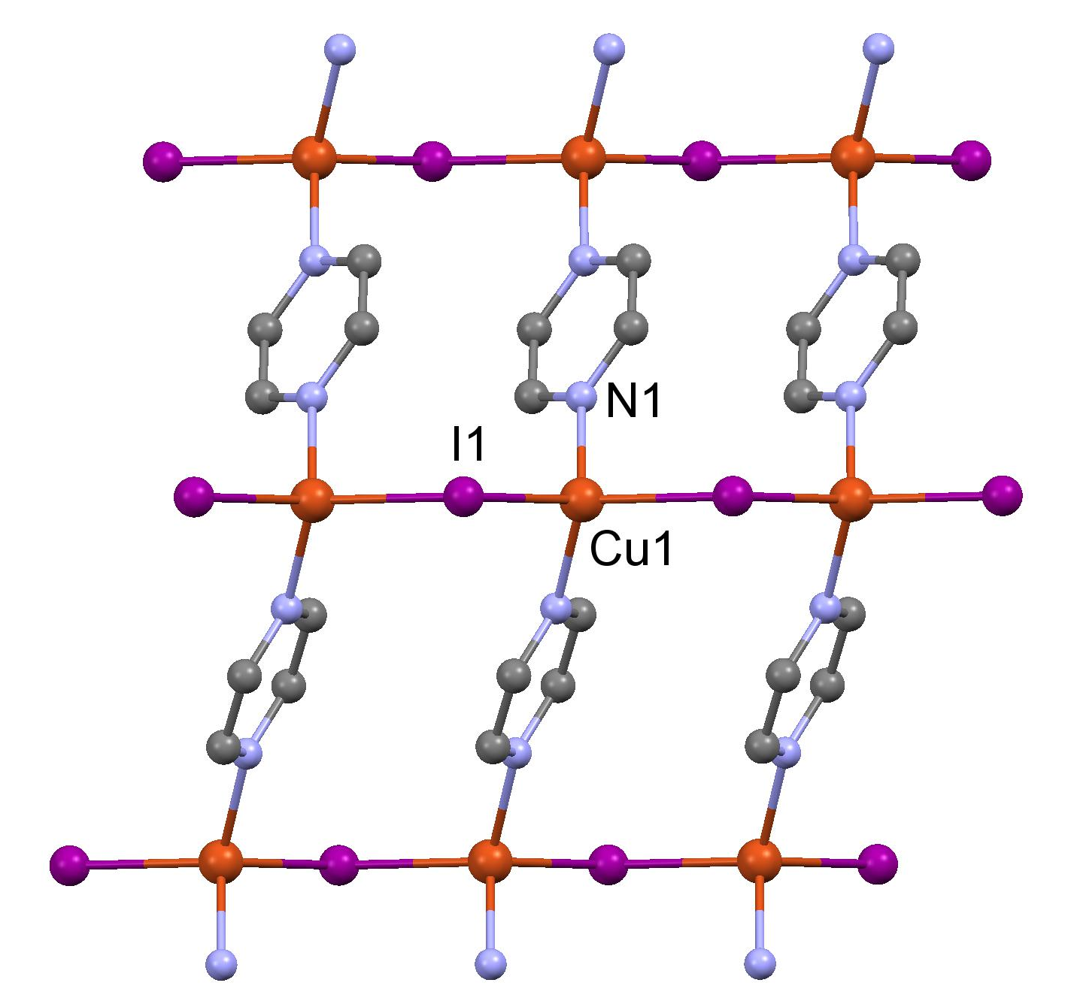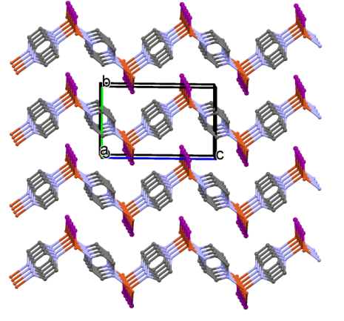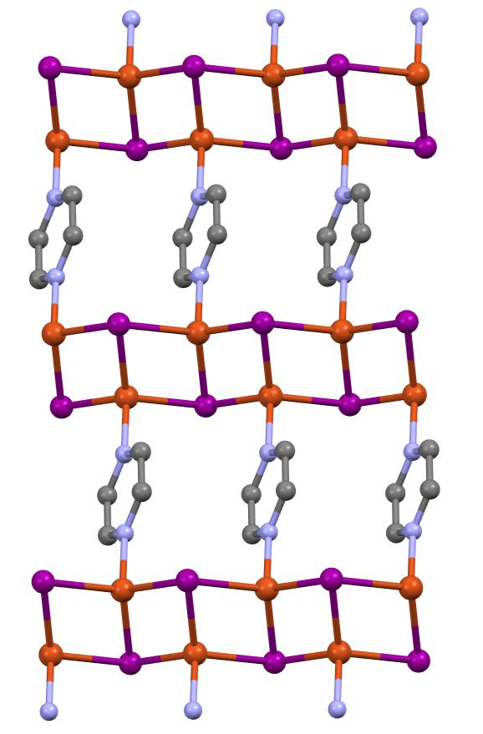
- (b) ( c)

Figure 2. Fragments of crystal packing in[Cu^{I}I(pyz)]_{n} and [Cu^{I}₂I₂(pyz)]_{n.} (a) Layer in [Cu^{I}I(pyz)]_{n}; (b) stacking of the layers in [Cu^{I}I(pyz)]_{n}; (c) Layer in [Cu^{I}₂I₂(pyz)]_{n}, reproduced using AGIYEU01 entry¹⁶ from CSD

The third compound which co-precipitated almost simultaneously with [CuI(pyz)]_{n}, crystallizes as big dark blue blocks with the metallic luster (Figure 1c) belonging to the orthorhombic Fdd2 space group. It has been proven to be the 3D coordination polymer with {[Cu(pyz)₂]I₅}_{n} composition (Figure 3). The asymmetric portion of the unit cell contains halves of the Cu(I) atom and pentaiodide anion, which reside on the two fold axis, and one pyz ligand in general position. In the 4-connected 3D diamondoid⁶⁴ network Cu(I) cation coordinates four bridging pyz ligands and adjusts the N₄-distorted tetrahedral geometry, with Cu–N_{av}= 2.025(10) Å, and N–Cu–N angles in the wide range of 98.2(4)–120.2(6)°.
There are only three examples of pyz-bridged 4-connected 3D networks: one with similar diamondoid like sqc6 topology⁶⁵ and two with different sqc182 and qtz network topologies.⁶⁶
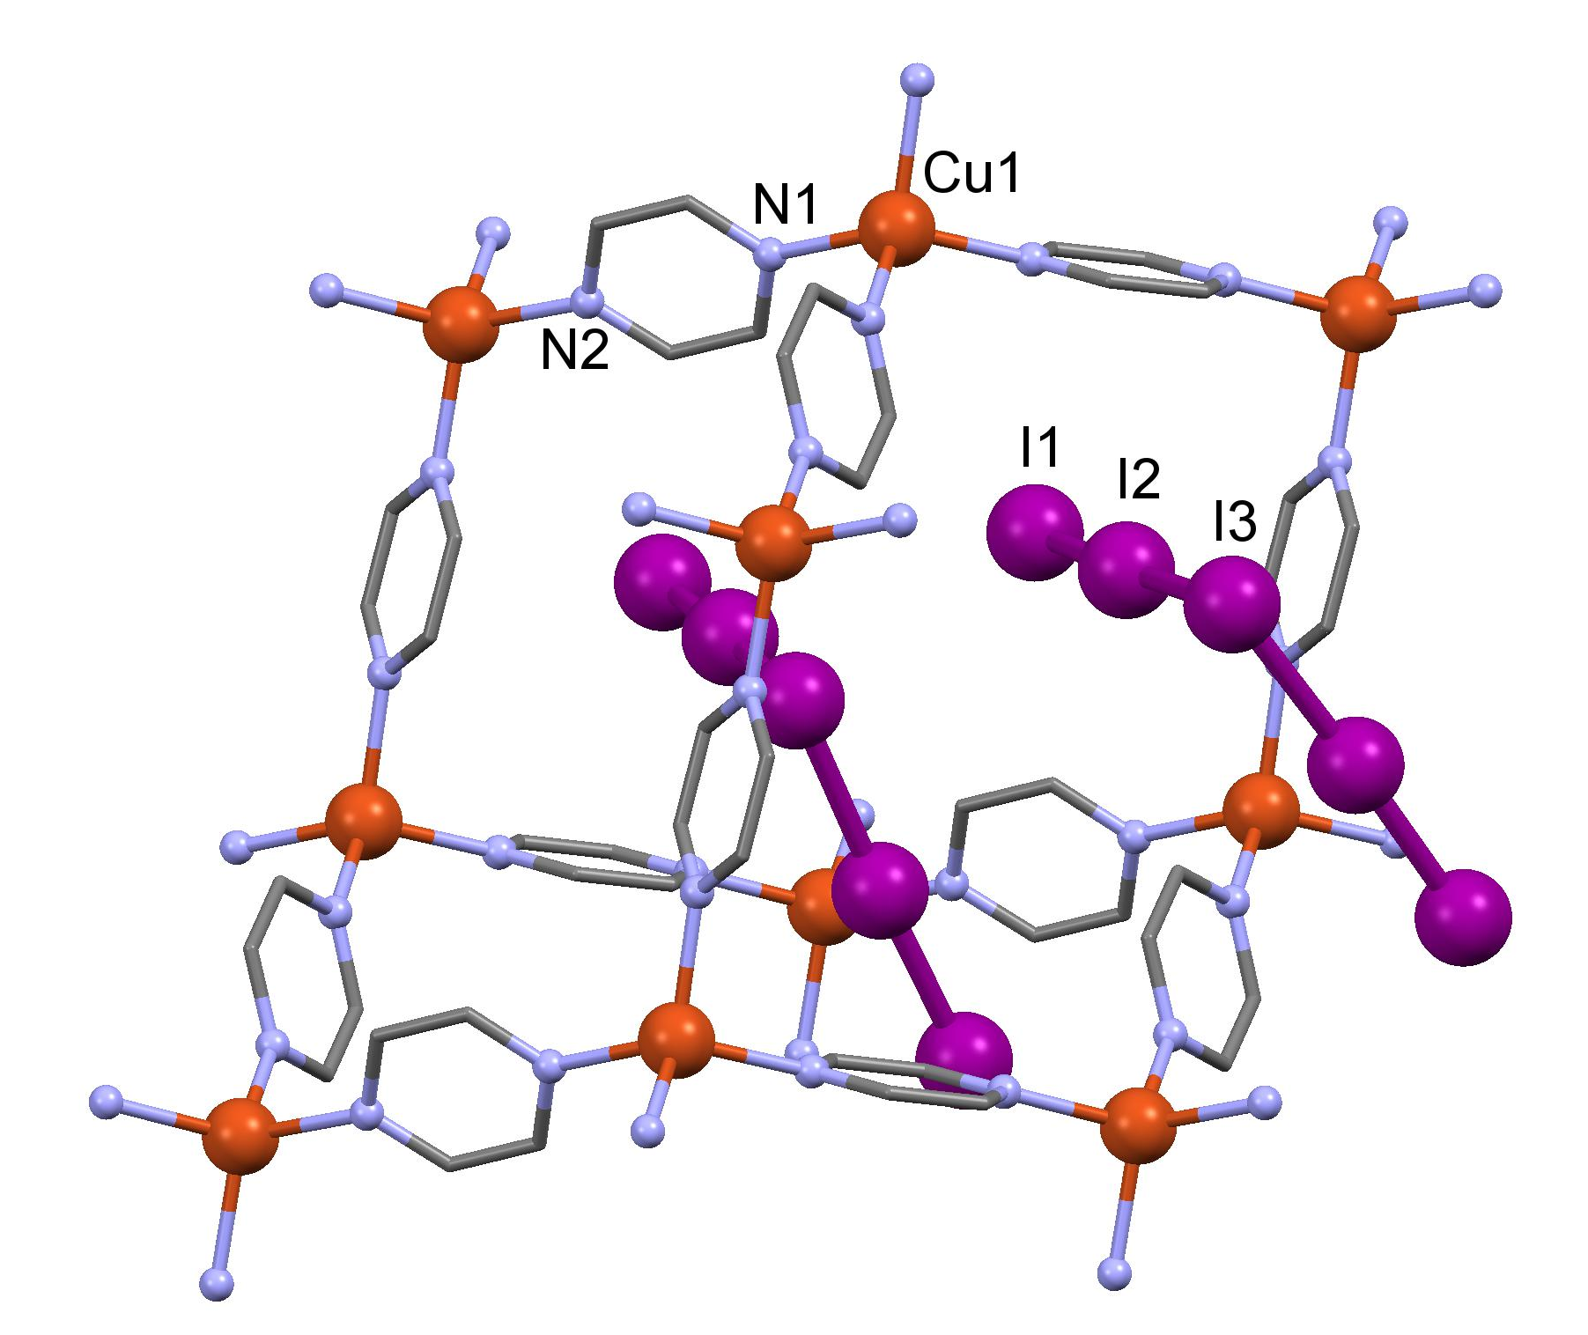

Figure 3. Fragment of 4-connected 3D diamondoid coordination network {[Cu(pyz)₂]I₅}_{n}.

Thus, the partial in situ reduction of Cu(II) in the presence of KI resulted in one-pot synthesis of three Cu(I) coordination polymers representing yellow [(CuI)₂(pyz)]_{n}, and orange [(CuI)(pyz)]_{n} 2D neutral networks, and dark blue [Cu(pyz)₂I₅]_{n} 3D cationic coordination grid.

Compounds prepared from Cu(NO₃)₂.3H₂O/ KI/4,4’-bipyridine. The use of bpy instead of pyz in the same synthetic conditions resulted in successive precipitation of the known yellow [Cu^{I}₂I₂(bpy)]_{n} 2D coordination polymer²³ confirmed by the IR spectrum and XRD powder diffraction pattern, and new brown 3D coordination polymer [Cu^{II}(NO₃)(bpy)₂(I₃)]_{n}.(dmf.H₂O)_{n} in which the Cu(II) cations are not affected by the reduction (Figure 4). Starting from either Cu(CH₃COO)₂⋅H₂O or Cu(BF₄)₂ the known yellow [Cu^{I}₂I₂(bpy)]_{n} and orange [Cu^{I}I(bpy)]_{n} ¹⁶ forms precipitated successively.

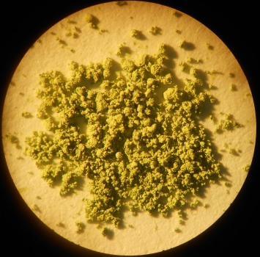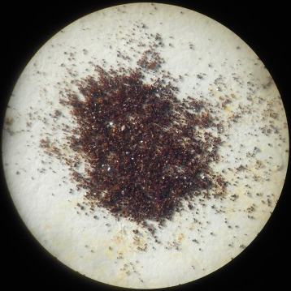

- (b)
Figure 4. Solid Cu–4,4’-bipyridine derivatives: (a) Yellow [(Cu^{I}I)₂(bpy)]_{n}; (b) brown crystals of [Cu^{II}(NO₃)(bpy)₂(I₃)]_{n}.(dmf.H₂O)_{n}

The brown 3D Cu(II) coordination polymer (Figure 5) crystallizes in the orthorhombic Cmca space group, and the asymmetric unit consists of halves of one Cu(II) ion and two halves of two symmetry independent bpy molecules, which reside on two fold axes, halves of one nitrate anion and I₃⁻ anion located on mirror plane, and disordered dmf and water molecules. The square-bipyramidal Cu(II) coordination core formulated as N₄O₂ goes from four bpy ligands in the equatorial plane with the Cu–N distances in the range 2.001(6)–2.027(5) Å and two NO₃ anions in axial positions with the Cu-O distance of 2.359(5) Å (Table 2). The bidentate bpy molecules and NO₃ anions bridge Cu(II) cations in the 3D cationic open framework with rectangular cells, having 11.112 x 11.094 x 6.845 Å dimensions calculated as the distances between the Cu(II) atoms in the vertexes of cells through bpy ligands and NO₃ anions in the directions parallel to the c, b and a crystallographic axes, respectively. Atoms of cationic framework occupy 45% of the crystal space, and the remaining 55.0% of the unit cell volume are filled with the I₃⁻ anions and the disordered solvents, which are dmf and water molecules.

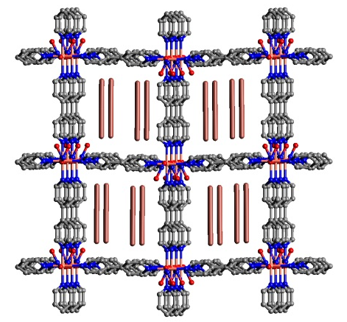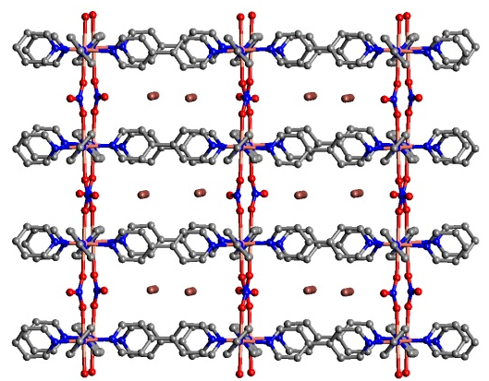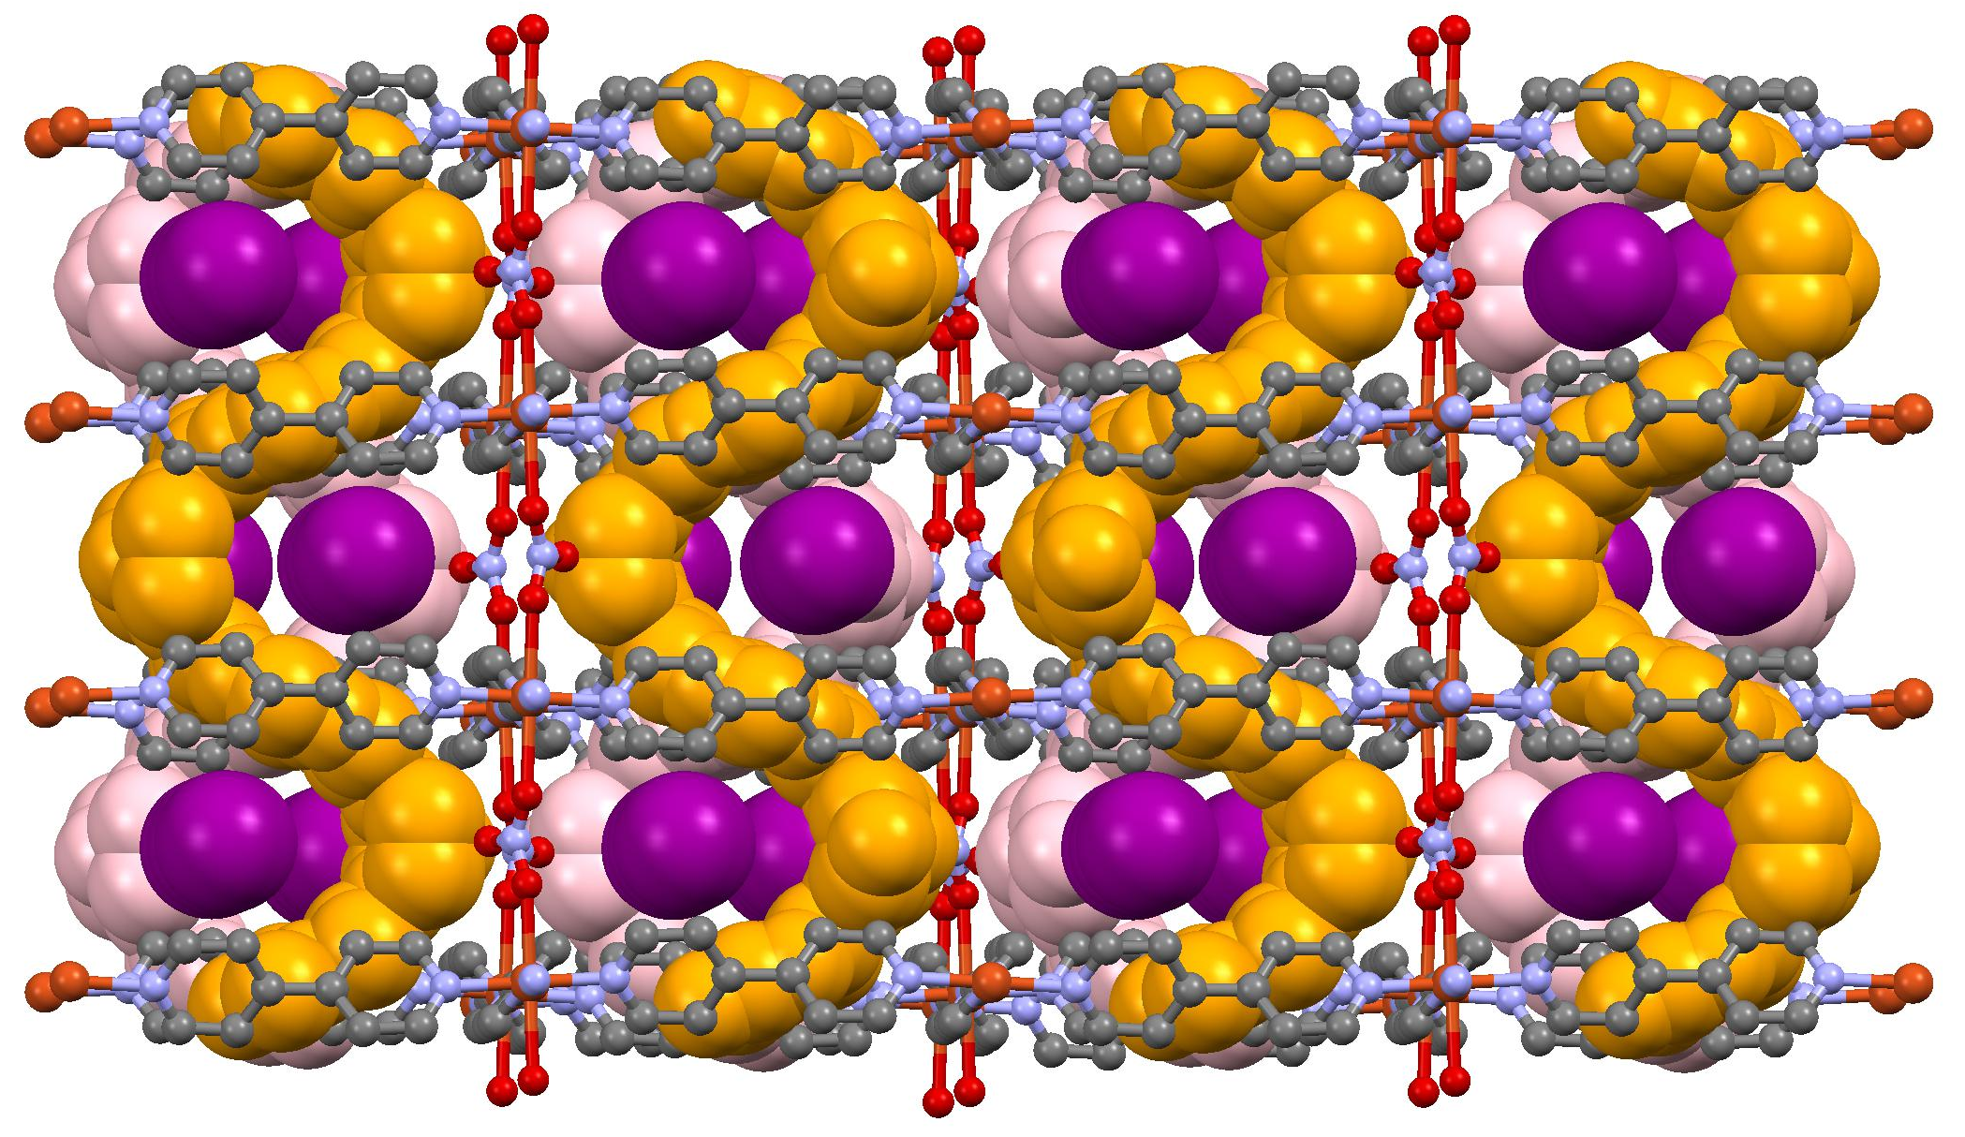
- (b) (c )

Figure 5.View of the 3D rectangular framework [Cu^{II}(NO₃)(bpy)₂(I₃)]_{n}.(dmf.H₂O)_{n} along the a (a) and c (b) axes (the disordered solvent molecules are omitted for sake of clarity) and with the solvents’ ribbons and I₃⁻ anions shown in space-filling mode (c).

While the square-grid {Cu^{II}(bpy)₂}_{n} 2D coordination framework is reported in a series of coordination polymers with the weakly bound anions occupying the Cu(II) axial positions,⁶⁷⁻⁷¹ or with outer sphere anions (including the weakly bound nitrate anion as well), the reported framework may be viewed as pillar-layered 3D structure, where the NO₃⁻ pillars unite these grids into 3D coordination network. To the best of our knowledge only one such example is known so far where the NO₃⁻ and PF₆⁻ anions alternate as the pillars in the 3D coordination grid.⁷¹
To compare the easiness of the iodine release from two 3D coordination networks, the crystals of [Cu(pyz)₂I₅]_{n} and [Cu^{II}(NO₃)(bpy)₂(I₃)]_{n}.(dmf.H₂O)_{n} that contain polyiodide anions were soaked in a methanol solution (Figure 6). The gradual coloring of organic layer and bleaching of the crystals occurred differently. From solid [Cu(pyz)₂I₅]_{n} the portion of iodine is easily and immediately extracted by the methanol solution, dark blue crystal blocks then were transforming into the colorless ones. Our attempts to run the X-ray single crystal experiment on these blocks failed due to the lack of the diffraction pattern. Thus we conclude the structure-directing function of the I₅⁻ template that occupies approximately 56.2 % or 2037.74 Å³ of the unit cell volume. Contrarily, the iodine release occurred slowly from crystals of [Cu^{II}(NO₃)(bpy)₂(I₃)]_{n}.(dmf.H₂O)_{n}, which retained their crystallinity as it was indicated by the repeated single crystal X-ray diffraction measurements from the partially bleaching crystals that reproduce the same unit cell dimensions. The changes in the channels’ content are currently under investigation in our laboratory. Such differences in the stability of the two frameworks were also evident in the thermogravimetric analysis (TGA) as shown in Figure S2. The TGA for [Cu(pyz)₂I₅]_{n} revealed two-step release of iodine (182.5 and 280.0 ˚C) (73.93 % calc) with the consequent collapse of the 3D framework completed at 489.3 ˚C. A more complicated degradation process was observed for [Cu^{II}(NO₃)(bpy)₂(I₃)]_{n}.(dmf.H₂O)_{n} whose framework remains stable up to 264.5 ˚C. The TGA curve indicates a weight loss of 52.23% which can be attributed to the loss of guest dmf and water molecules and release of iodine (51.88% calc). A weight loss of 88.9 % in the interval 260-488 ˚C is associated with the collapse of 3D grid.

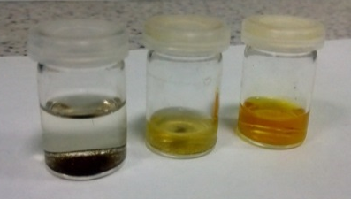
Figure 6. Extraction of iodine by methanol from the samples [Cu^{II}(NO₃)(I₃)(bpy)₂]_{n}.(dmf.H₂O)_{n} (immediate view – left tube, after one week stay – middle one) and [CuI₅(pyz)₂]_{n}(right tube– after a week)

Luminescence Studies. We have determined the photoluminescence behavior of all four solid samples [(CuI)_{x}(B)]_{n} x=1,2, B=pyz, bpy (Figures S3-S16). The results (emission maxima, quantum yields and lifetimes) are reported, together with available literature data, in Table 3. Particularly relevant is the elusive [CuI(pyz)]_{n} which fills the gap in the structural characterization of [(CuX)(pyz)]_{n} (X=Cl, Br, I) 2D coordination polymers. For what concerns the photoluminescence properties of this triad, those of [(CuBr)(pyz)]_{n} have been reported in two papers ^{25,27} while, to the best of our knowledge, those of [(CuCl)(pyz)]_{n} are missing maybe because it lacks any observable emission as is the case for several chloride derivatives.²⁷
- (b)
Figure 7. Emission spectra of [(CuI)(pyz)]_{n} (at 298 and 77 K, black and red respectively) and [(CuI)(bpy)]_{n} (at 298 K).

Crystals of [CuI(pyz)]_{n} display bright emission (centered at 639 nm, τ = 0.54 (39%), 3.32 (61%) µs, Φ equal to 2.7) at room temperature which can be assigned to a mixed halide-to-ligand and metal-to-ligand charge transfer (XL/MLCT) excited state. In fact, the shortest Cu…Cu separation (4.267 Å) is much longer than that required to generate a cluster centered excited state of d-s character (³CC). Moreover, DFT calculations on a model fragment [(CuI)₂(pyz)₂(CuI)₂] (see Figure S17) reveal that the HOMO and the other occupied MOs around the HOMO are mainly composed of I-4p and Cu-3d orbitals. The LUMO and the non-occupied orbitals close to it are essentially pyz π* orbitals (see Figures 8 and S18 for a plot of the frontier orbitals). Though the lowest-energy transition was calculated by TD-DFT at 566 nm (oscillator strength f = 0.0013), the first significant excitation was obtained at 507 nm (f = 0.070), in close agreement with the band observed at about 520 nm in the excitation spectrum (see Figure S3). Both transitions involve several configurations all showing XL/MLCT character (see Table S1 for the full set of excitation energies and assignments). Calculations then support the fact that the emission of [CuI(pyz)]_{n} is originated from an excited state of mixed XL/MLCT character. The same attribution was made for the analogous [CuBr(pyz)]_{n} derivative.²⁷ For this compound an emission at 648 nm (τ = 0.20 (67%), 1.19 (33%) µs)²⁷ or at 629 nm (τ = 62.9 ns)²⁵ was reported at room temperature (at 77 K the emission is red shifted at 690 nm, τ = 8 µs²⁷ or 644 nm²⁵ respectively). The almost independent position of the emission from the halide’s polarizability or the ionization potentials (648-629 vs 639 nm for X = Br or I, respectively) doesn’t contrast the XLCT contribution to such emission. Such behavior was, in fact, already encountered for other Cu(I) derivatives for which it was found from ab initio calculations that the coordinated iodine is less negatively charged than chlorine, thus compensating for the lower ionization potential of the former.^{3, 72} Moreover, a large structural relaxation in the photoexcited state could be large enough to cancel out the marginal difference of HOMO−LUMO gap in the ground state as previously reported.⁷³
Cu(I) complexes with transitions of charge transfer nature are often characterized by small energy separations between the lowest singlet S₁ and triplet T₁ state so that thermally activated delayed fluorescence (TADF) and, if applied to electroluminescent devices, singlet harvesting can become highly effective. Efficient TADF essentially requires small energy separations ΔE(S₁–T₁) with preference below about 1000 cm⁻¹ (≈120 meV). This is achievable with complexes that exhibit small spatial HOMO–LUMO overlap. For energy separations below 300 cm⁻¹ (≈37 meV) short radiative TADF decay times of less than 5 µs can be observed.⁷⁴
To check if TADF mechanism is involved in the luminescent behavior of solid [CuI(pyz)]_{n,} we have examined its emissive properties at 77 K. Upon cooling, the emission is slightly (≈24 nm, 70 meV) red shifted (663 nm) and the lifetime becomes three times longer (τ = 12 µs). Based on these, we suggest that the room temperature shortest component can be attributed to fluorescence while the longer one, shorter than what would be expected for phosphorescence (10−1000 μs), can be ascribed to TADF. At low temperature the probability of the thermally activated T₁→S₁ conversion is decreased reflecting in the increase of the lifetime up to twelve microseconds, which is characteristic of phosphorescence. The lifetime values and the energy differences between room and low temperature are compatible with TADF and are close to that observed for other Cu(I) coordination polymers for which TADF mechanism has been proposed.^{27, 74} This interpretation is supported by TDDFT calculations, which provide a vertical (i.e., without considering geometry relaxation of excited states) ΔE(S₁–T₁) energy gap of 0.14 eV.

Emissive behavior of [(CuI)₂(bpy)]_{n} and [(CuI)(bpy)]_{n} is in agreement with previous findings²⁵ and substantiate a XMCT as dominating transition. In addition, the short room temperature lifetimes indicate only a fluorescent character of the emission. More interestingly, preliminary results indicate for the latter a mechanochromic behavior upon grinding. A color change from orange to yellow and an increase in the emission intensity (Figure S7) are observed that most probably are connected with the solid state transformation of the coordination polymer which deserves further investigation.⁷⁵

Luminescent properties of [(CuI)₂(pyz)]_{n} have already been investigated independently by Pospisil et al.²⁵ and, more recently, by Khatri et al.²⁷ These latter authors suggest a TADF mechanism of the emission even if a large and hypsochromic shift is displayed at 77K. Our spectroscopic studies even though giving emission maxima quite different from those reported by Khatri (but similar to those observed by Pospisil), support this hypothesis. In fact a very small bathochromic shift and a more than seven times longer lifetime (calculated on the longer component) is measured when going from r.t. (582 nm; τ = 1.8 µs) to 77 K (593 nm; τ = 12.7 µs) (see Table 3).

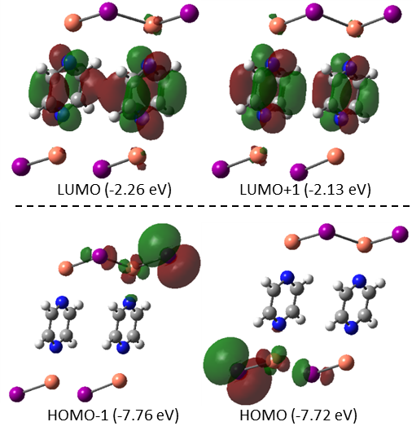

Figure 8. Isodensity surface plot of the frontier orbitals mainly involved in the low-energy transitions of [(CuI)₂(pyz)₂(CuI)₂] model compound (isosurface values: 0.03).

EXPERIMENTAL SECTION
Materials and Methods. All reagents and solvents were obtained from commercial sources and used without further purification. Elemental analyses were performed on an ElementarAnalysensysteme GmbH Vario El III elemental analyzer. The IR spectra were obtained in KBr pellets on a FT IR Spectrum-100 Perkin Elmer spectrometer in the range of 400-4000 cm⁻¹.
Thermal Analysis. Thermal behaviors of the complexes have been studied by thermogravimetric (TG), derivative weight loss (DTG) and differential thermal analyses (DTA) in air atmosphere. Thermal analysis was performed on Derivatograph Q-1500 system. Each sample (about 20 mg) was placed in a platinum crucible and was heated under air flow rate of 100 mL/min and a heating rate of 10 ºC/min from 20 to 1050 ºC. TG, DTG and DTA curves were simultaneously registered.
Luminescence measurements. Photoluminescence quantum yields were measured using a C11347 Quantaurus – Absolute Photoluminescence Quantum Yield Spectrometer (Hamamatsu Photonics K.K), equipped with a 150 W Xenon lamp, an integrating sphere and a multichannel detector.
Steady state emission and excitation spectra and photoluminescence lifetimes were obtained using a FLS 980 spectrofluorimeter (Edinburg Instrument Ltd). The steady state measurements were obtained by a 450 W Xenon arc lamp. Photoluminescence lifetime measurements were performed using both Edinburgh Picosecond Pulsed Diode Laser EPL-445 (Edinburg Instrument Ltd) and microsecond flash Xe- lamp (60W, 0.1÷100 Hz) with data acquisition devices time correlated single-photon counting (TCSPC) and multi-channel scaling (MCS) methods, respectively.
Synthesis. [(Cu^{I}I)₂(pyz)]_{n}, [Cu^{I}I(pyz)]_{n} and {[Cu^{I} (pyz)₂I₅]}_{n}. The acetonitrile solution (5 ml) of Cu(NO₃)₂⋅3H₂O (0.06g, 0.24 mmol), KI (0.04g , 0.24 mmol) and pyrazine (0.08 g, 0.99 mmol) was refluxed for 30 min. The yellow precipitate formed during the reaction was filtered off and washed with MeCN, yield: 0.021 g (36.84 %). Analyzing its IR and XRD powder diffraction data it corresponds to the published complex [(Cu^{I}I)₂(pyz)]_{n}¹⁶. The orange filtrate of the original solution was left in a covered vial for about one month that gives two types of crystals: orange plates that correspond to the complex [Cu^{I}I(pyz)]_{n}(yield: 0.019 g, 28.35 %). Anal.Calcd for C₄H₄Cu₁I₁N₂ C, 17.76; H, 1.49; N, 10.35.Found: C, 17.78; H, 1.46; N, 10.31 and dark brown blocks that correspond to the complex [Cu^{I} (pyz)₂I₅]_{n}2 (yield: 0.026 g ( 12.2 %). Anal.Calcd for C₈H₈Cu₁I₅N₄: C, 11.2; H, 0.94; N, 6.53. Found: C, 11.24; H, 0.96; N, 6.51. IR (KBr)/cm⁻¹ for [Cu^{I}I(pyz)]_{n}: 3674 m, 2988 s, 2973 sh, 2901 sh, 1929 w, 1871 w, 1753 w, 1697 w, 1616 w, 1583 w, 1484 w, 1452 w, 1414 m, 1394 sh, 1383 sh, 1303 w, 1250 m, 1241 sh, 1230 sh, 1157 w, 1075 sh, 1066 sh, 1055 vs, 1028 sh, 892 m, 880 sh, 869 sh, 795 m, 789 sh. IR (KBr)/cm⁻¹ for {[Cu^{I}I₅(pyz)₂]}_{n}: 3676 m, 3661 sh, 3087 w, 3068 sh, 2988 m, 2972 sh, 2901 sh, 2638 w, 1943 w, 1877 w, 1813 w, 1774 w, 1714 w, 1648 w, 1617 w, 1475 m, 1406 vs, 1356 sh, 1250 m, 1242 sh, 1230 sh, 1150 m, 1112 m, 1073 sh, 1046 vs, 1028 sh, 978 w, 892 w, 868 w, 799 s.
[(Cu^{I}I)₂(bpy)]_{n} and [Cu^{II}(NO₃)(bpy)₂I₃]_{n}⋅(dmf.H₂O)_{n.} A solution of 5 ml MeCN and 3 ml DMF containing Cu(NO₃)₂⋅3H₂O (0.06g, 0.24 mmol), KI (0.04g , 0.24 mmol) and 4,4҆-bipyridine (0.04 g, 0.25 mmol) was refluxed for 30 min. The yellow precipitate formed during the reaction was filtered off and washed with MeCN, yield: 0.03 g (45.4 %). Analyzing its IR, and XRD powder diffraction data it corresponds to the published complex [(Cu^{I}I)₂(bpy)]_{n.} ²³ The orange filtrate of the original solution was left in a covered vial for about two weeks to give brown crystals of [Cu^{II}(NO₃)(bpy)I₃]_{n}⋅(dmf.H₂O)_{n} (yield: 0.036 g ( 16.3 %). Anal.Calcd for C₂₃H₂₅CuI₃N₆O₅: C, 30.37; H, 2.77; N, 9.24. Found: C, 30.34; H, 2.74; N, 9.26. IR (KBr)/cm⁻¹: 3385 w, 3097 w, 3042 w, 2924 w, 1763 w, 1665 s, 1612 s, 1537 m, 1491 m, 1413 sh, 1375 sh, 1340 vs, 1315 sh, 1220 m, 1100 w, 1088 w, 1068 m, 1017 m, 854 w, 814 s, 797 sh, 726 w, 662 w.
[(Cu^{I}I)₂(bpy)]_{n} and [Cu^{I}I(bpy)]_{n.} A solution of MeCN (5 mL) and DMF (3 mL)containing Cu(MeCO₂)₂⋅H₂O (0.06g, 0.24 mmol), KI (0.04g, 0.24 mmol) and 4,4҆-bipyridine (0.04 g, 0.25 mmol) was refluxed for 30 min. The yellow precipitate formed during the reaction was filtered off and washed with MeCN, yield: 0.02g (22.7 %). Analyzing its XRD powder diffraction data it corresponds to the published complex [(Cu^{I}I)₂(bpy)]_{n.}¹⁶ The orange filtrate of the original solution was left in a covered vial for about two weeks to give red crystals of [(Cu^{I}I)(bpy)]_{n}¹⁶ (yield: 0.034 g (29.8 %). IR (KBr)/cm⁻¹ for [(Cu^{I}I)(bpy)]_{n}: 3072 sh, 3040 m, 3019 sh, 2601 w, 2456 w, 1944 w, 1723 w, 1688 w, 1598 m, 1527 m, 1482 m, 1414 sh, 1405 s, 1322 w, 1288 w, 1213 m, 1068 w, 1060 w, 1042 w, 1004 w, 965 w, 854 m, 814 sh, 797 vs, 743 w, 723 m, 672 w.
Crystallographic Studies. Single crystal diffraction measurements for [(Cu^{I}I)(pyz)]_{n}, {[Cu^{I}I₅(pyz)₂]}_{n},[(Cu^{I}I)(bpy)]_{n} and [Cu^{II}(NO₃) (bpy)₂(I₃)]_{n}.(dmf.H₂O)_{n} were carried out on an Xcalibur E diffractometer equipped with a CCD area detector and a graphite monochromator utilizing MoKα radiation at a room temperature.Additionally the low temperature experiment for [(Cu^{I}I)(pyz)]_{n} was run at 130 K on a Bruker SMART APEX-II CCD area-detector diffractometer equipped with an Oxford Cryosystems Cryostream 700Plus cryostat. Final unit cell dimensions were obtained and refined on an entire data set. All calculations to solve the structures and to refine the models proposed were carried out with the programs SHELXS97 and SHELXL2014.^{76,77} Hydrogen atoms attached to carbon atoms were positioned geometrically and treated as riding atoms using SHELXL default parameters with U_{iso}(H)=1.2U_{eq}(C). In [Cu^{II}(NO₃)(bpy)₂(I₃)]_{n}.(dmf.H₂O)_{n} disordered solvent molecules and the minor position of NO₃ anion were refined in isotropic approximation, the H-atoms in water molecules were not located. The X–ray data and the details of the refinement for [(Cu^{I}I)(pyz)]_{n}, [Cu^{I}I₅(pyz)₂]_{n} and [Cu^{II}(NO₃)(bpy)₂(I₃)]_{n}.(dmf.H₂O)_{n} are summarized in Table 1, selected geometric parameters are summarized in Table 2. The Figures were produced using Mercury.⁷⁸
Powder Powder patterns were recorded on a Philips PW1820 diffractometer (Cu-Kα radiation, λ = l.5405 Å) in the 5–40° 2θ range (0.02° and 1.5 s per step).
Computational details. Computational studies have been performed on a discrete model of the [CuI(pyz)]_{n} polymeric structure, [(CuI)₂(pyz)₂(CuI)₂], comprising two (CuI)₂ chains and two pyrazine molecules interconnecting the (CuI)₂ chains (see Figure S17), using the Gaussian 09 suite of programs.⁷⁹ The geometry of the fragment has been optimized at the M06-2X/6-311++G(d,p) level of theory starting from the 130 K X-ray structure, freezing angles and torsions to preserve the correct geometry coordination around the copper ions. The basis set for iodine⁸⁰ was downloaded from the Basis Set Exchange site.⁸¹ The M06-2X functional has been chosen in view of its optimal performance in treating noncovalent interactions,⁸² which in the present structure revealed to be important owing to the short distance between adjacent pyrazine rings. Their interplanar distance (3.441 Å in the low temperature (130 K) X-ray crystal structure) would suggest in fact π-π stacking interaction. For the same reason, a large basis set including diffuse functions has been chosen. In the final structure, the pyrazine rings kept essentially unvaried their parallel arrangement, with interplanar distance equal to 3.416 Å. The Cu–I bond lengths were slightly shorter for the iodine atoms external to the chain with respect to the internal one (2.48-2.58 vs. 2.63-2.67 Å, respectively) and the Cu∙∙∙Cu separation was 4.22 Å, in very good agreement with the X-ray values (2.609 and 4.247 Å, respectively). The Cu–N bond lengths, on the other hand, showed a rather wide range of variability (from 2.08 to 2.21 Å) and were longer than the experimental value, 2.057 Å. Following the computational protocol previously developed to treat organic emitters showing TADF,⁸³ TDDFT calculations have been performed on the optimized ground-state structure using the range-separated LC-ωPBE* functional⁸⁴ with ω=0.30 to obtain both the lowest singlet (S₁) and triplet (T₁) excited states determining the ‘vertical’ ΔE_{ST} energy gap. The choice of the ω value, in place of the default one (0.40) was based on its better performance in reproducing the experimental lowest-energy transition. All excited state calculations were performed with the same 6-311++G(d,p) basis set used for ground state calculations.

Conclusion
The partial in situ reduction of Cu(II) in the presence of KI and pyrazine (pyz) resulted in two two-dimensional and one three-dimensional Cu(I) coordination networks including the so far elusive orange [Cu^{I}I(pyz)]_{n} that represents the missing member in the row of two-dimensional coordination networks of general formula [CuX(pyz)]_{n} (X=Cl, Br, I). In the presence of 4,4’-bipyridine (bpy) the same procedure resulted in the known Cu(I) 2D polymers, [(Cu^{I}I)_{x}(bpy)]_{n} x=1,2; and new Cu(II) 3D coordination polymer, [Cu^{II}(NO₃) (bpy)₂(I₃)]_{n}.(dmf.H₂O)_{n}. Powders of [CuI(pyz)]_{n} display TADF behavior associated with a small (M/XLCT) singlet-triplet splitting.

ASSOCIATED CONTENT
Supporting Information

The Supporting Information is available free of charge on the ACS Publications website at DOI: 10.1021/acs.inorgchem.XXXX. IR spectra, TGA data and full emission spectra (PDF). Cif files for [(Cu^{I}I)(pyz)]_{n} (RT & LT), {[Cu^{I}I₅(pyz)₂]}_{n},[(Cu^{I}I)(bpy)]_{n} and [Cu^{II}(NO₃) (bpy)₂(I₃)]_{n}.(dmf.H₂O)_{n} were deposited in CSD, CCDC deposition numbers CCDC 1530503-1530507.

AUTHOR INFORMATION

Corresponding Authors
*E-mail: fonari.xray@phys.asm.md; a.forni@istm.cnr.it

Acknowledgement The authors are indebted to the Moldova-Italy bilateral project 15.820.16.02.01/It. Authors thank Prof. Lucia Carlucci for XRPD measurements.

Author Contributions
The manuscript was written through contributions of all authors. All authors have given approval to the final version of the manuscript.

Notes
The authors declare no competing financial interest.

References

- Cramer, C. J.; Tolman, W. B. Mononuclear Cu–O₂ Complexes: Geometries, Spectroscopic Properties, Electronic Structures, and Reactivity. Acc. Chem. Res. 2007, 40, 601–608.
- Cuttell, D. G.; Kuang, S.-M.; Fanwick, P. E.; McMillin, D. R.; Walton, R. A. Simple Cu(I) Complexes with Unprecedented Excited-State Lifetimes J. Am. Chem. Soc. 2002, 124, 6–7.
- Ford, P. C.; Cariati, E.; Bourassa, J. Photoluminescence Properties of Multinuclear Copper(I) Compounds. Chem. Rev. 1999, 99, 3625–3647.
- Cariati, E.; Lucenti, E.; Botta, C.; Giovanella, U.; Marinotto, D.; Righetto, S. Cu(I) hybrid inorganic–organic materials with intriguing stimuli responsive and optoelectronic properties Coord. Chem. Rev. 2016, 306, 566–614.
- Barbieri, A.; Accorsi, G.; Armaroli, N. Luminescent complexes beyond the platinum group: the d¹⁰ avenue. Chem. Commun. 2008, 2185–2193.
- Vitale, M.; Ford, P. C. Luminescent mixed ligand copper(I) clusters (CuI)n(L)m(L=pyridine, piperidine): thermodynamic control of molecular and supramolecular species. ,Coord. Chem. Rev. 2001, 219–221, 3–16.
- Xu, X.; Bai, X.; Lu, Y.; Wang, E.; Ma, Y. Synthesis, structure, and luminescent property of one mixed-valence Cu–halide complex constructed from pyridine-3-carboxylate. Inorg. Chem. Commun. 2006, 9, 872−876.
- Fu, Z.; Lin, J.; Wang, L.; Li, C.; Yan, W.; Wu, T. Cuprous Iodide Pseudopolymorphs Based on Imidazole Ligand and Their Luminescence Thermochromism. Cryst.Growth & Des. 2016, 16, 2322-2327.
- Cariati, E.; Roberto, D.; Ugo, R.; Ford, P. C.; Galli, S.; Sironi, A. New Structural Motifs, Unusual Quenching of the Emission, and Second Harmonic Generation of Copper(I) Iodide Polymeric or Oligomeric Adducts with para-Substituted Pyridines or trans-Stilbazoles. Inorg. Chem. 2005, 44, 4077–4085.
- Li, J.-C.; Li, H.-X.; Li, H.-Y.; Gong, W.-J.; Lang, J.-P. Ligand Coordination Site-Directed Assembly of Copper(I) Iodide Complexes of ((Pyridyl)-1-pyrazolyl)pyridine. Cryst. Growth Des. 2016, 16, 1617–1625.
- Yan, H.-R.; Wang, J.; Yu, Y.-H.; Hou, G.-F.; Zhang, H.-X.; Gao, J.-S. Two cationic [(Cu_{x}I_{y})_{x−y}]_{n} motif based coordination polymers and their photocatalytic properties. RSC Adv. 2016, 6, 71206–71213.
- Ji, W.; Qu, J.; Jing, S.; Zhu, D.; Huang, W. Copper(I) halide clusters based upon ferrocenylchalcogenoether ligands: donors, halides and semi-rigidity effects on the geometry and catalytic activity. Dalton Trans. 2016, 45, 1016–1024.
- Bai, S.-Q.; Jiang, L.; Young, D. J.; Hor, T. S. A. Luminescent [Cu₄I₄] aggregates and [Cu₃I₃]⁻cyclic coordination polymers supported by quinolyl-triazoles. Dalton Trans. 2015, 44, 6075–6081.
- Song, Y.; Fan, R.; Wang, P.; Wang, X.; Gao, S.; Du, X.; Yang, Y.; Luan, T. Copper(I)-iodide based coordination polymers: bifunctional properties related to thermochromism and PMMA-doped polymer film materials. J. Mater. Chem. C 2015 3, 6249–6259.
- Goher, M. A. S.; Mautner, F. A. Spectral and structural characterization of copper(I) halide, nitrate and perchlorate complexes of pyrazine carboxamide (pyza) and X-ray crystal structure of polymeric [Cu(pyza)₂I]ncomplex. Polyhedron. 2000, 19, 601–606.
- Blake, A. J.; Brooks, N. R.; Champness, N. R.; Cooke, P.A M. Crew., A. M. Deveson, L. R. Hanton, P. Hubberstey, D. Fenske, M. Schröder, Copper(I) Iodide Coordination Networks – Controlling the Placement of (CuI)∞ Ladders and Chains within Two-dimensional Sheets. Cryst. Eng. 1999, 2, 181–195.
- Graham, P. M.; Pike, R. D.; Sabat, M.; Bailey; R. D.; Pennington, W. T. Coordination Polymers of Copper(I) Halides. Inorg. Chem. 2000, 39, 5121–5132.
- Pike, R. D.; Graham, P. M.; Guy, K. A.; Johnson, T. J.; Cole, J. R.; Stamps S. M.; Klemmer, L. E. Network Complexes of Copper(I) Halides. J. Chem. Educ. 2001, 78, 1522.
- Moreno, J. M.; Suarez-Varela, J.; Colacio, E.; Avila-Roson, J. C.; Hildago, M. A.; Martin-Ramos, D. Can. J. Chem. 1995, 73, 1591–1595.
- Persky, N. S.; Chow, J. M.; Poschmann, K. A.; Lacuesta, N. N.; Stoll, S. L.; Bott, S. G.; Obrey, S. Hydrothermal Syntheses, Structures, and Properties of [Cu₃Cl₂CN(pyrazine)] and Copper(I) Halide Pyrazine Polymers. Inorg. Chem. 2001, 40, 29–35.

Kawata, S.; Kitagawa, S.; Kumagai, H.; Iwabuchi, S.; Katada, M. The structural characterization of the novel ribbon sheet, [Cu₂Cl₂(pyz)]n (pyz = pyrazine). Inorg. Chim. Acta. 1998, 267, 143–145.
- Kuhlman, R.; Schimek, G. L.; Kolis, J. W. Inorganic–organic composites from solvothermal routes: Extended structures of [CuX(pyrazine)] (X=CN, Cl, CF₃CO₂), and Cu(NO₂)₂(pyz). Polyhedron. 1999, 18, 1379–1387.
- Näther, C.; Jeß, I. Crystal Structure of _{infin;}²[Cu₂I₂(μ-4-4′-bipyridine)] and Investigations on the Thermal Decomposition of CuX-4,4′-bipyridine Coordination Polymers, Monatsh. Chem. 2001, 132, 897–910.
- Ay, B.; Karaca, S.; Yildiz, E.; Lopez, V.; Nanao, M. H.; Zubieta, J. In situ hydrothermal syntheses, structures and photoluminescent properties of four novel metal-organic frameworks constructed by lanthanide (Ln=Ce(III), Pr(III), Eu(III)) and Cu(I) metals with flexible dicarboxylate acids and piperazine-based ligands. J. Solid State Chem. 2016, 233, 415–421.
- Pospisil, J.; Jess, I.; Näther, C.; Necas, M.; Taborsky, P. Luminescence properties of “double-stranded staircase” copper(I) halide coordination polymers with N-containing ligands. New J. Chem. 2011, 35, 861–864.
- Jess, I.; Näther, C. Investigations on the Synthesis, Structures, and Properties of New Copper(I) 2,3-Dimethylpyrazine Coordination Compounds. Inorg. Chem. 2006, 5, 7446–7454.
- Khatri, N. M.; Pablico-Lansigan, M. H.; Boncher, W. L.; Mertzman, J. E.; Labatete, A.C.; Grande, L. M.; Wunder, D.; Prushan, M.J.; Zhang, W.; ShivHalasyamani, P.; Monteiro, J. H.S.K.; deBettencourt-Dias, A.; Stoll, S. L. Luminescence and Nonlinear Optical Properties in Copper(I) Halide Extended Networks. Inorg. Chem. 2016, 55, 11408–11417.
- AbdulHalim, R. G.; Shkurenko, A.; Alkordi, M. H.; Eddaoudi, M. Supramolecular Isomers of Metal−Organic Frameworks Derived from a Partially Flexible Ligand with Distinct Binding Motifs. Cryst. Growth Des. 2016, 16, 722−727.
- Colacio, E.; Kiveka, R.; Lloret, F.; Sunberg, M.; Suarez-Varela, J.; Bardajı´, M.; Laguna, A. Architecture Dependence on the Steric Constrains of the Ligand in Cyano-Bridged Copper(I) and Copper(II)−Copper(I) Mixed-Valence Polymer Compounds Containing Diamines: Crystal Structures and Spectroscopic and Magnetic Properties. Inorg. Chem. 2002, 41, 5141−5149.
- Qin, Y.-L.; Hou, J.-J.; Lv, J.; Zhang, X.-M. Organic Templated Cuprous Cyanide Open Frameworks Based on Cu₂(CN)₆ Dimer with Strong and Long-Lived Luminescence. Cryst. Growth Des. 2011, 11, 3101–3108.
- Zhou, X.-P.; Li, D.; Zheng, S.-L.; Zhang, X.; Wu, T. Cu(I) or Cu(I)-Cu(II) Mixed-Valence Complexes of 2,4,6-Tri(2-pyridyl)-1,3,5-triazine: Syntheses, Structures, and Theoretical Study of the Hydrolytic Reaction Mechanism. Inorg. Chem. 2006, 45, 7119–125.
- Amo-Ochoa, P.; Castillo, O.; Zamora, F. Cu(I), Co(II) and Fe(II) coordination polymers with pyrazine and benzoate as ligands. Spin crossover, spin canting and metamagnetism phenomena. Dalton Trans., 2013,42, 13453–13460.
- Jana, S.; Chattopadhyay, S. Formation of a mixed valence copper(II)–copper(I) coordination polymer {[Cu(1,2-pn)₂(μ₃-I)Cu₂(μ₂-I)₃(CH₃CN)]⋅CH₃CN}_{n}: in situ reduction of copper(II) at ambient condition. J. Coord. Chem. 2013, 66, 3906–3914.
- Jana, S.; Harms, K.; Chattopadhyay, S. In situ assembly of a host–guest linked, mixed valence copper(II)–copper(I) coordination polymer [Cu(1,2-en)₂(μ₃-I)₂Cu₂(μ₂-I)₂]_{n} via partial reduction of copper(II) under ambient conditions. J. Coord. Chem. 2014, 67, 2954–2966.
- Lu, J. Y.; Babb, A. M. A Simultaneous Reduction, Substitution, and Self-Assembly Reaction under Hydrothermal Conditions Afforded the First Diiodopyridine Copper(I) Coordination Polymer. Inorg. Chem. 2002, 41, 1339−1341.
- Nandy, M.; Shit, S.; Dhal, P.; Rizzoli, C.; Gómez–García, C. J.; Mitra, S. Ferromagnetic copper(II)–copper(II) interaction in a single chlorido and dicyanamido bridged mixed–valence copper(I/II) 2-D polymer generated by in situ partial reduction of copper(II). J. Coord. Chem. 2015, 68, 916-927.
- Guchhait, S. K.; Chandgude, A. L.; Priyadarshani, G. CuSO₄−Glucose for in Situ Generation of Controlled Cu(I)−Cu(II) Bicatalysts: Multicomponent Reaction of Heterocyclic Azine and Aldehyde with Alkyne, and Cycloisomerization toward Synthesis of N-Fused Imidazoles. J. Org. Chem. 2012, 77, 4438−4444.
- Zhang, Q.; Zhou, Q.; Cheng, Y.; Wang, L.; Ma, D.; Jing, X.; Wang, F. Highly Efficient Green Phosphorescent Organic Light-Emitting Diodes Based on Cu^{I} Complexes, Adv. Mater. 2004, 16, 432–436.

Armaroli, N.; Accorsi, G.; Holler, M.; Moudam, O.; Nierengarten, J.-F.; Zhou, Z.; Wegh, R. T.; Welter, R. Highly Luminescent Cu^{I} Complexes for Light-Emitting Electrochemical Cells. Adv. Mater. 2006, 18, 1313–1316.

Che, G.; Su, Z.; Li, W.; Chu, B.; Li, M.; Hu, Z.; Zhang, Z. Highly efficient and color-tuning electrophosphorescent devices based on Cu^{I} complex. Appl. Phys. Lett. 2006, 89, 103511.

Zhang, Q.; Zhou, Q.; Cheng, Y.; Wang, L.; Ma, D.; Jing, X.; Wang, F. Highly Efficient Electroluminescence from Green-Light-Emitting Electrochemical Cells Based on Cu^{I} Complexes. Adv. Funct. Mater. 2006, 16, 1203–1208.

Tsuboyama, A.; Kuge, K.; Furugori, M.; Okada, S.; Hoshino, M.; Ueno, K. Photophysical Properties of Highly Luminescent Copper(I) Halide Complexes Chelated with 1,2-Bis(diphenylphosphino)benzene. Inorg. Chem. 2007, 46, 1992–2001.

Zhang, Q.; Ding, J.; Cheng, Y.; Wang, L.; Xie, Z.; Jing, X.; Wang, F. Novel Heteroleptic Cu^{I} Complexes with Tunable Emission Color for Efficient Phosphorescent Light-Emitting Diodes. Adv. Funct. Mater. 2007, 17, 2983–2990.

Deaton, J. C.; Switalski, S. C.; Kondakov, D. Y.; Young, R. H.; Pawlik, T. D.; Giesen, D. J.; Harkins, S. B.; Miller, A. J. M.; Mickenberg, S. F.; Peters, J. C. E-Type Delayed Fluorescence of a Phosphine-Supported Cu₂(μ-NAr₂)₂Diamond Core: Harvesting Singlet and Triplet Excitons in OLEDs. J. Am. Chem. Soc. 2010, 132, 9499–9508.

Hashimoto, M.; Igawa, S.; Yashima, M.; Kawata, I.; Hoshino, M.; Osawa, M. Highly Efficient Green Organic Light-Emitting Diodes Containing Luminescent Three-Coordinate Copper(I) Complexes. J. Am. Chem. Soc. 2011, 133, 10348–10351.

Liu, Z.; Qayyum, M. F.; Wu, C.; Whited, M. T.; Djurovich, P. I.; Hodgson, K. O.; Hedman, B.; Solomon, E. I.; Thompson, M. E. A Codeposition Route to CuI−Pyridine Coordination Complexes for Organic Light-Emitting Diodes. J. Am. Chem. Soc. 2011, 133, 3700–3703.

Wada, A.; Zhang, Q.; Yasuda, T.; Takasu, I.; Enomoto, S.; Adachi, C. Efficient luminescence from a copper(I) complex doped in organic light-emitting diodes by suppressing C–H vibrational quenching. Chem. Commun. 2012, 48, 5340–5342.
- Zhang, Q.; Komino, T.; Huang, S.; Matsunami, S.; Goushi, K.; Adachi, C. Adv. Funct. Mater. 2012, 22, 2327–2336.

Igawa, S.; Hashimoto, M.; Kawata, I.; Yashima, M.; Hoshino, M.; Osawa, M.Highly efficient green organic light-emitting diodes containing luminescent tetrahedral copper(I) complexes. J. Mater. Chem. C, 2013, 1, 542–551.

Chen, X.-L.; Yu, R.; Zhang, Q.-K.; Zhou, L.-J.; Wu, X.-Y.; Zhang, Q. Lu, C.-Z. Rational Design of Strongly Blue-Emitting Cuprous Complexes with Thermally Activated Delayed Fluorescence and Application in Solution-Processed OLEDs. Chem. Mater. 2013, 25, 3910–3920.

Liu, Z.; Qiu, J.; Wei, F.; Wang, J.; Liu, X.; Helander, M. G.; Rodney, S.; Wang, Z.; Bian, Z. Lu, Z.; Thompson; M. E.; Huang, C. Simple and High Efficiency Phosphorescence Organic Light-Emitting Diodes with Codeposited Copper(I) Emitter. Chem. Mater. 2014, 26, 2368–2373.

Zink, D. M.; Volz, D.; Baumann, T.; Mydlak, M.; Flügge, H.; Friedrichs, J.; Nieger, M.; Bräse, S. Heteroleptic, Dinuclear Copper(I) Complexes for Application in Organic Light-Emitting Diodes. Chem. Mater. 2013, 25, 4471–4486.

Czerwieniec, R.; Kowalski; K.; Yersin, H. Highly efficient thermally activated fluorescence of a new rigid Cu(I) complex [Cu(dmp)(phanephos)]⁺. Dalton Trans. 2013, 42, 9826–9830.

Leitl, M. J.; Küchle, F.-R.; Mayer, H. A.; Wesemann, L.; Yersin, H. Brightly Blue and Green Emitting Cu(I) Dimers for Singlet Harvesting in OLEDs. J. Phys. Chem. A. 2013, 117, 11823–11836.

Zink, D. M.; Bächle, M.; Baumann, T.; Nieger, M.; Kühn, M.; Wang, C.; Klopper, W.; Monkowius, U.; Hofbeck, T.; Yersin H.; Bräse, S. Synthesis, Structure, and Characterization of Dinuclear Copper(I) Halide Complexes with P^N Ligands Featuring Exciting Photoluminescence Properties. Inorg. Chem. 2013, 52, 2292–2305.

Linfoot, C. L.; Leitl, M. J.; Richardson, P.; Rausch, A. F.; Chepelin, O.; White, F. J.; Yersin, H.; Robertson, N. Thermally Activated Delayed Fluorescence (TADF) and Enhancing Photoluminescence Quantum Yields of [Cu^{I}(diimine)(diphosphine)]⁺ Complexes—Photophysical, Structural, and Computational Studies. Inorg. Chem. 2014, 53, 10854–10861.

Czerwieniec, R.; Yu, J.; Yersin, H. Blue-Light Emission of Cu(I) Complexes and Singlet Harvesting. Inorg. Chem. 2011, 50, 8293–8301.

Parker, C. A.; Hatchard, C. G. Triplet-singlet emission in fluid solutions. Phosphorescence of eosin. Trans. Faraday Soc. 1961, 57, 1894–1904.

Yersin, H.; Rausch, A. F.; Czerwieniec, R.; Hofbeck, T.; Fischer, T. The triplet state of organo-transition metal compounds. Triplet harvesting and singlet harvesting for efficient OLEDs. Coord. Chem. Rev. 2011, 255, 2622–2652.
- Yersin, H.; Rausch, A. F. Czerwieniec, R. Organometallic Emitters for OLEDs: Triplet Harvesting, Singlet Harvesting, Case Structures, and Trends, in Physics of Organic Semiconductors, ed. W. Brütting and C. Adachi, Wiley-VCH Verlag, 2012, pp. 371–424.

Yersin, H.; Leitl, M. J.; Czerwieniec, R. TADF for singlet harvesting: next generation OLED materials based on brightly green and blue emitting Cu(I) and ag(I) compounds. Proc. SPIE, 2014, 9183, 22–21.

Leitl, M. J.; Krylova, V. A.; Djurovich, P. I.; Thompson, M. E. Yersin, H. Phosphorescence versus Thermally Activated Delayed Fluorescence. Controlling Singlet–Triplet Splitting in Brightly Emitting and Sublimable Cu(I) Compounds. J. Am. Chem. Soc. 2014, 136, 16032–16038.
- Shaffer, P. A.; Hartmann, A. F. The iodometric determination of copper and its use in sugar analysis. J. Biol. Chem. 1921, 45, 349-364.
- Zaworotko, M. J. Crystal engineering of diamondoid networks. Chem. Soc. Rev., 1994, 23, 283-288.
- Guo, H.-X.;Weng, W.; Li, X.-Z.; Liang, M.; Zheng, C.-Q. A novel three-dimensional coordination polymer constructed from pyrazine and copper(I): poly[[copper(I)-di-₂-pyrazine-⁴N:N'] 3,5-dicarboxy-benzene-sulfonate monohydrate. Acta Crystallogr. 2008, C64, m314-m316.
- Amo-Ochoa, P.; Castillo, O.; Zamora, F. Cu(I), Co(II) and Fe(II) coordination polymers with pyrazine and benzoate as ligands. Spin crossover, spin canting and metamagnetism phenomena. Dalton Trans. 2013, 42, 13453-13460.
- Hu, F.; Yin, X.; Mi, Y.; Li, W.; Tang, X.; Ma, Z. Synthesis, structure and properties of a new copper (II) complex, [Cu₂(4,4′-bpy)₅(H₂O)₄](ClO₄)₄(4,4′-bpy)(DMF)₂(H₂O)₂ Inorg. Chem. Comm. 2010, 13, 720–723.
- Du, M.; Zhao. X.-J. {[Cu(bipy)_{2.5}(H₂O)](ClO₄)₂·(H₂O)·(CH₃OH)_{1.5}}n (bipy=4,4′-bipyridine): organic template effect in formation of a novel bilayer coordination polymer with large chiral channels. Inorg. Chem. Comm. 2004, 7, 1056–1060.
- Kong, X.-J.; Ren, Y.-P.; Zheng, P.-Q.; Long, Y.-X.; Long, L.-S.; Huang, R.-B.; Zheng, L.-S. Construction of Polyoxometalates-Based Coordination Polymers through Direct Incorporation between Polyoxometalates and the Voids in a 2D Network. Inorg. Chem. 2006, 45, 10702–10711.
- Jiang, Y.-M.; Yin, Z.; He, K.-H.; Zeng, M.-H.; Kurmoo, M. Reversible Shuttle Action upon Dehydration and Rehydration Processes in Cationic Coordinatively-Bonded (4,4) Square-Grid Nets Threaded by Supramolecular Bonded Anions, {[Cu^{II}(4,4′-bpy)₂(H₂O)][Cu^{II}(2-pySO₃)₃](NO₃)}·H₂O. Inorg. Chem. 2011, 50, 2329–2333.
- Noro, S.; Kitaura, R.; Kondo, M.; Kitagawa, S.; Ishii, T.; Matsuzaka, H.; Yamashita, M. Framework Engineering by Anions and Porous Functionalities of Cu(II)/4,4‘-bpy Coordination Polymers. J. Am. Chem. Soc. 2002, 124, 2568–2583.
- Cariati, E.; Roberto, D.; Ugo, R.; Ford, P. C.; Galli, S.; Sironi, A. X-ray Structures and Emissive and Second-Order Nonlinear Optical Properties of Two Inorganic-Organic Polymeric Adducts of CuI with 4-Acetylpyridine. The Role of Both “Intrastrand” Charge Transfers and Structural Motifs on the Nonlinear Optical Response of Cu(I) Polymeric Adducts with Pseudoaromatic η¹-Nitrogen Donor Ligands. Chem. Mater. 2002, 14, 5116-5123.
- Kobayashi, A.; Hasegawa, T.; Yoshida, M.; Kato, M. Environmentally Friendly Mechanochemical Syntheses and Conversions of Highly Luminescent Cu(I) Dinuclear Complexes. Inorg. Chem. 2016, 55, 1978−1985.
- Czerwieniec, R.; Leitl, M. J.; Homeier, H. H. H.; Yersin, H. Cu(I) complexes – Thermally activated delayed fluorescence. Photophysical approach and material design. Coord. Chem. Rev. 2016, 325, 2–28.
- Wen, T.; Zhang, D.-X.; Liu, J.; Lin, R.; Zhang, J. A multifunctional helical Cu(I) coordination polymer with mechanochromic, sensing and photocatalytic properties. Chem. Commun. 2013, 49, 5660–5662.

Sheldrick, G. M. A short history of SHELX. Acta Crystallogr. 2008, A64, 112–122.

Sheldrick, G. M. Crystal structure refinement with SHELXL. Acta Crystallogr. 2015, C71, 3–8.

Macrae, C. F.; Edgington, P. R.; McCabe, P.; Pidcock, E.; Shields, G. P.; Taylor, R.; Towler, M.; van de Streek, J. Mercury: visualization and analysis of crystal structures. J. Appl. Crystallogr. 2006, 39, 453–457.
- M. Frisch et al., Gaussian 09, Revision D.01. Gaussian Inc., Wallingford CT, 2013.
- Glukhovstev, M. N.; Pross, A.; McGrath, M. P.; Radom, L. Extension of Gaussian-2 (G2) theory to bromine‐ and iodine‐containing molecules: Use of effective core potentials. J. Chem. Phys. 1995, 103, 1878-1885.
- Feller, D. The role of databases in support of computational chemistry calculations. J. Comp. Chem. 1996, 17, 1571-1586; Schuchardt, K. L.; Didier, B. T.; Elsethagen, T.; Sun, L.; Gurumoorthi, V.; Chase, J.; Li, J.; Windus, T. L. Basis Set Exchange: A Community Database for Computational Sciences. J. Chem. Inf. Model. 2007, 47, 1045-1052.
- Zhao, Y.; Truhlar, D. G. The M06 suite of density functionals for main group thermochemistry, thermochemical kinetics, noncovalent interactions, excited states, and transition elements: two new functionals and systematic testing of four M06-class functionals and 12 other functionals. Theor. Chem. Acc. 2008, 120, 215-241.
- Sun, H.; Zhong, C.; Brédas, J.-L. Reliable Prediction with Tuned Range-Separated Functionals of the Singlet–Triplet Gap in Organic Emitters for Thermally Activated Delayed Fluorescence. J. Chem. Theory Comput. 2015, 11, 3851−3858.
- Vydrov, O. A.; Scuseria, G. E. Assessment of a long-range corrected hybrid functional. J. Chem. Phys. 2006, 125, 234109.

Table 1.Crystal Data and Selected Refinement Parameters for [(Cu^{I}I)(pyz)]_{n}, [Cu^{I}I₅(pyz)₂]_{n}, and [Cu^{II}(NO₃)(bpy)₂(I₃)]_{n} (dmf.H₂O)_{n}

Compound | [(Cu^{I}I)(pyz)]n_LT | [(Cu^{I}I)(pyz)]n_RT | [Cu^{I}(pyz)₂I₅]_{n} | [Cu^{II}(NO₃)(bpy)₂(I₃)]_{n}.(dmf.H₂O)_{n}
Empirical formula | C₄H₄CuIN₂ | C₄H₄CuIN₂ | C₈H₈CuI₅N₄ | C₂₃H₂₅CuI₃N₆O₅
Formula weight | 270.53 | 270.53 | 858.22 | 909.73
Temperature, K | 130(2) | 293(2) | 293(2) | 293(2)
Crystal system | monoclinic | monoclinic | orthorhombic | orthorhombic
Space group | P2/c | P2/c | Fdd2 | Cmca
Unit cell dimensions
a, Å | 4.2472(14) | 4.2671(7) | 18.9011(8) | 13.6907(6)
b, Å | 6.890(4) | 6.8814(7) | 14.8488(7) | 22.2234(8)
c, Å | 11.065(4) | 11.1642(16) | 12.9302(6) | 22.1776(8)
α ,° | 90 | 90 | 90 | 90
β,° | 98.104(9) | 96.322(12) | 90 | 90
γ ,° | 90 | 90 | 90 | 90
V, Å³ | 320.6(3) | 325.83(8) | 3629.0(3) | 6747.6(4)
Z | 2 | 2 | 8 | 8
D(calcd) Mg/m3 | 2.803 | 2.757 | 3.142 | 1.791
μ mm-1 | 8.109 | 7.978 | 9.701 | 3.430
F(000) | 248 | 248 | 3024 | 3464
Reflections collected | 11025 | 1004 | 1825 | 6766
Independent reflections | 559 [R(int)=0.0214] | 603 [R(int) = 0.0344] | 1129 [R(int) = 0.0227] | 3116 [R(int) = 0.0315]
Data / restraints / parameters | 559 / 0 / 38 | 603 / 0 / 39 | 1129 / 1 / 84 | 3116 / 1 / 177
Goodness-of-fit on F2 | 1.001 | 1.028 | 1.068 | 1.085
Final R indices [I>2σ(I)] R₁, wR₂ | 0.0185, 0.0571 | 0.0446, 0.0993 | 0.0314, 0.0768 | 0.0579, 0.1465
R indices (all data)  R₁, wR₂ | 0.0186, 0.0571 | 0.0521, 0.1072 | 0.0348, 0.0792 | 0.0942, 0.1641
Largest diff. peak and hole, e. Å⁻³ | 0.673 and -1.633 | 1.218 and -1.213 | 0.763 and -0.495 | 1.213 and -0.895

Table 2. Selected Bond Distances and Angles in the Complexes [(Cu^{I}I)(pyz)]_{n}, [Cu^{I}(pyz)₂I₅]_{n}, and [Cu^{II}(NO₃) (bpy)₂(I₃)]_{n}.(dmf.H₂O)_{n}.

[(Cu^{I}I)(pyz)]_{n} | LT |  | RT |  |  | LT |  | RT
Cu(1)-I(1) | 2.6091(8) |  | 2.6115(10) |  | Cu(1)-N(1) | 2.057(2) |  | 2.059(7)
Cu(1)-I(1)-Cu(1)^{#1} | 108.96(4) |  | 109.57(6) |  | I(1)-Cu(1)-I(1)^{#3} | 108.96(4) |  | 109.57(6)
I(1)-Cu(1)-N(1)^{#2} | 105.12(7) |  | 105.66(19) |  | N(1)-Cu(1)-I(1) | 115.31(6) |  | 113.83(18)
N(1)-Cu(1)-N(1)^{#2} | 107.35(13) |  | 108.5(4)
Symmetry transformations used to generate equivalent atoms: #1 x-1,y,z #2 1-x,y, 1/2-z; #3 x+1,y,z; #4 1-x, 1-y, 1-z
[Cu^{I}(pyz)₂I₅]_{n}
Cu(1)-N(1) |  | 2.023(10) |  | Cu(1)-N(2)^{#2} |  |  | 2.026(10)
I(1)-I(2) |  | 2.8142(15) |  | I(2)-I(3) |  |  | 3.0803(16)
N(1)-Cu(1)-N(1)^{#1} |  | 120.2(6) |  | N(1)-Cu(1)-N(2)^{#3} |  |  | 111.2(4)
N(1)-Cu(1)-N(2)^{#2} |  | 98.2(4) |  | N(2)^{#2}-Cu(1)-N(2)^{#3} |  |  | 119.4(6)
I(1)-I(2)-I(3) |  | 177.81(5) |  | I(2)-I(3)-I(2)^{#4} |  |  | 86.21(6)
Symmetry transformations used to generate equivalent atoms: #1 1-x, 1-y, z; #2 5/4-x, y+1/4, z+1/4; #3 x-1/4, 3/4-y,z+1/4; #4 3/2-x, 3/2-y,z
[Cu^{II}(NO₃)(bpy)₂(I₃)]_{n} (dmf.H₂O)}_{n}
Cu(1)-N(1) |  | 2.001(6) |  | Cu(1)-N(2)^{#1} |  |  | 2.022(7)
Cu(1)-N(3) |  | 2.027(5) |  | Cu(1)-O(1) |  |  | 2.359(5)
I(1)-I(2) |  | 2.9235(11) |  | I(1)-I(3) |  |  | 2.9351(11)
I(2)-I(1)-I(3) |  | 179.73(4) |  | N(3)-Cu(1)-N(3)^{#2} |  |  | 178.7(2)
N(1)-Cu(1)-N(2)^{#1} |  | 180.0 |  | N(1)-Cu(1)-O(1) |  |  | 92.03(12)
N(1)-Cu(1)-N(3) |  | 90.65(12) |  | N(2)^{#1}-Cu(1)-O(1) |  |  | 87.97(12)
N(2)^{#1}-Cu(1)-N(3) |  | 89.35(12) |  | N(3)-Cu(1)-O(1) |  |  | 91.16(19)
N(3)^{#2}-Cu(1)-O(1) |  | 88.79(19) |  | O(1)-Cu(1)-O(1)^{#2} |  |  | 175.9(2)
Symmetry transformations used to generate equivalent atoms: #1 x,y+1/2, 1/2-z; #2 1/2-x,y+0, 1-z

Table 3. Solid state Luminescence data for Coordination Polymers [(CuI)_{x}(B)]_{n}, x=1,2, B=pyz, bpy

sample | λ_{em} (nm) |  | λ_{exc} (nm) |  | τ |  | Φ (%) | Reference
sample | RT | 77K | RT | 77K | RT | 77K
[(CuI)(pyz)]_{n} | 639 | 663 | 450 | 450 | 0.54μs (39.47)  3.32μs (60.53) | 11.89μs | 2.7 | This work
 | 582 | 593 | 480 | 480 | 0.154μs (10)  0.608μs (45.14)  1.8μs (44.06) | 5.25μs  (31.08)  12.72μs  (68.92) | 7 | this work
[(CuI)₂(pyz)]_{n} | 560 | 606 | 370 | 370 | 0.544μs |  | 0.2 | [25]
 | 663 | 614 | 400 | 400 | 0.028μs (0.21)  0.175μs (0.47)  0.944μs (0.32) | 12.3μs (0.91)  32.0μs  (0.09) | n.a. | [27]
[(CuI)(bpy)]_{n} | 680 | - | 450 | - | 21.53μs (24.43) 82.63μs (75.57) | - | - | This work
 | 644 | 675 | 370 | 370 | n.a. | n.a | 0.066 | [25]
[(CuI)₂(bpy)]_{n} | 555 | 560 | 440 | 440 | 6.82ns (24)  0.51μs (76) | 0.59μs (32.12)  3.2μs (67.88) | 0.2-0.3 | This work
 | 541 | 568 | 370 | 370 | 0.59μs | n.a. | 0.090 | [25]

GRAPHICAL ABSTRACT

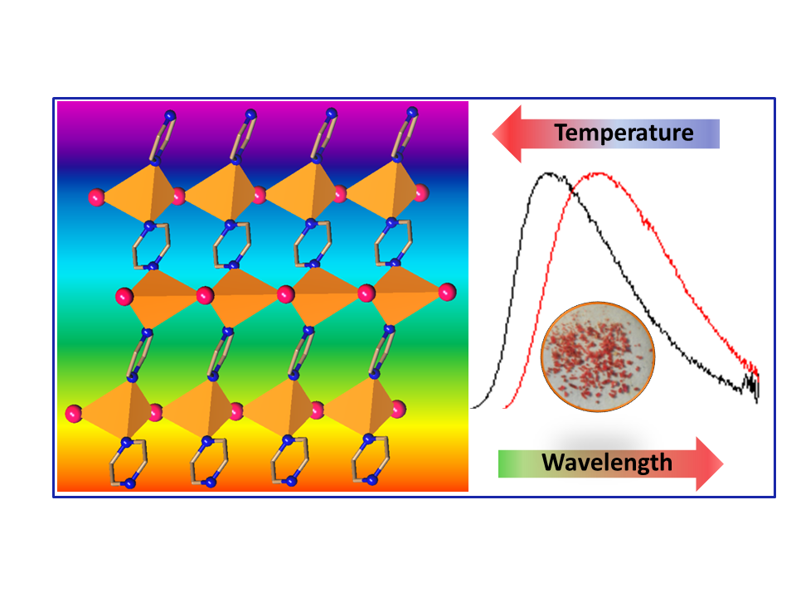
SYNOPSIS:

The so far elusive member of the row [CuX(pyz])_{n} X=Cl, Br, I for X=I was obtained and revealed a TADF behaviour in the solid state.

