Summary
- General experimental remarks
- Synthetic Details
2.0 Reference compound synopsis and general synthetic schemes
2.1 Synthesis of (benzodithiophen-2-ylmethyl)triphenylphosphonium bromide
2.2 Synthesis of E/Z−dithiaazaalkene 2
2.3 Synthesis of dithiaaza[7]helicene 1
2.4 Synthesis of E/Z−dithiaalkene 4
2.5 Synthesis of dithia[7]helicene 3
2.6 Synthesis of 2-aza[7]helicene 5
2.7 Synthesis of 2-aza[6]helicene 6
- NMR spectroscopy
3.1 ¹H and ¹³C APT NMR spectra of E-dithiaazaalkene 2
3.2 ¹H and ¹³C{¹H} NMR spectra of dithiaaza[7]helicene 1
3.3 ¹H and ¹³C APT NMR spectra of E-dithiaalkene 4
3.4 ¹H and ¹³C{¹H} NMR spectra of dithia[7]helicene 3
3.5 ¹H NMR spectrum of 2-aza[7]helicene 5
- UV-Vis spectroscopy
4.1 Comparison of UV-Vis molecular extinction coefficients for dithiaaza[7]helicene 1 and E−dithiaazaalkene 2
- Electrochemistry
5.1 Dithiaaza[7]helicene 1: CV potential scan rate effects
Experiment nr.1
Experiment nr.2
5.2 Dithiaazaalkene 2: CV potential scan rate effects
5.3 Dithia[7]helicene 3: CV potential scan rate effects
5.4 Dithiaalkene 4: CV synopsis, CV potential scan rate effects, DPV synopsis
5.5 2-Aza[7]helicene 5: CV potential scan rate effects
5.6 2-Aza[6]helicene 6: CV potential scan rate effects
5.7 Dithiaaza[7]helicene 1: electrodeposition and stability experiments
- On GC, in CH₃CN + 01 M TBAPF₆
b) On ITO, in CH₃CN + 01 M TBAPF₆
Experiment nr.1
Experiment nr.2
Experiment nr.3
c) On ITO, in CH₂Cl₂ + 01 M TBAPF₆
Experiment nr. 1
Experiment nr. 2
  - Dithia[7]helicene 3: electrodeposition and stability experiments
- On GC, in CH₃CN + 01 M TBAPF₆
Experiment nr.1
Experiment nr.2
Experiment nr.3
- On ITO, in CH₃CN + 01 M TBAPF₆
Experiment nr.1
Experiment nr.2
Experiment nr.3
Experiment nr.4
  - Dithiaalkene 4: electrodeposition experiment
On GC, in CH₃CN + 01 M TBAPF₆
  - 2-Aza[7]helicene 5: electrodeposition attempts
  - 2-Aza[6]helicene 6: electrodeposition attempt
  - Electrochemical Impedance spectroscopy EIS on a film obtained by dithiaza[7]helicene 1 electrodeposition
  - CV and DPV Comparisons (A) between open precursors and (B) among helicenes
- Chiral HPLC study on 2-aza[7]helicene 5

1. General experimental remarks
Compound preparation and basic characterizations
If not stated otherwise, commercially available compounds were used as received.
Synthetic protocols for new or non-commercial ones are detailedly reported at the following section.
Photochemical experiments were performed using a 125 W medium-pressure Hg immersion lamp equipped with a water-cooling quartz jacket and a Pyrex reactor. Column chromatography was performed using silica gel 60 (Macherey–Nagel, Sigma Aldrich; 70–230 mesh).
NMR spectra were recorded at 298 K using the Bruker AMX 300 and Avance Neo-400 spectrometers. Chemical shift values are referenced to (residual) solvent signals (¹H/¹³C{¹H}; CDCl₃: δ = 7.26/77.16, CD₃OD: δ = 3.31/49.00, DMSO-d₆: δ = 2.50/39.52). Resonance assignments were aided by ¹³C APT, ¹³C DEPT, ^{H, H}COSY, ^{H, C}HSQC, and ^{H, C}HMBC spectra. Melting points were determined with Stuart Scientific melting point apparatus and are uncorrected. Abbreviations: s = singlet; d = doublet; dd = doublet of doublets; Cq = quaternary carbon; eq = equivalent; M.p. = melting point; DBU: 1,5-diazabiciclo(5.4.0)undec-7-ene; DCM: methylene chloride
Mass spectra High-resolution ESI spectra were measured on a Waters Q-ToF SYNAPT G2-Si HDMS 8K spectrometer. MALDI-TOF/TOF spectra were recorded on Bruker Autoflex III spectrometer by using α-cyano-4-hydroxycinnamic acid (HCCA) or 4-hydroxy-3,5-dimethoxycinnamic acid (SA) as the matrix.
Absorption and emission spectroscopy studies
UV–vis absorption spectra were obtained on a Shimadzu UV–vis–NIR 3600 spectrophotometer in a 1 cm path length quartz cell.
Photoluminescence quantum yields (Φ_{PL}) were measured with a C11347 Hamamatsu Quantaurus - Absolute Photoluminescence Quantum Yield Spectrometer, equipped with a 150 W Xenon lamp, an integrating sphere, and a multi-channel detector.
Steady state emission and excitation spectra and photoluminescence lifetimes were obtained with a Edinburgh FLS 980 spectrofluorimeter. Continuous excitation for the steady state measurements was provided by a 450 W Xenon arc lamp. Emission spectra were corrected for the detector sensitivity. Photoluminescence lifetime measurements, determined by TCSPC (time-correlated single-photon counting) method, were performed using an Edinburgh Picosecond Pulsed Diode Laser EPL-375, in nitrogen degassed solutions (10⁻⁵-10⁻⁷ mol L⁻¹).
Electrochemistry studies
Cyclic voltammetry (CV) and differential pulse voltammetry (DPV) measurements as well as potentiodynamic electrodepositions and characterizations of electroactive films were performed using an AutoLab PGStat potentiostat managed by a PC with GPES software (and FRA software for electrochemical impedance spectroscopy recording) and a three-electrode glass minicell (working volume ∼3 cm³), including:
- as working electrode (i) a glassy carbon GC disk (Amel, embedded in Teflon®, S ∼ 0.071 cm², or Metrohm embedded in glass, S ∼ 0.0314 cm²), polished by synthetic diamond powder (1 μm Aldrich) on a wet cloth (Struers® DP-NAP), or (ii) transparent electrodes cut from ultraflat ITO slides (Kuramoto Co., Japan);
- as counter electrode a platinum wire;
- as reference electrode an aqueous calomel one, which was inserted in a compartment with the working medium CH₃CN (Aldrich) + 0.1 M TBAPF₆ (Aldrich), ending in a porous frit, to avoid contamination of the working solution by water and KCl traces. The recorded potentials were normalized vs the formal potential of the intersolvental ferricinium/ferrocene (FcH⁺|FcH) reference redox couple¹, recorded in the same conditions.
The CV features were studied as a function of scan rate (in many cases in the 0.1–20 V/s interval) on solutions in the 0.0001-0.001 M concentration range, previously deaerated by bubbling N₂ (previously passed through a presaturator filled with the operating solvent to keep solute concentration constant) and then keeping it above the solution while recording. Many partial CV recordings in both positive and negative direction were made to focus on selected peak features and to avoid reciprocal contamination by electron transfer products.
Ohmic drop compensation in CV studies was obtained by the positive feedback method.²
HOMO and LUMO energies were evaluated from first oxidation and first reduction peak potentials, respectively, by the following equations:³
E_{LUMO}(eV) ≈ 1e × [E_{p,Ic} /V(Fc⁺|Fc) + 4.8V(Fc⁺|Fc vs zero)]
E_{HOMO}(eV) ≈ 1e × [E_{p,Ia} /V(Fc⁺|Fc) + 4.8V(Fc⁺|Fc vs zero)]
Electrodeposition of conducting films was performed from racemic monomers in potentiodynamic mode without ohmic drop compensation, by repeated potential cycling (usually 12 cycles) around the first oxidation peak as shown in the Figures in the main paper and in this supporting information; then the filmed electrode was moved into a monomer-free solution performing 2-3 further potential cycles to evaluate the film stability and equilibrate it in the working medium eliminating monomer traces.
¹ G. Gritzner, J. Kuta, Recommendations on reporting electrode potentials in nonaqueous solvents (Recommendations 1983), Pure Appl. Chem. 1984, 56.
² A. J. Bard, L.R. Faulkner, Electrochemical Methods: Fundamentals and Applications, 2nd Edition, (2000) Wiley.
³ D. Malpicci, S. R. Araneo, S. Arnaboldi, E. Cariati, A. Forni, S. Grecchi, E. Lucenti, D. Marinotto, D. Maver, P. R. Mussini, Electrochemical insight on the nitrogen-rich, weakly aromatic cyclic triimidazole multifunctional system expanded with pyridine or thiophene terminals, Electrochim. Acta 2023, 469, 143117.
AFM imaging
AFM imaging was performed in air using a Nanoscope Multimode IIId system (Bruker, Santa Barbara, CA, USA) operating in tapping-mode.
Rectangular silicon probes with nominal spring constant around 2.5 N/m (NT-MDT, Russia) and cantilever length of 120 μm were used. The cantilever resonance frequency was about 130 kHz.
Images were recorded at ~1 Hz line rate and a resolution of 512x512 pixels per image was chosen.
AFM images were subject to a line-by-line subtraction of linear background to eliminate sample tilt from the images and correct for step-wise changes between individual scan lines.
The rms surface roughness has been calculated according to the following equation:
where Z_{average} is the average Z value within the examined area, Z_{x,y} is the local Z value, and N indicates the number of points within the area.
For both the samples the rms surface roughness has been measured on 200x200 nm² areas.
Rms data have been reported as mean ± SD, n = 20
2. Synthetic Details

2.0 Reference compound synopsis and general synthetic schemes

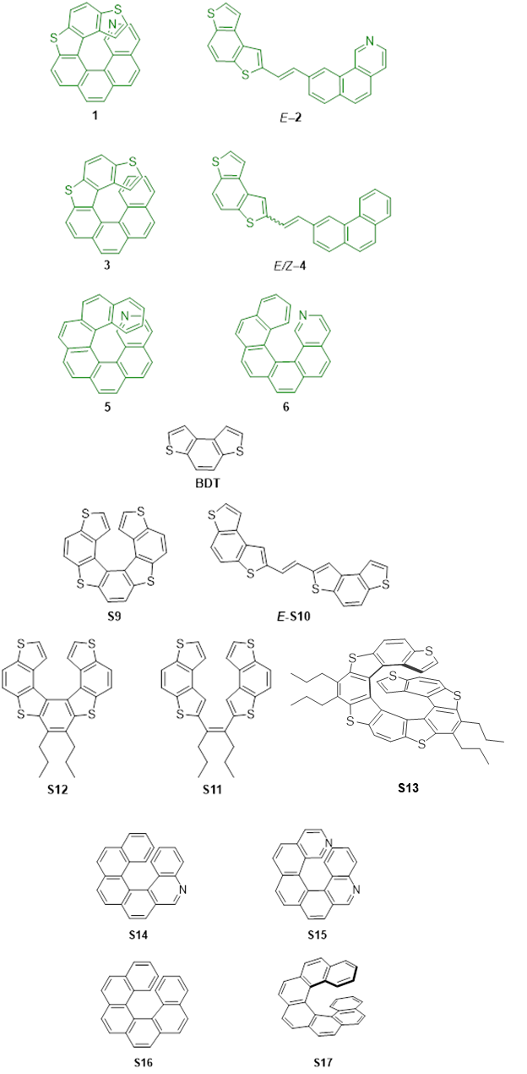
Chart S1

2.1 Synthesis of (benzodithiophen-2-ylmethyl)triphenylphosphonium bromide⁴⁻⁶

A 250-mL flask, equipped with a reflux condenser, was charged with benzodithiophen-2-ylmethanol⁶ (2.06 g, 9.35 mmol), PPh₃HBr (5.45 g, 15.9 mmol, 1.7 eq) and CHCl₃ (50 mL). The resulting mixture was heated to reflux for 5 h. A white suspension was obtained. After cooling to r.t., the reaction mixture was filtered and the precipitate was washed with CHCl₃ and Et₂O. S1 was obtained as a white solid and it was proved to be the desired compound by NMR analysis (5.00 g, 9.17 mmol; y = 98%).

¹H NMR (300 MHz, DMSO): δ = 7.14-6.69 (m, 7H), 6.99-6.82 (m, 11H), 6.83 (d, ³J(H,H) = 5.3 Hz, 1H), 6.69 (d, ³J(H,H) = 3.2 Hz, 1H), 4.89 (d, ²J(H,P) = 15.1 Hz, 2H; H-1).
¹³C{¹H}NMR (75 MHz, CDCl₃): δ = 136.40, 136.31, 135.36 (CH phenyl), 133.96 (d, J(C,P) = 10.2 Hz; CH phenyl), 133.33, 130.28 (d, J(C,P) = 12.5 Hz; CH phenyl), 128.43, 125.63, 125.51, 121.88, 119.74, 118.53, 118.24, 117.10, 25.09 (d, J(C,P) = 50.6 Hz; C-9).
³¹P{¹H}NMR (121.5 MHz, CDCl₃): δ = 21.6.

⁴ P. G. Lehman and H. Wynberg, Reel. Trae. Chim. Pays-Bas, 1971, 90, 1113
⁵ H. Dopper, D. Oudman, H. Wynberg, J. Am. Chem. Soc., 1973, 95, 3692.
⁶ T. Caronna, M. Catellani, S. Luzzati, L. Malpezzi, S. V. Meille, A. Mele, C. Richter, R. Sinisi, Chem. Mater., 2001, 13, 3906.

2.2 Synthesis of the E/Z−dithiaazaalkene 2

A 100-mL flask, equipped with a reflux condenser, was charged with benzo[h]isoquinoline-9-carbaldehyde⁷ (330 mg, 1.59 mmol), the phosphonium salt S1 (956 mg, 1.75 mmol, 1.1 eq) and CHCl₃ (20 mL). A solution of DBU (0.26 mL, 1.1 eq) in CHCl₃ (5 mL) was then added and the resulting mixture was heated to reflux and stirred for 6 h. The solvent was evaporated at reduced pressure, the residue taken up with CH₂Cl₂ and washed with water until neutral pH. After separation of the two layers, the organic phase was dried over Na₂SO₄, and the solvent evaporated. The crude product (brown solid) was purified via column chromatography on silica gel (n-hexane/ethyl acetate 1:1), yielding an equimolar mixture of the E/Z isomers of 2 (500 mg, 1.27 mmol; y = 80%). Pure E-isomer of 2 was obtained as yellow solid by precipitation from a saturated CH₂Cl₂/n-pentane (1:2) solution.

Characterization data of E-2:
¹H NMR (400 MHz, CDCl₃): δ = 10.10 (s, 1H), 8.82 (s, 1H), 8.72 (d, ³J(H,H) = 5.4 Hz, 1H), 7.94-7.87 (m, 3H), 7.82 (d, J = 8.6 Hz, 1H), 7.75 (d, ³J(H,H) = 8.6 Hz, 1H), 7.74-7.64 (m, 4H), 7.65 (d, ³J(H,H) = 6 Hz, 1H), 7.60-7.57 (m, 1H), 7.31 (d, ³J(H,H)_{trans} = 16 Hz, 1H).
¹³C{¹H} NMR (101 MHz, CDCl₃): δ = 146.82 (CH), 145.30 (CH), 143.09 (Cq), 136.94 (Cq), 136.41 (Cq), 135.92 (Cq), 135.28 (Cq), 134.62 (Cq), 132.06 (Cq), 131.55 (CH), 130.42 (CH), 129.90 (Cq), 129.55 (CH), 126.99 (CH), 125.12 (CH), 125.10 (CH), 123.88 (CH), 122.09 (CH), 121.99 (CH), 121.45 (CH), 120.87 (CH), 119.61 (CH), 118.68 (CH). Two Cq resonances were not observed.
MS (ESI+): Calculated m/z for [C₂₅H₁₅NS₂]+: 393.06 found 394.26 [M+H]⁺.

⁷ S. Abbate, C. Bazzini, T. Caronna, F. Fontana, C. Gambarotti, F. Gangemi, G. Longhi, A. Mele, I. N. Sora, W. Panzeri. Tetrahedron, 2006, 62, 139.

2.3 Synthesis of dithiaaza[7]helicene 1

A stirred solution of E/Z mixture of dithiaazaalkene 2 (60 mg, 0.15 mmol) and a catalytic amount of I₂ (0.2 eq) in AcOEt (500 mL) was irradiated for 2h with a 125 W medium-pressure Hg lamp. The reaction progress was monitored by ¹H NMR. The solvent was evaporated under reduced pressure and the residue was purified via column chromatography on silica gel (n-hexane/AcOEt 7:3). A yellow solid was obtained and it was proved to be the desired compound by NMR and mass analysis (20 mg, 0.051 mmol; y = 34%).
¹H NMR (400 MHz, CDCl₃): δ = 8.97 (s, 1H; H-21), 8.22 (d, J(H,H) = 8.5 Hz, 1H; H-16; overlapped with H-12/H-13), 8.20 (d, J(H,H) = 8.3 Hz, 1H; H-12/H-13; overlapped with H-16), (8.16 (d, ³J(H,H) = 5.4 Hz, 1H; H-19; overlapped with H-4), 8.14 (d, ³J(H,H) = 8.3 Hz, 1H; H-4; overlapped with H-19), 8.08 (d, ³J(H,H) = 8.3 Hz, 1H; H-5), 8.01 (d, ³J(H,H) = 8.3 Hz, 1H; H-12/H-13), 7.93 (d, J(H,H) = 8.5 Hz, 1H; H-15; overlapped with H-9/H-10), 7.91 (d, J(H,H) = 8.5 Hz, 1H; H-9/H-10; overlapped with H-15), 7.89 (d, J(H,H) = 8.5 Hz, 1H; H-9/H-10), 7.56 (d, ³J(H,H) = 5.4 Hz, 1H; H-18), 6.67 (d, ³J(H,H) = 5.6 Hz, 1H; H-1), 5.75 (d, ³J(H,H) = 5.6 Hz, 1H; H-2).
¹³C{¹H} NMR (101 MHz, CDCl₃): δ = 149.07 (CH, C-21), 143.59 (CH, C-19), 139.86 (Cq, C-6), 137.08 (Cq, C-3), 136.15 (Cq, C-8), 134.88 (Cq, C-17), 134.36 (Cq, C-3a), 132.22 (Cq, C-8a), 131.47 (Cq, C-14), 131.30 (Cq), 131.25 (Cq), 130.97 (CH, C-16), 128.38 (CH, C-5), 126.74 (CH, C-4), 126.12 (CH, C-15 + C-12/C-13), 125.69 (Cq), 125.28 (Cq, C-17a), 124.25 (CH, C-1), 124.06 (Cq, C-6a), 123.61 (CH, C-2), 122.22 (CH, C-12/C-13), 121.58 (CH, C-9/C-10), 119.85 (CH, C-18), 119.10 (CH, C-9/C-10).
HRMS (ESI+): calculated for C₂₅H₁₄NS₂ 391.0489, found 392.0569 [M+H]⁺.
M.p. = 215 °C (dec).

2.4 Synthesis of E/Z−dithiaalkene 4
See section 2.1 for the synthesis of S1.
A 100-mL flask, equipped with a reflux condenser, was charged with S1 (300 mg, 0.53 mmol, 1.1 eq), 3-phenanthrenecarboxaldehyde⁸ (100mg, 0.48 mmol, 1 eq), and CHCl₃ (30 mL). The resulting suspension was treated with DBU (150 mg, 0.98 mmol, 2 eq), heated to reflux and stirred for 5h. The reaction mixture was therefore allowed to cool to r.t. and stirred overnight. The reaction progress was monitored by TLC (n-hexane/ CH₂Cl₂ 1:1). Water (50 mL) was added and the two layers were separated and the aqueous phase was extracted with CH₂Cl₂ (3 × 40 mL). The combined organic phases were washed with water (2 × 30 mL), dried over Na₂SO₄ and filtered. The solvent was evaporated and the crude product (brown solid) was purified via column chromatography on silica gel (CH₂Cl₂). 4 was isolated in 95% yield as a mixture of E/Z isomers.
Pure E-isomer of 4 was obtained as a pale-yellow solid by treatment of the mixture of E/Z isomers with Et₂O.

Characterization data of E-4:
¹H NMR (300 MHz, DMSO): δ = 9.08 (s, 1H), 8.98 (d, J = 8.2 Hz, 1H), 8.04 (d, J = 11.5 Hz, 2H), 8.01 – 7.91 (m, 7H), 7.85 (s, 2H), 7.77-7.67 (m, 2H), 7.43 (d, ³J(H,H)_{trans} = 16.1 Hz, 1H).
¹³C{¹H} NMR (75 MHz, DMSO): δ = 143.09 (Cq), 136.32 (Cq), 134.98 (Cq), 134.88 (Cq), 134.22 (Cq), 131.90 (Cq), 131.38 (Cq), 130.69 (CH), 130.11 (Cq), 129.80 (Cq), 129.03 (CH), 128.57 (CH), 128.10 (CH), 127.06 (CH), 127.02 (CH), 126.91 (CH), 126.54 (CH), 124.42 (CH), 123.17 (CH), 123.04 (CH), 122.34 (CH), 122.14 (CH), 122.12 (CH), 119.61 (CH), 118.72 (CH). One Cq resonance not detected.
MS (ESI+): calculated for C₂₆H₁₆S₂ 392.07, found 392.27.

⁸ M. Samal, L. Sturm, M. Banasiewicz, I. Deperasinska, B. Kozankiewicz, O. Morawski, Y. Nagata, P. Dechambenoit, H. Bock, A. Rossel, M. Buděšínský, A. Boudier, A. Jančařík, Chem. Sci. 2024, 15, 9842.

2.5 Synthesis of dithia[7]helicene 3

A stirred solution of E/Z mixture of dithiaalkene 4 (100 mg, 0.25 mmol) and a catalytic amount of I₂ (0.2 eq) in AcOEt (150 mL) was irradiated for 6h with a 125 W medium-pressure Hg lamp. The reaction progress was monitored by ¹H NMR. The solvent was evaporated under reduced pressure and the residue was purified via column chromatography on silica gel (n-hexane/CH₂Cl₂ 2:1). A pale-yellow solid (45 mg) was obtained. The solid was suspended and stirred in AcOEt (0.5 mL) and then filtered. This treatment was repeated for 3 times. The yellow solid thus obtained (30 mg, y = 30%) was proved to be the dithiahelicene 3 by NMR and mass analysis.
¹H NMR (300 MHz, CDCl₃): δ = 8.20-8.00 (m, 6H; H-9/H-10, H-12/H-13, H-15/H-16), 7.93 (d, J(H,H)= 8.5 Hz, 1H; H-5/H-6), 7.87 (d, J(H,H) = 8.5 Hz, 1H; H-5/H-6), 7.80 (d, J(H,H) = 7.8 Hz, 1H; H-18/H-21), 7.62 (d, J(H,H)= 8.5 Hz, 1H; H-18/H-21), 7.17 (t, J(H,H)= 7.5 Hz, 1H; H-19/H-20), 6.62 (d, J(H,H) = 5.7 Hz, 2H; H-1), 6.59 (t, J(H,H) = 7.8 Hz, 1H; H-19/H-20, partly overlapped with H-1), 5.74 (d, J(H,H) = 5.6 Hz, 1H; H-2).
¹³C{¹H} NMR (75 MHz, CDCl₃): δ = 139.06 (Cq), 136.48 (Cq), 135.33 (Cq), 135.29 (Cq), 132.16, (Cq), 131.95 (Cq), 131.86 (Cq), 131.35 (Cq), 131.27 (Cq), 130.56 (Cq), 128.19 (CH), 127.54 (CH), 127.40 (C-18/C-21), 126.83 (CH), 126.71 (Cq) 126.61 (C-18/C-21), 126.30 (CH), 126.10 (CH), 125.94 (C-19/C-20), 124.96 (Cq), 124.73 (C19/C-20), 124.04 (C1) 123.77 (C2), 121.23 (CH), 120.88 (C-5/C-6), 118.60 (C-5/C-6).

MS (ESI+): calculated for C₂₆H₁₄S₂, 390.05, found: 390.56.

2.6 Synthesis of 2-aza[7]helicene 5
Benzo[h]isoquinoline-9-carbaldehyde (319,13 mg, 1.54 mmol)⁹ and t-BuOK (271.54 mg, 2.42 mmol) were added to a solution of phosphonium salt of 3-(bromomethyl)phenanthrene⁹ (896.22 mg, 1.21 mmol) in CH₃CN (15 mL). The mixture was refluxed for 24 hrs. The solvent was then evaporated, water (30 mL) was added and the product extracted with AcOEt (2 × 30 mL); the organic phase was dried and the solvent removed. The product was purified by flash chromatography on silica gel (eluent: hexane/ethyl acetate, 1:1). The diarylethene 7 was obtained as a mixture of Z and E isomers (93 mg, 0.24 mmol, y = 10%)
MS (ESI+): calculated for C₂₉H₁₉N 381.15, found 382.10 [M+H]⁺.
The diarylethene 7 was then dissolved in AcOEt and a catalytic amount of I₂ was added; the mixture was then irradiated with UV light (365 nm) under stirring for 5 hrs. The solvent was evaporated and the crude was purified by flash chromatography on silica gel with eluent hexane/AcOEt 1:1, thus isolating 2-aza[7]helicene 5.
MS (ESI+): calculated for C₂₉H₁₇N: 379.14; found 380.10 [M+H]⁺.
¹H NMR (400 MHz, CD₃OD) δ 8.30 (s, 1H), 8.20-8.00 (m, 7 H), 7.83 (d, ³J = 8.0 Hz, 1 H), 7.76 (d, ³J = 4.0 Hz, 1 H), 7.57 (d, ³J = 8.0 Hz, 1 H), 7.55 (d, ³J = 4.0 Hz, 1 H), 7.36 (d, ³J = 8.0 Hz, 1 H), 7.25 (d, ³J = 4.0 Hz, 1 H), 7.08 (d, ³J = 8.0 Hz, 1 H), 6.91 (t, ³J = 8.0 Hz, 1H), 6.39 (t, ³J = 8.0 Hz, 1H).
¹³C DEPT-135 NMR (100 MHz, CD₃OD) δ 146.62 (s, CH), 142.17 (s, CH), 132.45 (s, CH), 129.42 (s, CH), 129.24 (s, CH), 129.02 (s, CH), 128.71 (s, CH), 128.53 (s, CH), 128.29 (s,2CH), 128. 20 (s,2CH), 128.08 (s, CH), 127.46 (s, CH), 126.35 (s, 2 CH), 125.38 (s, CH), 125.03 (s, CH), 121.23 (s, CH).
⁹ S. Abbate, C. Bazzini, T. Caronna, F. Fontana, C. Gambarotti, F. Gangemi, G. Longhi, A. Mele, I. Natali Sora, W. Panzeri, Monoaza[5]helicenes. Part 2: Synthesis, characterisation and theoretical calculations, Tetrahedron 2006, 62, 139.
2.7 Synthesis of 2-aza[6]helicene 6
This molecule was already described in the literature^{10,11}; however in this work it has been prepared through a different synthetic approach, similar to the one described in ¹² .
2-methylbenzo[c]phenanthrene (506.4 mg, 2.09 mmol) was added to a solution of NBS (578 mg, 3.14 mmol) with a catalytic amount of benzoyl peroxide in CCl₄ (15 mL), and refluxed overnight. The succinimide byproduct was filtered and the solvent evaporated to give bromomethylbenzophenanthrene; the latter was dissolved in toluene (85 mL) with addition of triphenylphosphine (548.2 mg, 2.09 mmol). The reaction mixture was heated at 100 °C for 2 days, yielding a brownish precipitate of phosphonium salt (264 mg, 0.45 mmol). The 4-pyridine carboxaldehyde (49 mg, 0.45 mmol) and t-BuOK (0,9 mol) were added to a solution of phosphonium salt in methanol (5 mL) and the mixture was refluxed overnight. After the reaction completion the solvent was evaporated, water (10 mL) was added, and the product was extracted with AcOEt (3 × 20 mL); the organic phase was dried and the solvent removed. The product was purified by flash chromatography on silica gel (eluent hexane/AcOEt, 1:1). The diarylethene, obtained as a mixture of Z and E isomers (89 mg, 0.27 mmol), was dissolved in AcOEt (37 mL) with a catalytic amount of I₂, and the mixture was irradiated with UV light (365 nm) under stirring for 5 hrs. The solvent was evaporated and the crude was purified by flash chromatography on silica gel (eluent: hexane/AcOEt, 1:1). 2-Aza[6]helicene 6 was isolated and checked by ¹H NMR.

¹⁰ Mišek, J.; Teplý, F.; G. Stara,I.G.; Tichý, M.; Šaman, D.; Císařová, I.; Vojtšek, P.; Starý, I. A Straightforward Route to Helically Chiral N-Heteroaromatic Compounds: Practical Synthesis of Racemic 1,14-Diaza[5]helicene and Optically Pure 1- and 2-Aza[6]helicenes, Angew. Chem. Int. Ed. 2008, 47, 3188.
¹¹ J. Storch, J. Čermák, J. Karban, I. Císařová, J. Sýkora, Synthesis of 2-Aza[6]helicene and Attempts To Synthesize 2,14-Diaza[6]helicene utilizing Metal-Catalyzed Cycloisomerization, J. Org. Chem. 2010, 75, 3137.
¹² F. Fontana, B. Bertolotti, S. Grecchi, P.R. Mussini, L. Micheli, R. Cirilli, M.Tommasini, S. Rizzo 2,12-Diaza[6]helicene: An Efficient Non-Conventional Stereogenic Scaffold for Enantioselective Electrochemical Interphases Chemosensors 2021, 9, 216.

3. NMR spectra
3.1. ¹H and ¹³C APT NMR spectra of E-dithiaazaalkene 2
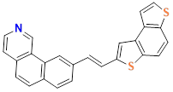
Figure S1. ¹H NMR spectrum of E−dithiaazaalkene 2 (CDCl₃, 400 MHz).
Figure S2. ¹³C APT NMR spectrum of E−dithiaazaalkene 2 (CDCl₃, 101 MHz).

3.2. ¹H and ¹³C{¹H} NMR spectra of dithiaaza[7]helicene 1
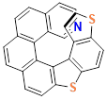
Figure S3. ¹H NMR spectrum of dithiaaza[7]helicene 1 (CDCl₃, 400 MHz).

Figure S4. ¹³C{¹H} NMR spectrum of dithiaaza[7]helicene 1 (CDCl₃, 101 MHz).

3.3. ¹H and ¹³C APT NMR spectra of E-dithiaalkene 4
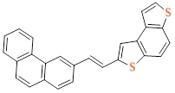
Figure S5. ¹H NMR spectrum of E/Z−dithiaalkene 4 (DMSO, 300 MHz).
Figure S6. ¹³C APT NMR spectrum of E/Z−dithiaalkene 4 (DMSO, 75 MHz).

3.4. ¹H and ¹³C{¹H} NMR spectra of dithia[7]helicene 3
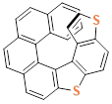
Figure S7. ¹H NMR spectrum of dithia[7]helicene 3 (CDCl₃, 400 MHz).
Figure S8. ¹³C{¹H} NMR spectrum of dithia[7]helicene 3 (CDCl₃, 101 MHz).

3.5 ¹H NMR spectrum of 2-aza[7]helicene 5
Figure S9. ¹H NMR spectrum of 2-aza[7]helicene 5 (CD₃OD, 400 MHz).

4. UV-Vis spectroscopy
4.1 Comparison of UV-Vis molecular extinction coefficients
for dithiaaza[7]helicene 1 and dithiaazaalkene 2
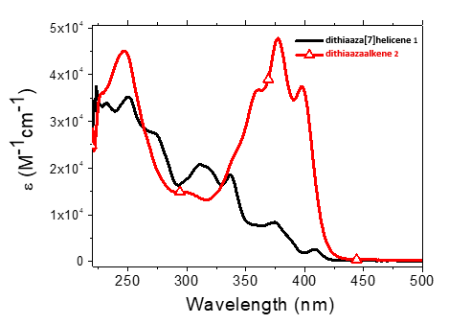
Figure S10.

5. Electrochemistry
5.1 Dithiaaza[7]helicene 1: CV potential scan rate effects
Experiment Nr. 1
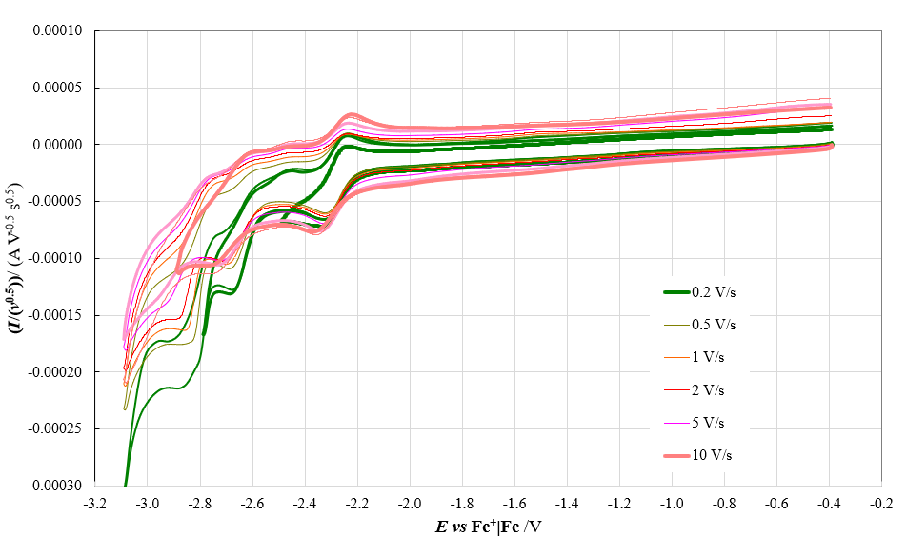
a)
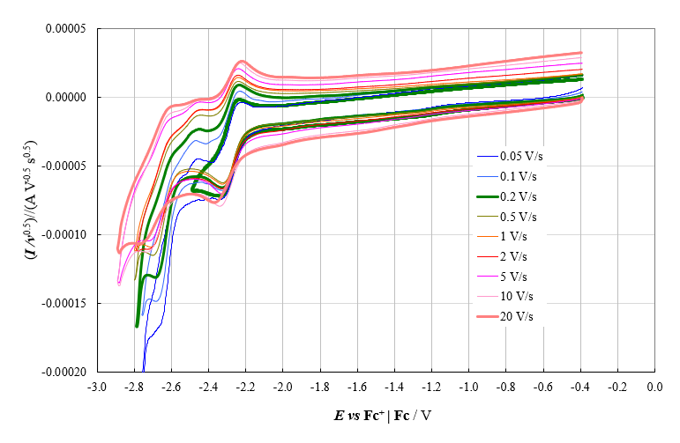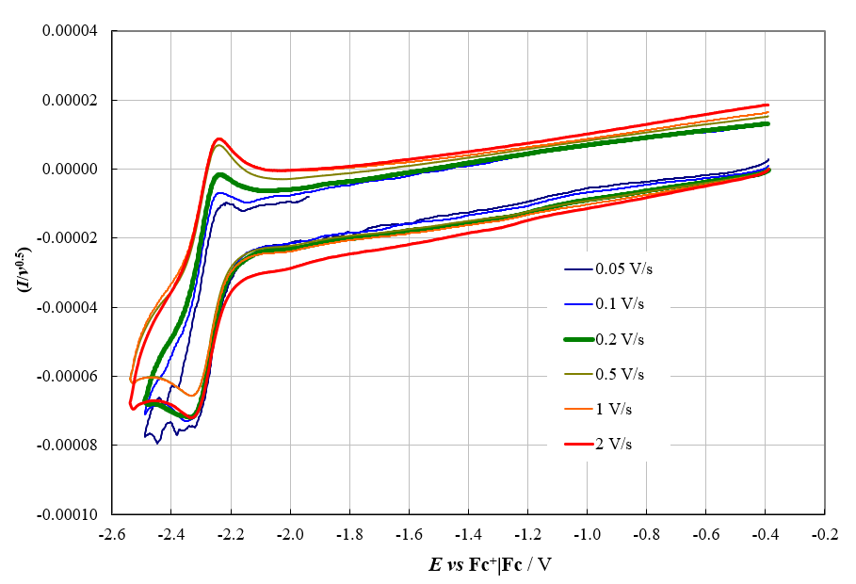
c)
b)
Figure S11.
Experiment Nr. 2
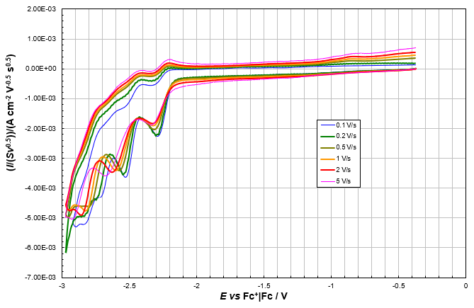
a)
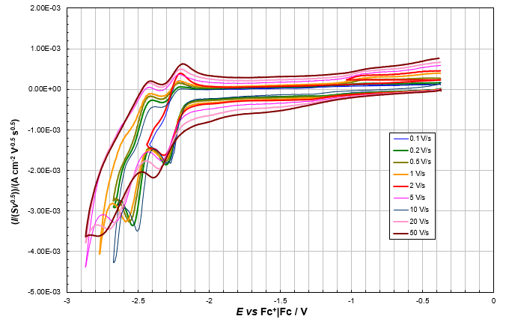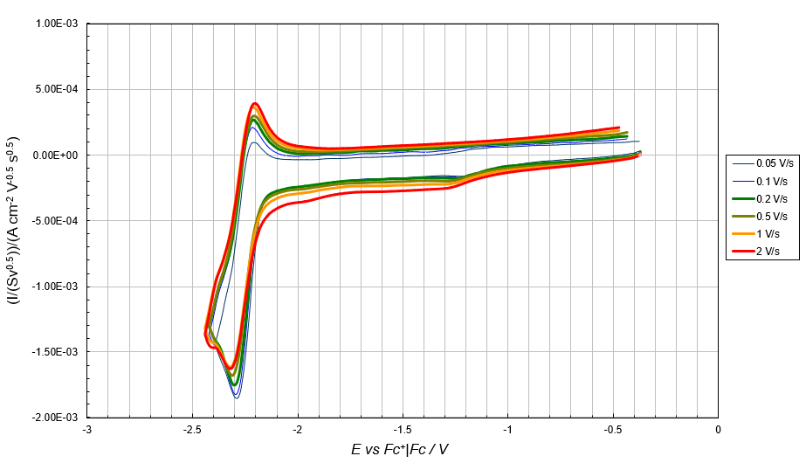
c)
b)
Figure S12.
5.2 Dithiaazaalkene 2: CV potential scan rate effects
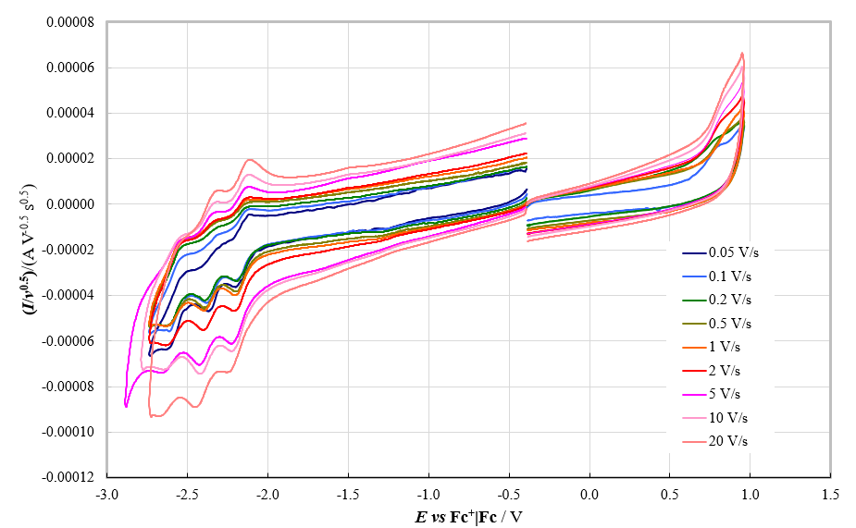
Figure S13.

5.3 Dithia[7]helicene 3: CV potential scan rate effects
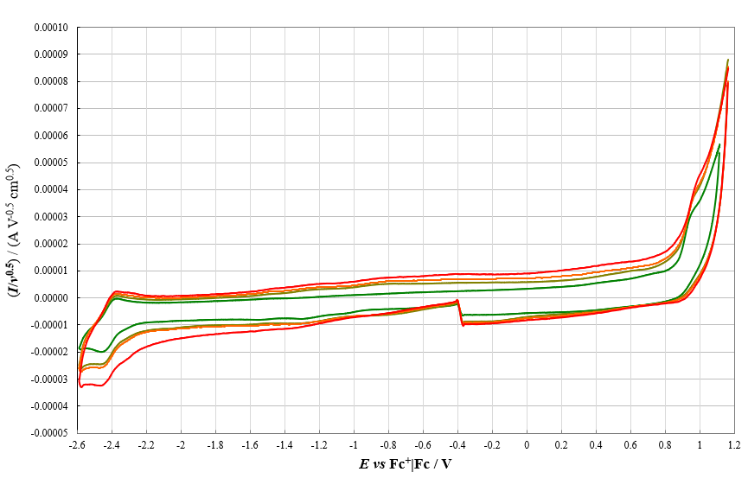
a)
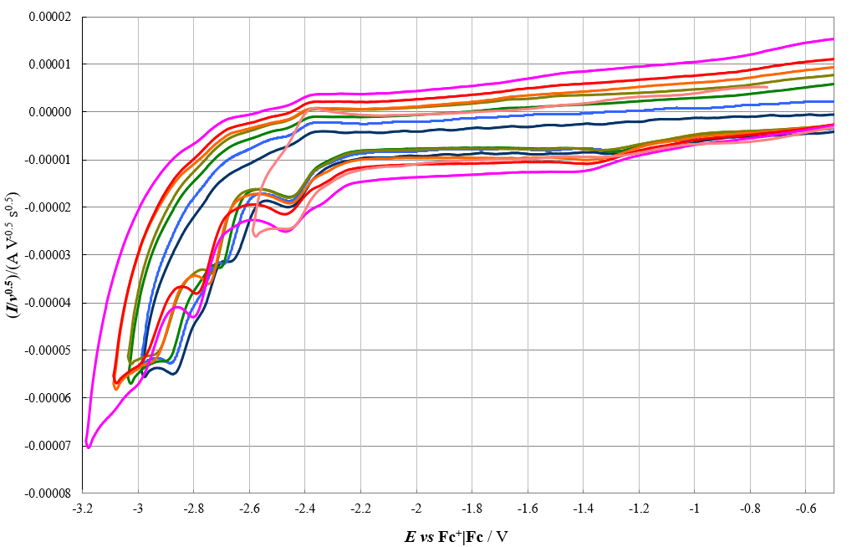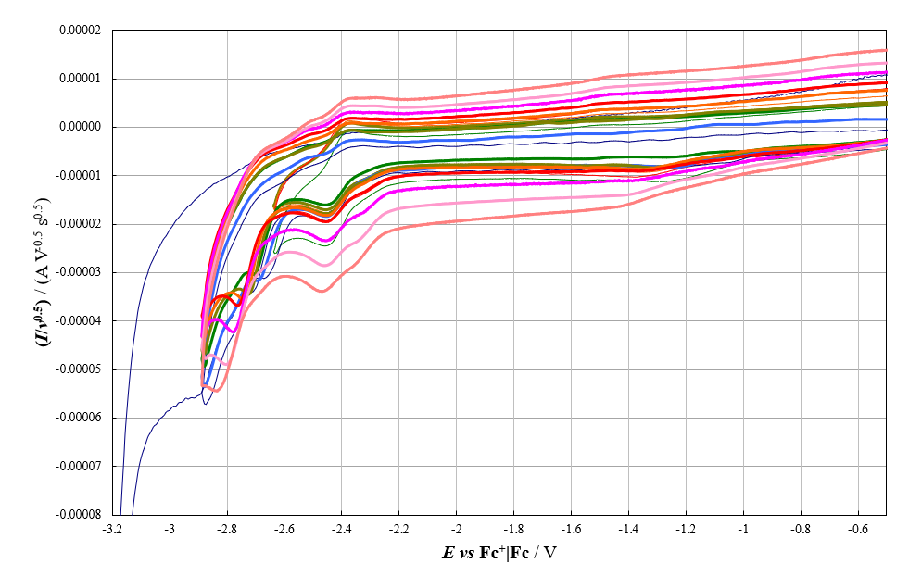
c)
b)
Figure S14.

5.4 Dithiaalkene 4: CV and DPV synopsis and CV potential rate effects
a)
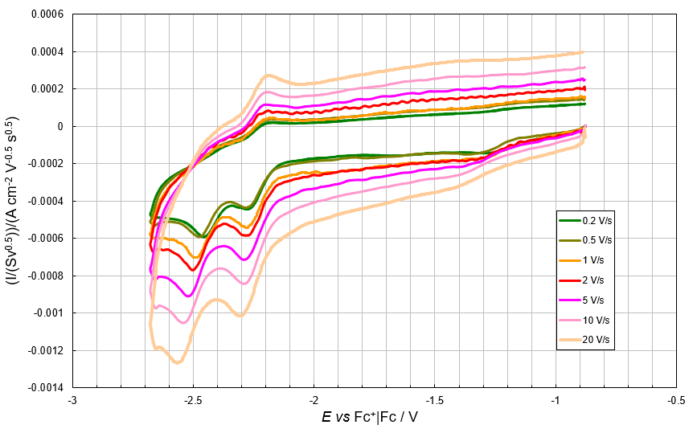
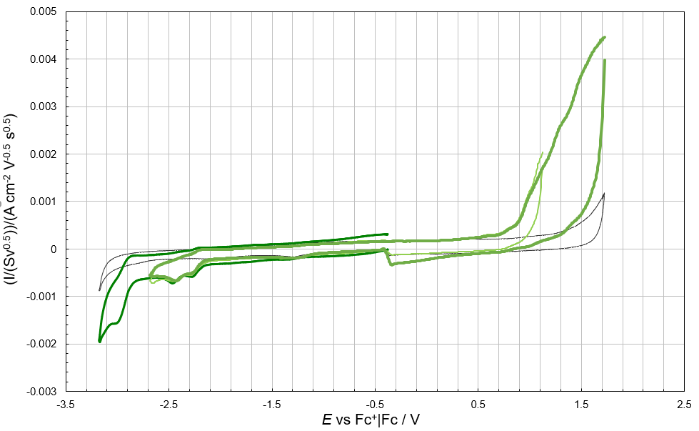
b)
c)
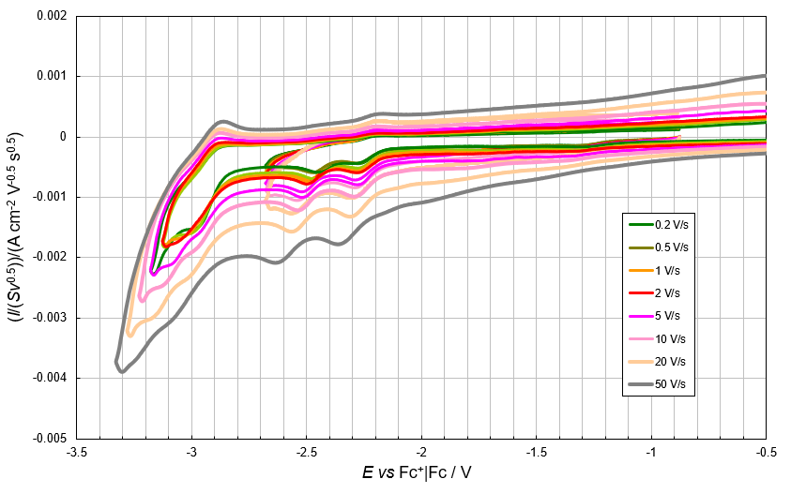
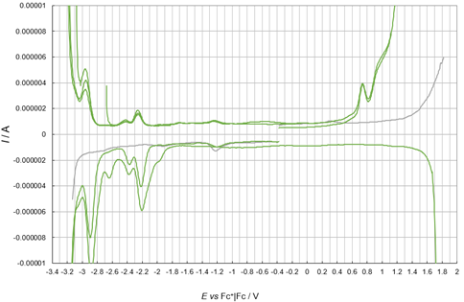
d)
Figures S15.

5.5 2-Aza[7]helicene 5: CV potential rate effects

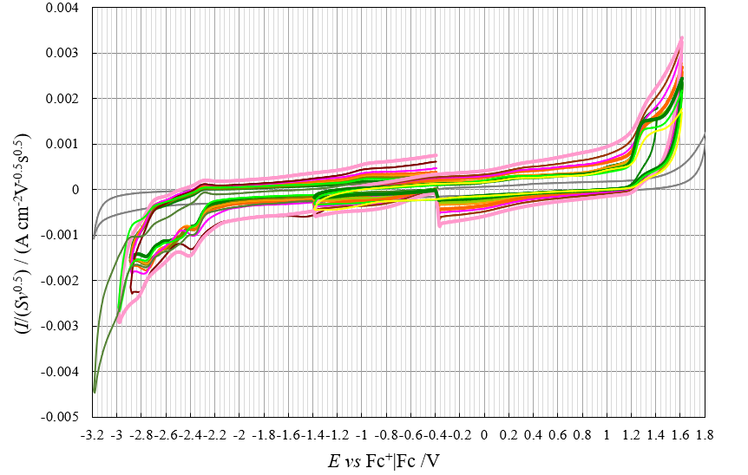
Figure S16.

5.6 2-Aza[6]helicene 6: CV potential scan rate effects

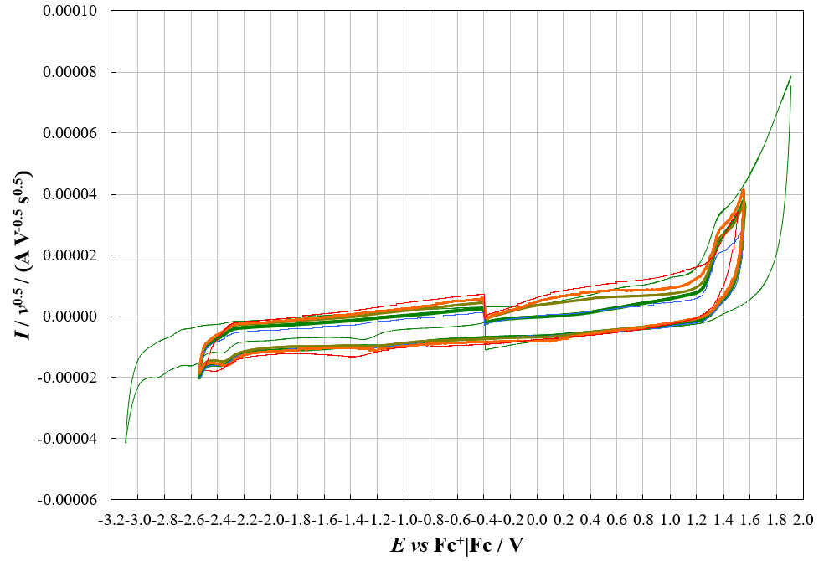
a)

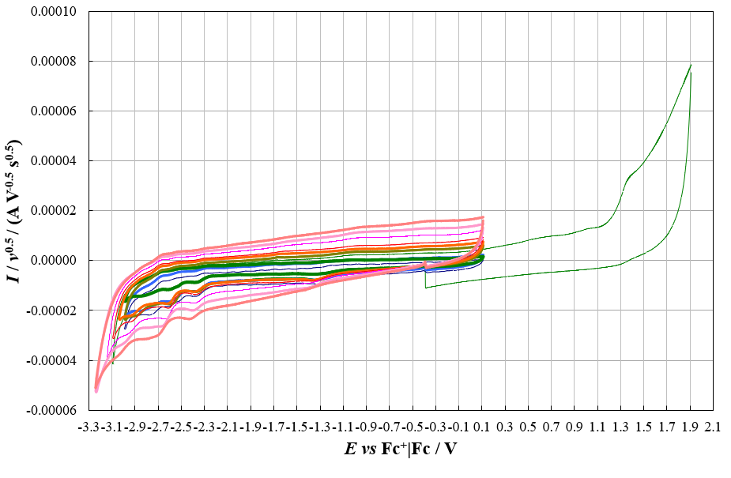
b)

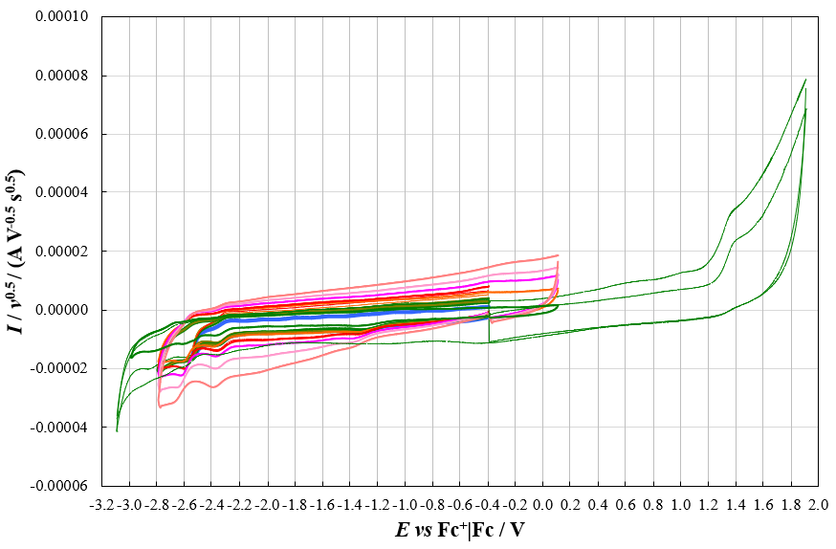
c)
Figure S17.

  - Dithiaaza[7]helicene 1: electrodeposition and stability experiments
- On GC, in CH₃CN + 01 M TBAPF₆

Electrodeposition cycles
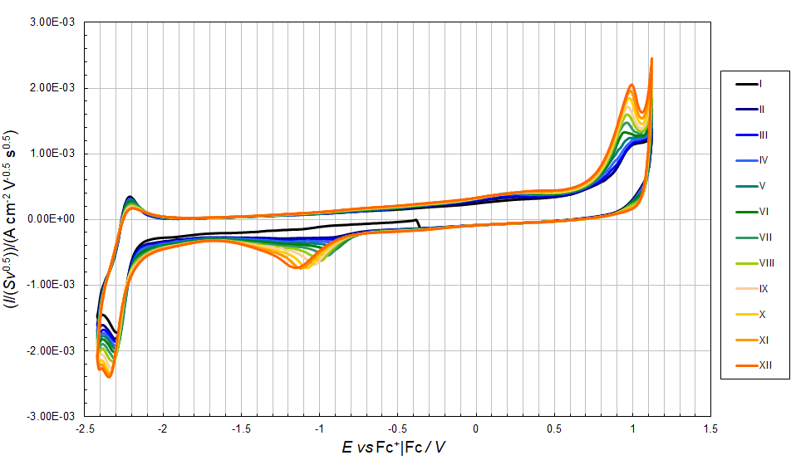
a)
Stability cycles
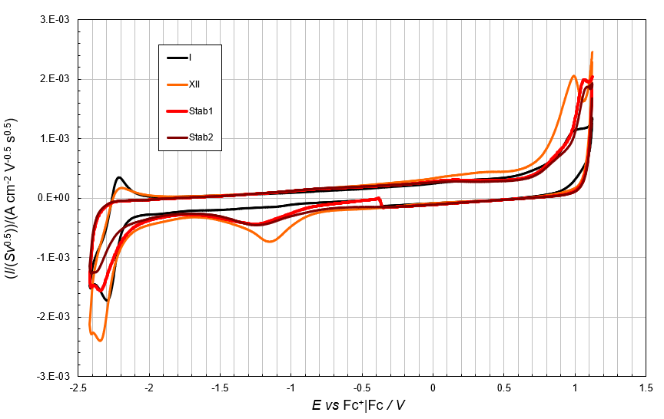
b)
Figure S18.

b) On ITO, in CH₃CN + 01 M TBAPF₆
Experiment nr. 1
Electrodeposition cycles
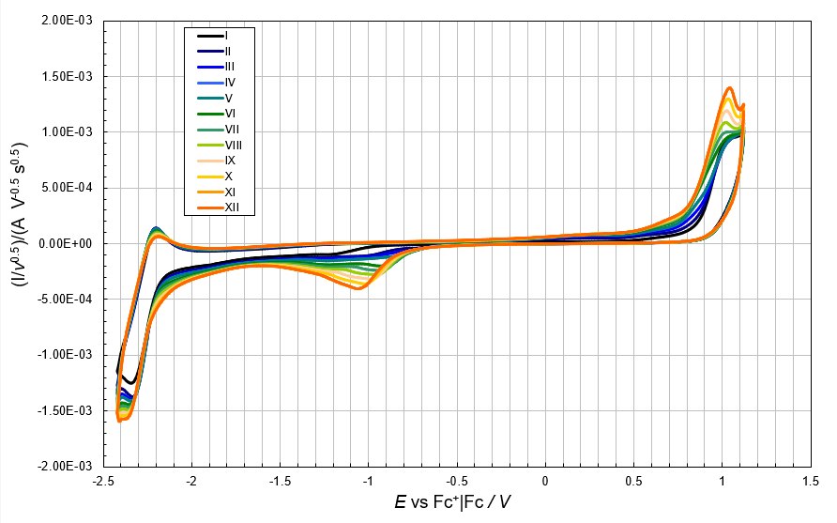
a)
Stability cycles
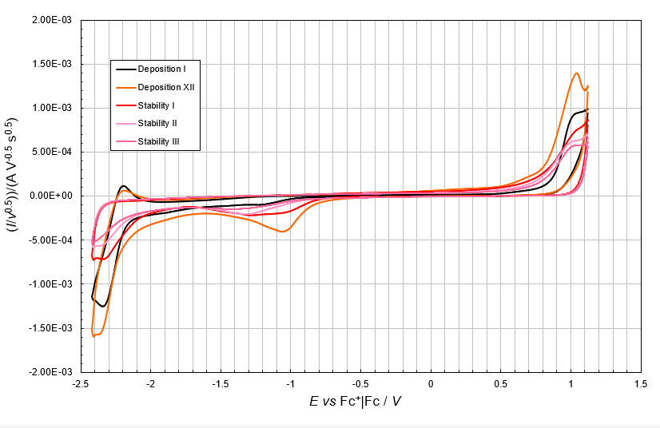
b)
Figure S19.

Experiment nr. 2
Electrodeposition cycles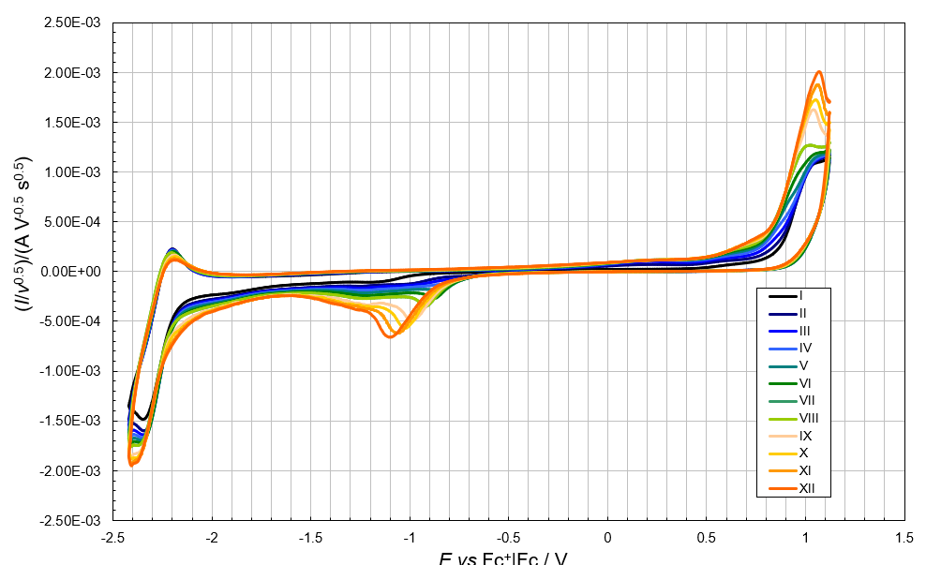
a)

Stability cycles
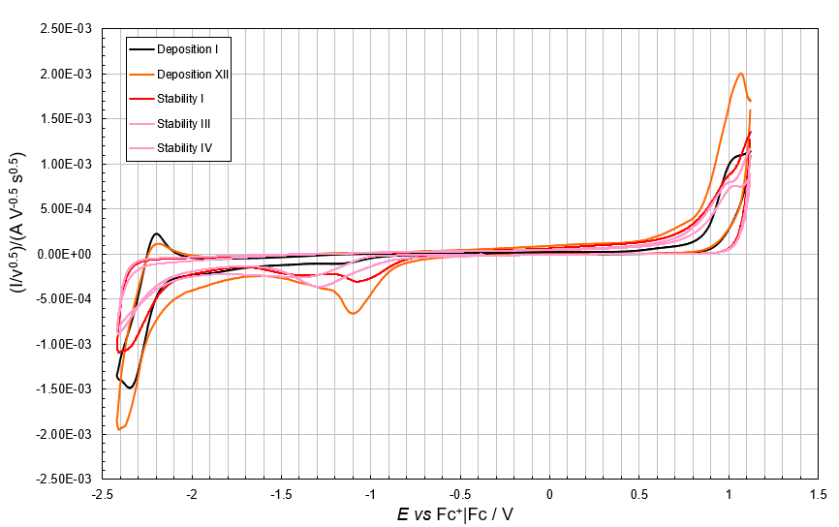
b)
Figure S20.

Experiment nr. 3
Electrodeposition cycles
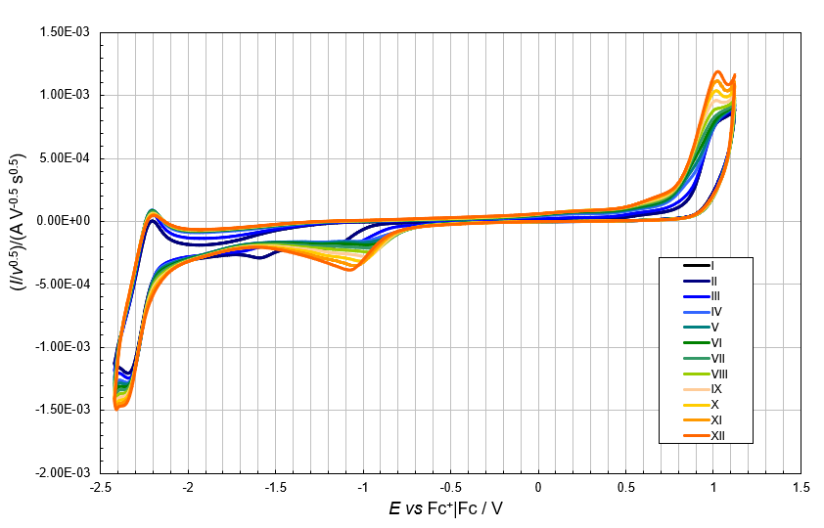
a)

Stability cycles
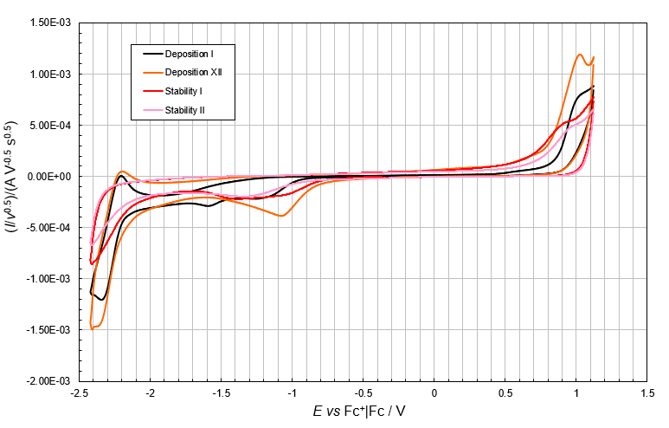
b)
Figure S21.

- On ITO, in CH₂Cl₂ + 01 M TBAPF₆

Experiment nr. 1
Electrodeposition cycles
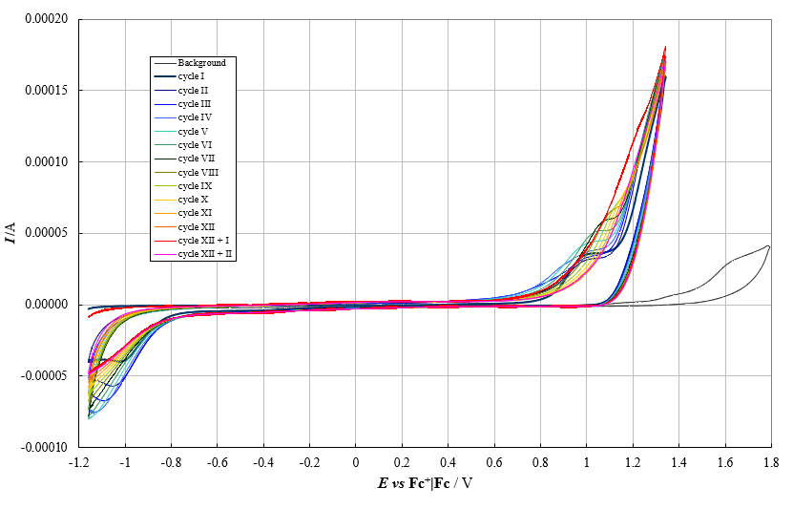
a)
Stability Cycles
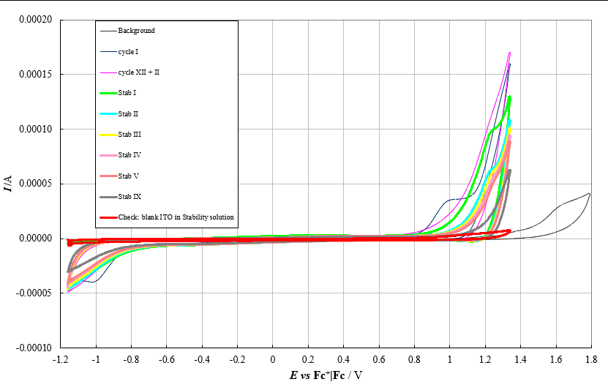
b)
Figure S22.

Experiment nr. 2
Electrodeposition cycles
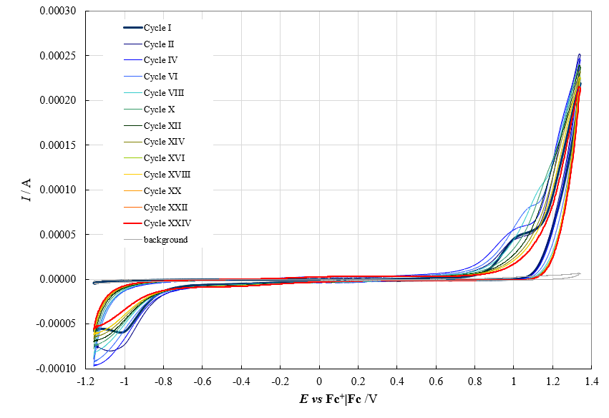
a)
Stability Cycles
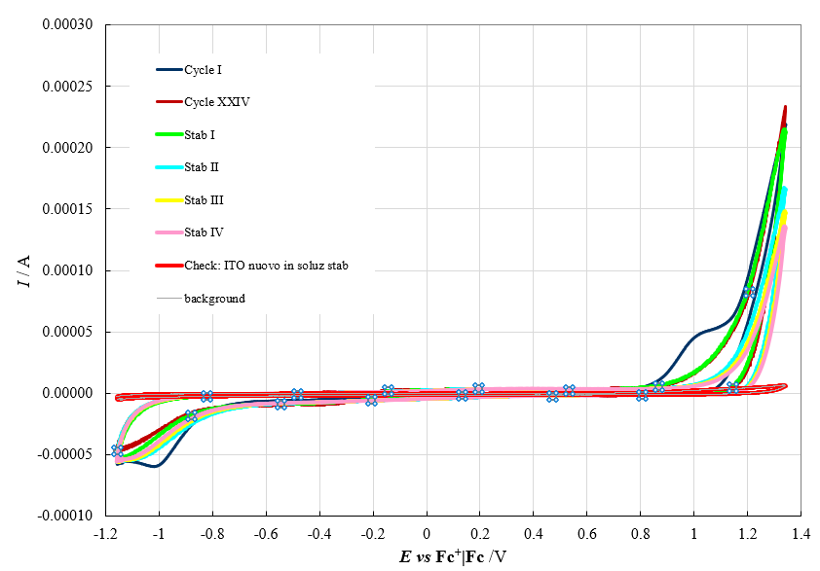
b)
Figures S23.

  - Dithia[7]helicene 3: electrodeposition and stability experiments

- On GC, in CH₃CN + 01 M TBAPF₆

Experiment nr. 1
Electrodeposition cycles

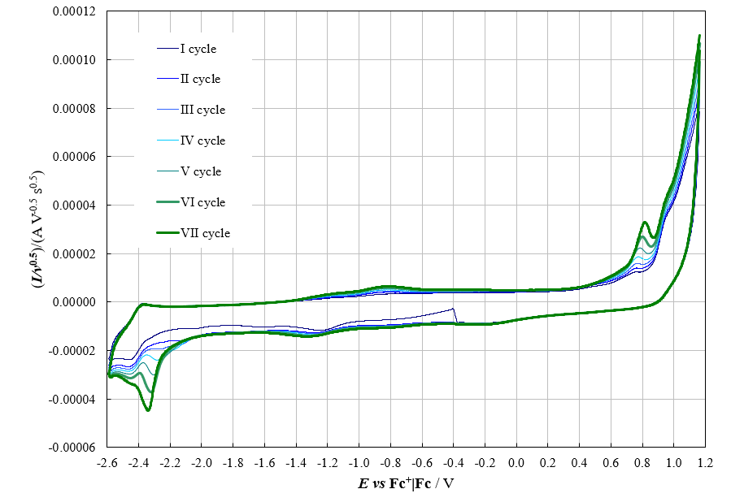
Figure S24.

Experiment nr. 2
Electrodeposition cycles

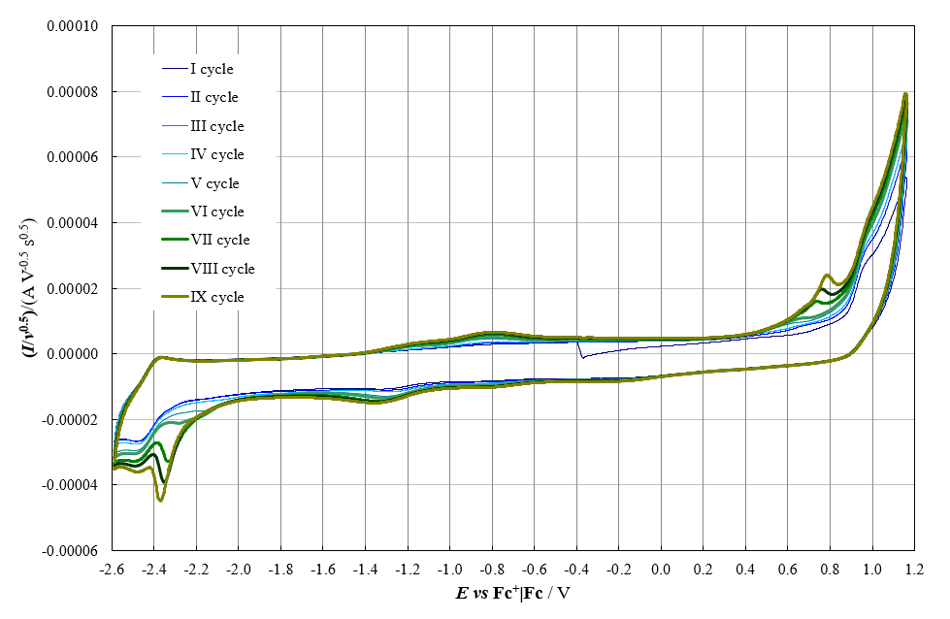
a)
Stability cycles
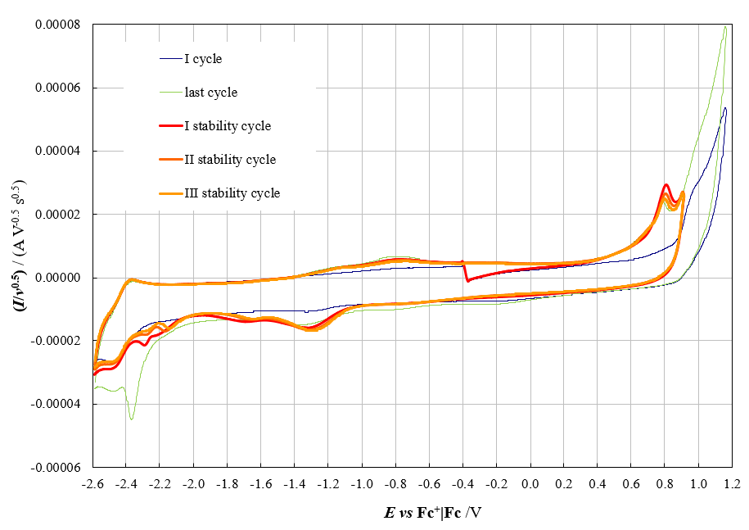
b)

Figure S25.

Experiment nr. 3
Electrodeposition cycles
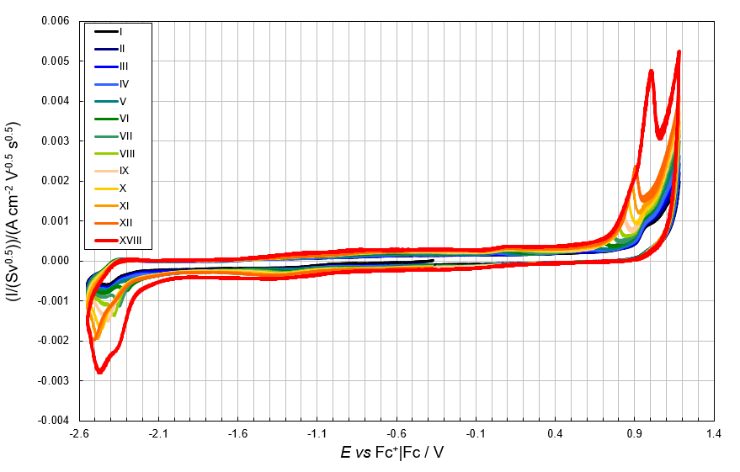
a)
Stability cycles

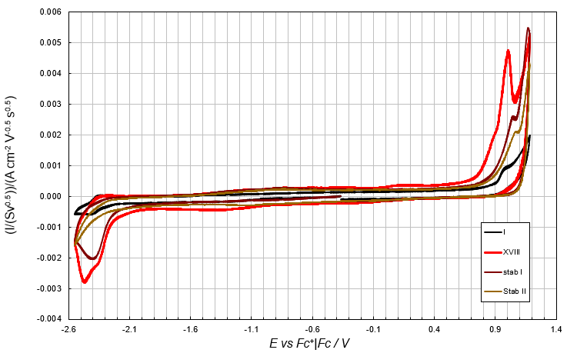
b)
Figure S26.

b) On ITO, in CH₃CN + 01 M TBAPF₆

Experiment nr. 1
Electrodeposition cycles

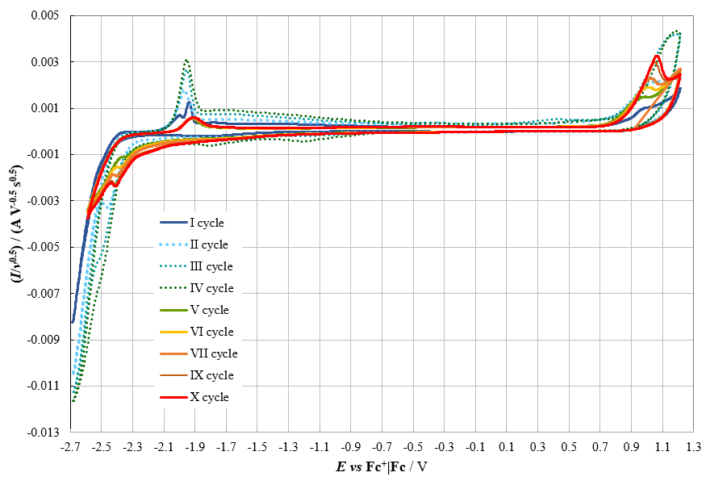
a)
Stability cycles
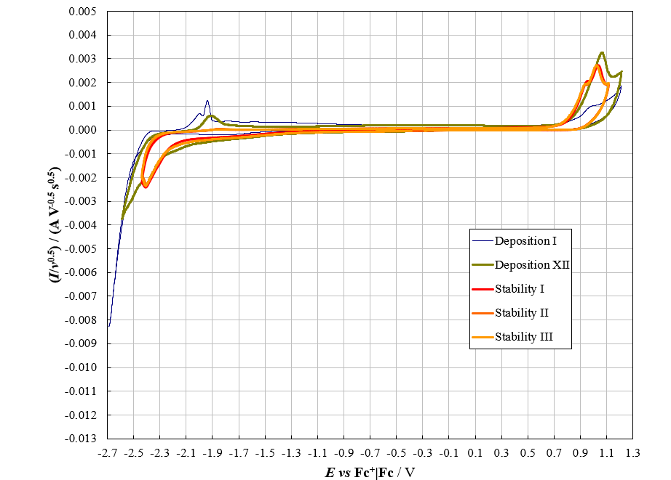
b)
Figure S27.

Experiment nr. 2
Deposition cycles
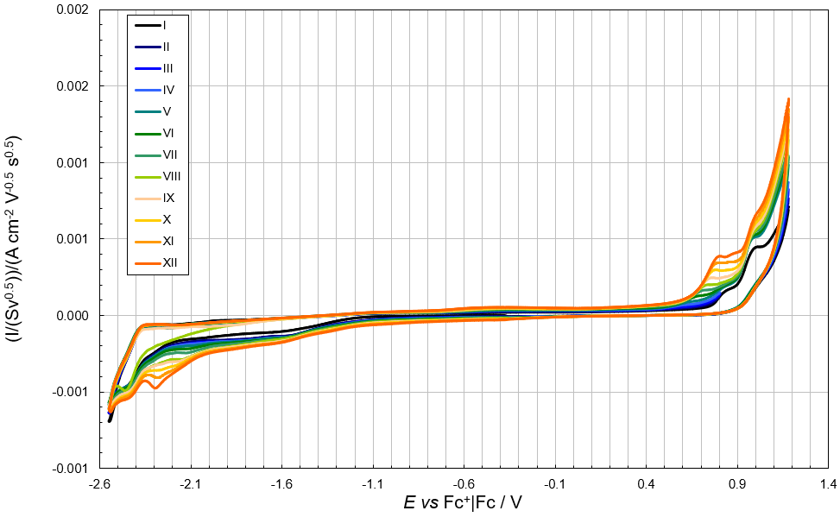
a)
Stability cycles
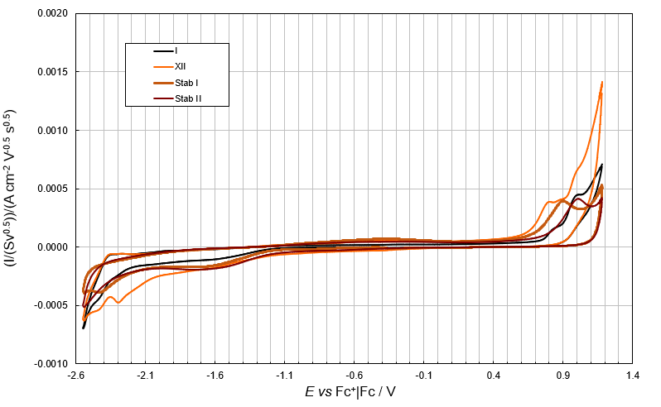
b)
Figure S28.

Experiment nr. 3

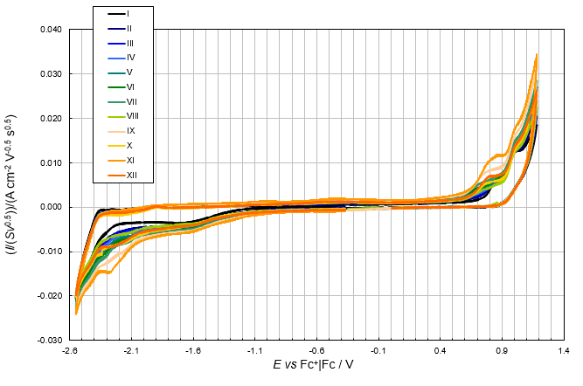
a)
Stability cycles
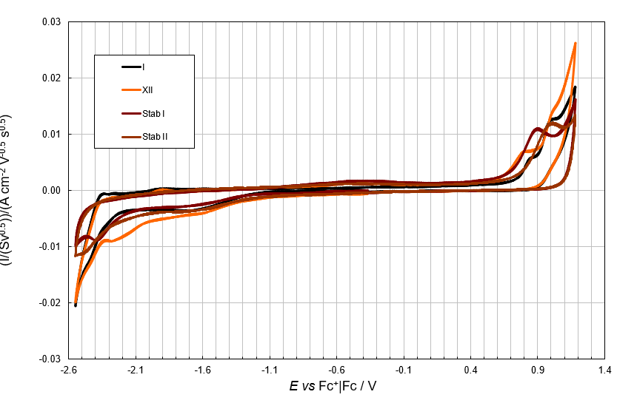
b)

Figure S29.

Experiment nr. 4

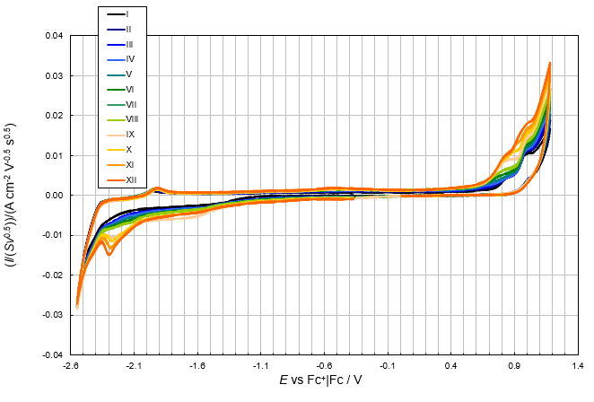
a)
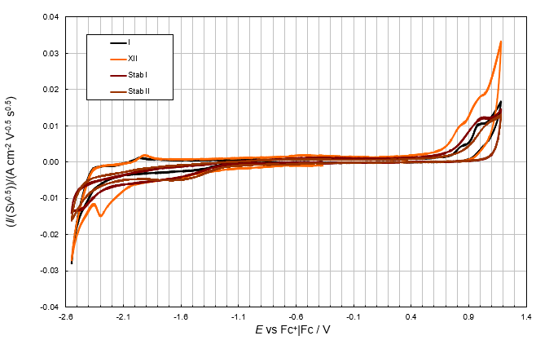
b)
Figure S30.
  - Dithiaalkene 4: electrodeposition experiment

On GC, in CH₃CN + 01 M TBAPF₆

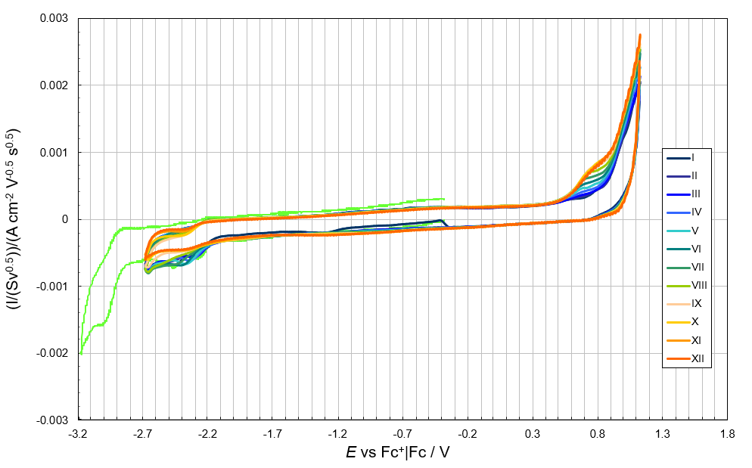
Figure S31.

  - 2-Aza[7]helicene 5: electrodeposition attempts

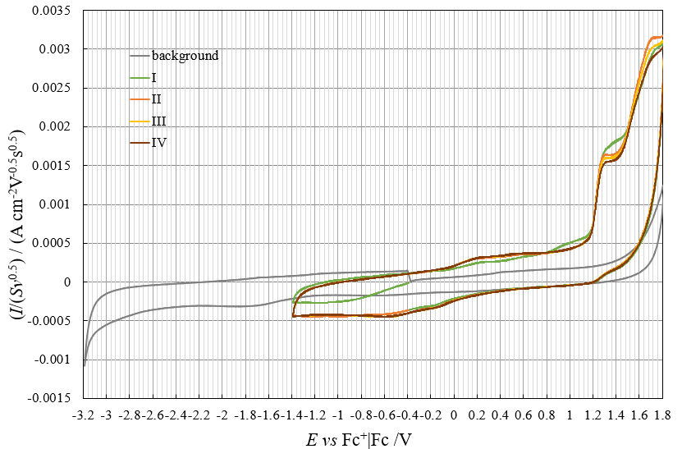
a)

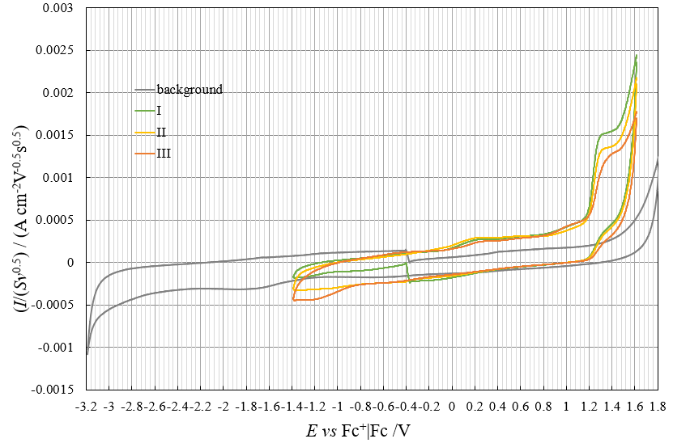
b)
Figure S32.

  - 2-Aza[6]helicene 6: electrodeposition attempt

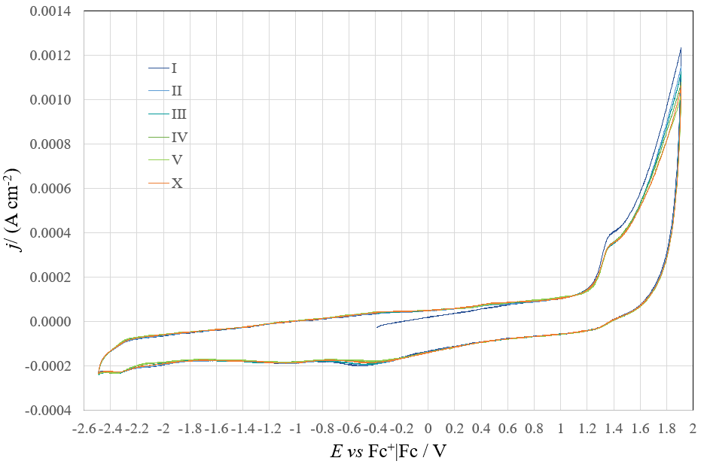
Figure S33.

  - Electrochemical impedance spectroscopy EIS on a film obtained by dithiaza[7]helicene 1 electrodeposition on ITO in CH₃CN + 0.1 M TBAPF₆ (12 deposition cycles + 2 stability cycles)

Nyquist plot
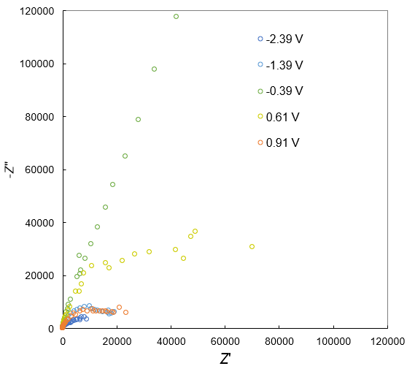
a)

Bode modulus plot Bode phase plot
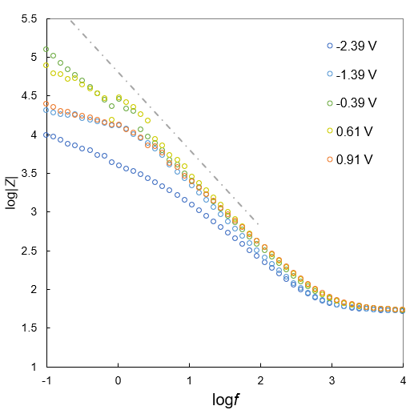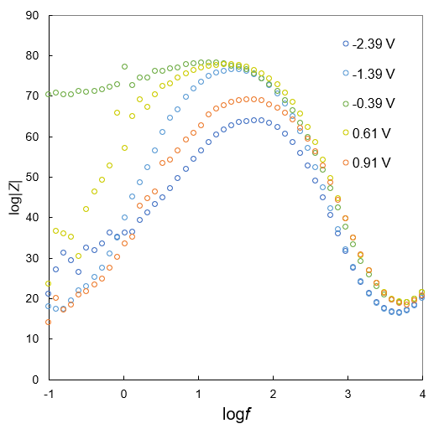
c)
b)

Figure S34.

5.13 CV and DPV Comparisons (A) between two open precursors
and (B) among four helicenes
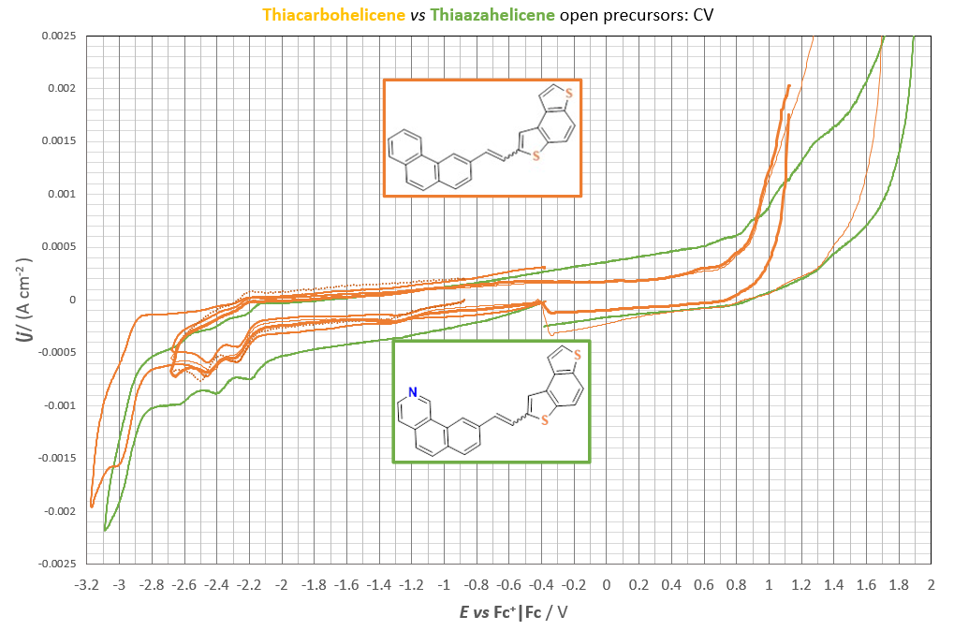
a)
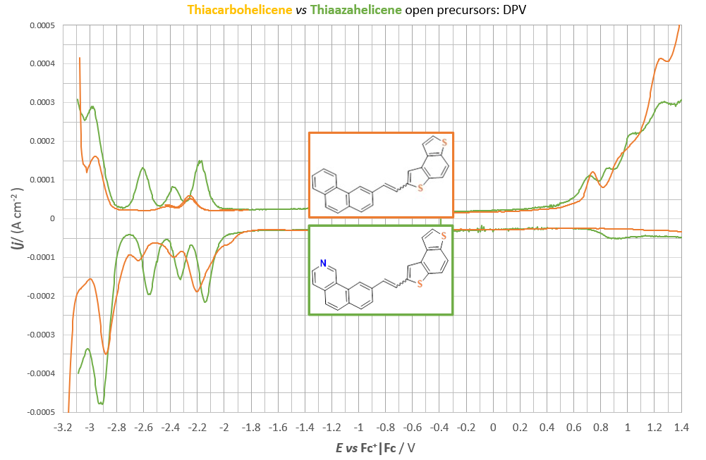
b)
Figure S35.

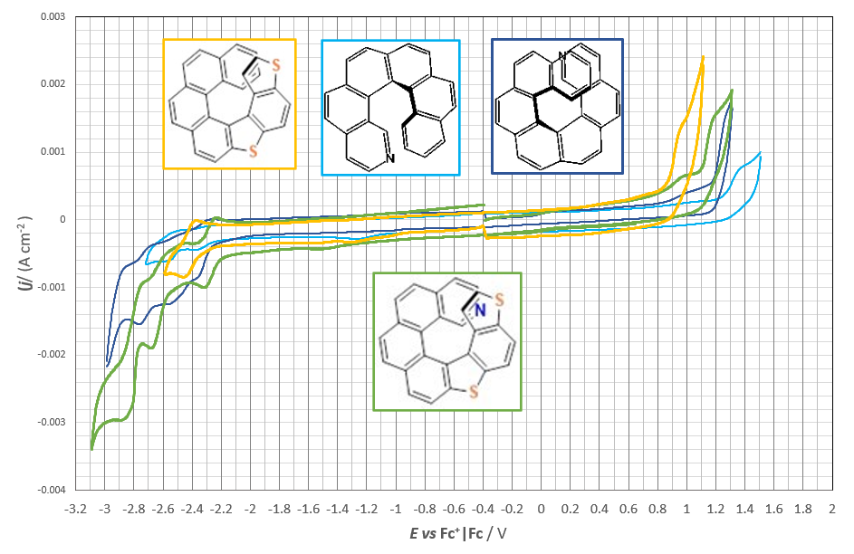
a)
b)
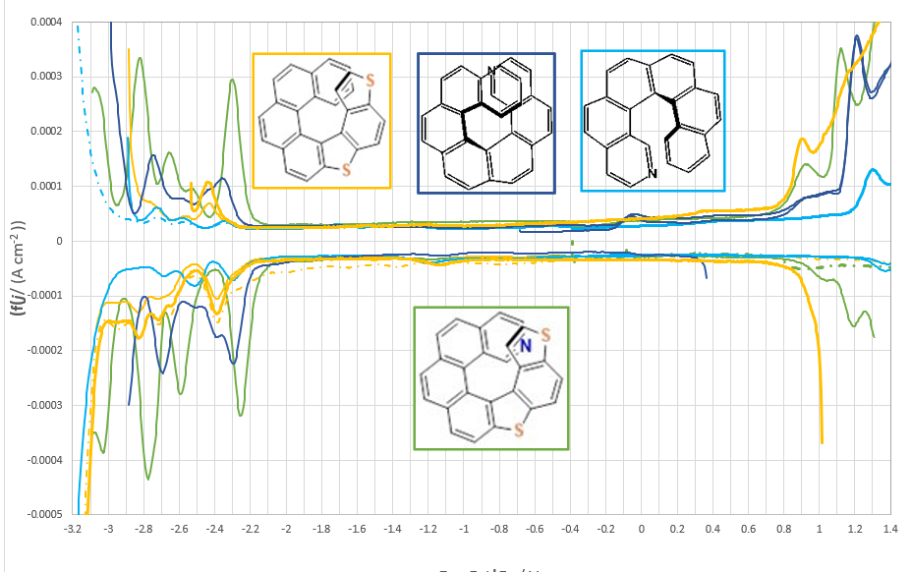
Figure S36.

6. Chiral HPLC study on 2-aza[7]helicene 5

The HPLC-grade solvents were supplied by Aldrich (Milan, Italy).
The HPLC purification of 2-aza[7]helicene 5 was performed on a stainless steel Chiralpak IA 250 mm × 10 mm, 5 μm, column (Chiral Technologies Europe, Illkirch-Graffenstaden, France). The HPLC apparatus consisted of a PerkinElmer (Norwalk, CT, USA) 200 LC pump, equipped with a Rheodyne (Cotati, CA, USA) injector, a 2-ml sample loop, a PerkinElmer LC 101 oven, and a Waters 484 detector. The HPLC apparatus used for analytical enantioseparation of 2-aza[7]helicene 5 consisted of a PerkinElmer 200 LC pump equipped with a Rheodyne injector, a 50-mL sample loop, an HPLC PerkinElmer oven, and a Jasco (Jasco, Tokyo, Japan) Model CD2095 Plus UV/CD detector. The signal was acquired and processed by Clarity software (DataApex, Prague, Czech Republic).

The chiral sample was purified using high-performance liquid chromatography (HPLC) on a 250 mm x 10 mm Chiralpak IA column. The mobile phase consisted of a mixture of n-hexane-acetone-2-propanol-diethylamine (DEA) (50:50:0.2:0.2). The temperature was fixed at 10 °C.
As shown in Figure S37, under these conditions a partial enantioseparation was observed, with some impurities eluting before and after the enantiomeric peaks.

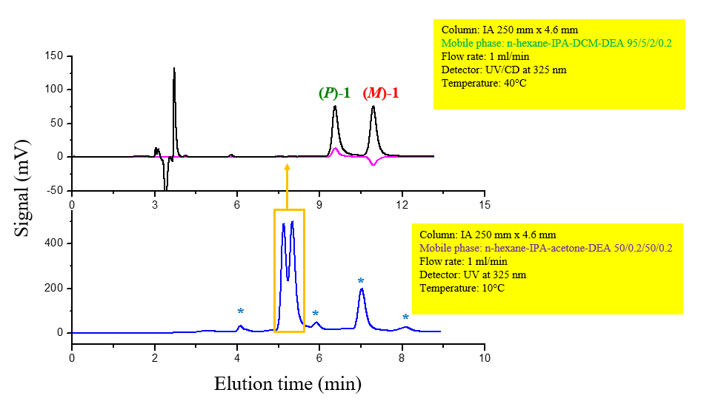
Figure S37

The helicene was isolated as a racemic mixture and subsequently subjected to analysis on the same Chiralpak IA chiral stationary phase, but employing a distinct elution mode. At a column temperature of 40 °C and with the mixture n-hexane-2-propanol-dichloromethane-DEA 95:5:2:0.2 as a mobile phase, enantioselectivity was enhanced, resulting in the baseline separation of two enantiomeric peaks, each characterized by a distinct CD signal. In accordance with the CD data of the analogue 5-aza[6]helicene¹³, the positive CD signal at 325 nm exhibited by the first eluting enantiomer was correlated with the (P) absolute configuration, while the reversed CD signal of the more retained enantiomer was correlated with the (M) absolute configuration.

¹³ F. Fontana, G. Carminati, B. Bertolotti, P.R. Mussini, S. Arnaboldi, S. Grecchi, R. Cirilli, L. Micheli, S. Rizzo, Helicity: A Non-Conventional Stereogenic Element for Designing Inherently Chiral Ionic Liquids for Electrochemical Enantiodifferentiation, Molecules 2021, 26, 311.

