Expression of CYP153A6 monoxygenase in Acetic Acid Bacteria allows the production of carboxylic acids starting from alkanes

Nespoli Luca¹, Cannazza Pietro¹, Molinari Francesco¹, Diego Romano¹
¹Department of Food, Environmental And Nutritional Sciences, DEFENS, University of Milan

Enzymatic hydroxylation mediated by cytochrome P450 monooxygenases has been extensively studied since only molecular oxygen and reducing equivalents from NAD(P)H are requested for the reaction, which often occurs with high chemo- and regioselectivity. Even if many genetic approaches have been developed for the functional expression of CYP450 (together with cofactor regeneration systems and alkane transporter¹), low biocatalytic efficiency and low enzymatic stability were frequently reported. Here we present the development of genetically modified acetic acid bacteria (AAB) as biocatalysts for the functionalization of methyl groups in the allylic position of different terpene derivatives (e.g., limonene, carveol, carvone) and non-functionalized methyl groups of aromatic substrates (e.g., toluene, xylenes, p-cymene, p-ethyl toluene).
We engineered two acetic acid bacteria (AAB) strains (Acetobacter malorum and Komagataeibacter xylinus) with a plasmid (based on the pSEVA331Bb vector backbone) encoding for a limonene monoxygenase operon from Mycobacterium spp. ¹, including genes for the expression of a CYP153A6, a ferredoxin and a ferredoxin reductase for cofactor recycling.
The resulting recombinant strains were able to hydroxylate different terpenes thanks to the monooxygenase activity and to further oxidize alcohols into the corresponding aldehydes and carboxylic acids, exploiting the action of the AAB’s unspecific membrane-bound alcohols (ADH) and aldehydes (ALDH) dehydrogenases². Their activity towards (S)- and (R)-limonene was compared with a recombinant strain of E. coli expressing the same genes²: whereas the use of the E. coli strain allowed for the preparation of perillyl alcohol, recombinant AABs gave complete oxidation of both the enantiomers of limonene to perillic acid, with transient formation of perillyl alcohol and perillaldehyde. (Figure 1).

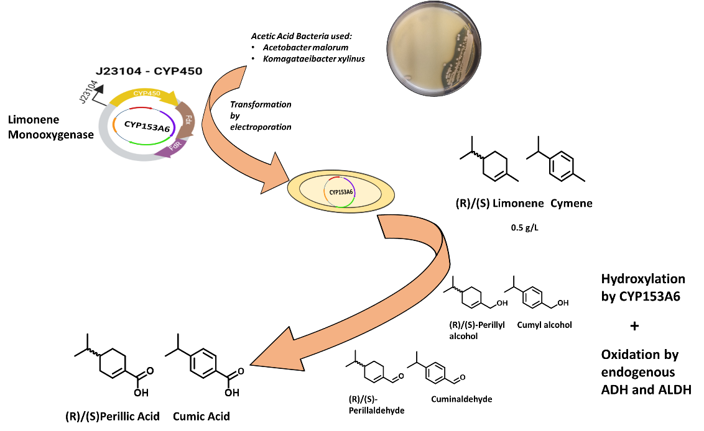

Figure 1: Oxidation of (S)/(R)-limonene or cymene to perillic acid and cumic acid mediated by recombinant acetic acid bacteria.

- van Beilen, J.B.; Holtackers, R.; Luscher, D.; Bauer, U.; Witholt, B.; Duetz, W.A. Biocatalytic production ofperillyl alcohol from limonene by using a novel Mycobacterium sp cytochrome P450 alkane hydroxylase expressed in Pseudomonas putida. Appl. Environ. Microbiol. 71, 1737-1744. 2005.
- Cannazza, P.; Rabuffetti, M.; Donzella, S.;De Vitis, V.; Contente, M.L.;De Oliveira, M. D. C. F.; De Mattos , M.C.B.; Francisco, G. D.S.O.; Ricardo, P.;Pinto, A.; Molinari, F.; Romano, D. Whole cells of recombinant CYP153A6-E. coli as biocatalyst for regioselective hydroxylation of monoterpenes. AMB Expr 12, 48 2022.

