SALICYLALDEHYDE-TAGGED PEPTIDES FOR THE REVERSIBLE-COVALENT ENGAGEMENT OF PROTEIN LYSINE RESIDUES

M.Mason,* L.Belvisi, L.Pignataro, A. Dal Corso
Università degli Studi di Milano, Dipartimento di Chimica, Via C. Golgi, 19, 20133, Milan, Italy

e-mail: mattia.mason@unimi.it

Inserting electrophilic species into small molecule ligands or peptides is a well-established method for enhancing binding affinity to target proteins. The amino acid Lysine (Lys) is highly abundant in the proteome and one of the most frequent residues on the outer structural layers of proteins. For these reasons, the derivatization of synthetic ligands with aldehyde tags capable of imine bond formation with Lys ɛ-amino groups may represent a general strategy for the discovery of potent small-molecule inhibitors.

Ortho-hydroxy aldehydes such as pyridoxal or salicylaldehyde (SA) derivatives have been used to form imines in aqueous media, stabilized by an intramolecular H-bond between the imine N atom and the ortho-phenolic proton. By virtue of this reactivity, SA derivatives are being installed into various classes of protein ligands, aimed at the reversible-covalent engagement of protein Lys residues.^{1,2}

This talk will describe our recent contribution to this field, with focus on the installation of the Lys-engaging SA module into peptide ligands.^{3,4}

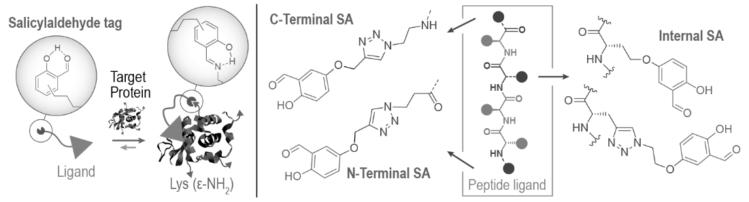

Figure 1. Left: Binding mechanism of a reversible-covalent ligand equipped with a salicylaldehyde (SA) tag. Ideally, SA forms a remarkably stable imine bond with a Lys(ε-NH₂) residue proximal to the ligand binding site. This covalent ligand-protein connection is stabilized by a H bond between the OH phenolic proton and the imine N atom. As a result, the final ligand-protein complex is stabilized by a combination of non-covalent and covalent interactions. Right: Current options for the SA tag installation at different peptide positions, recently developed by our group.

References

1. A. Dal Corso, M. Catalano, A. Schmid, J. Scheuermann, D. Neri, Angew. Chem. Int. Ed. 2018, 57, 17178.

2. M. Mason, L. Belvisi, L. Pignataro, A. Dal Corso, ChemBioChem 2023, e202300743.

3. G. Sacco, D. Arosio, M. Paolillo, A. Gloger, J. Scheuermann, L. Pignataro, L. Belvisi, A. Dal Corso, C. Gennari, Chem. Eur. J. 2023, e202203768.

4. M. Mason, B. Nava, L. Belvisi, L. Pignataro, A. Dal Corso, Eur. J. Org. Chem. 2024, 27, 202400229.

